CO₂ and Global Warming and Climate Change
Despite 30 years of effort and many billions of dollars spent, the world has failed utterly to stop the rise of human CO₂ emissions. Is this because people don’t care, or is it becoming more and more obvious that the Global Warming/Climate Change hype is just that? This century is warmer than the last two, but that all stopped in 1998, yet CO₂ increased by 30%.
Half of the warming had already occurred by 1943, before human CO₂ emissions began to increase around 1950, so what caused this early warming if it was not CO2? Since 1900, there have been two periods of warming, the first without significant CO₂ emissions, the second from 1978-98, with sharply increasing CO₂. Two periods of cooling/lack of warming, both accompanied by increasing CO₂. If CO₂ causes warming, the world should have continued to warm, but it did not. It seems human CO₂ emissions do not cause warming, so why penalise CO₂?
What the increase in atmospheric CO₂ has done, is increase crop yields world-wide, so why do we need to cut emissions? We have been warned for over 50 years that if the world continues to warm, we are doomed to more droughts, floods, hurricanes, fires, crop failures, food and water shortages, melting ice and sea level rise, and much less snow; the list is endless. Yet these predictions never come to pass and fail to explain why or how it is that
- human emissions of CO₂ drive global warming;
- 97% of atmospheric CO₂ is natural, yet the 3% of human CO₂ alone drives global warming and the 97% of natural emissions do not;
- there were no ‘tipping points’ or runaway global warming in the past when atmospheric CO₂ was hundreds of times higher than now;
- ice ages start when atmospheric CO₂ is far higher than at present, and end when it is much lower;
- atmospheric CO₂ increases after periods of natural warming?
The idea that CO₂ drives global warming is derived from computer models, not data which is why they consistently fail to predict the climate we get. Yet it is these models that governments use to define/decide climate and emissions policy under the mistaken assumption that 97% of scientists agree that the science is settled, which it is not.
Even if it were necessary to reduce global CO₂ emissions, if Australia reduced its current level of 407 Mt CO₂ to zero, what difference would it make? Total human CO₂ emissions in 2017 were 33,444 Mt (= just 4.3 ppm added to the atmosphere), with China contributing 9,330 Mt and USA 5,100 Mt and Australia 427 Mt (~= 0.05 ppm). And what would its removal cost? Just look at South Australia, where the price of electricity is double what it is in Canberra, and three times the price in the US; and the state’s share of the Australian economy has fallen from 8% in 1986 to 6% in 2017, as more and more factories close; now apply that to the whole country.
Clean coal fired power stations are being built all round the world, why not in Australia? Pinning hopes on unreliable renewables – wind and solar, is not justified, neither are reliable enough to provide base load power that is needed to run modern day infrastructure. And as CO₂ emissions do not cause climate change then it is madness to make Australian power, which used to be the cheapest in the world, one of the most expensive and unreliable.
The alarming and baseless claim that global climate change can be prevented, Canute-like, by spending US$2.4 trillion per year for 30 years, is contradicted by the total inability to achieve any reduction in global emissions despite 30 years of massive expenditure and loss of jobs, productivity and living standards.
Revise your governments climate change policy by looking at the data and listening to the many level-headed scientists who are rightly sceptical of the utility of the Paris accord, and get out before it really is too late.

Daily we are told that Climate Change disasters are crippling the planet, as weather becomes more and more extreme, but it is not. 2018 is the first year ever, without severe (>F3) tornadoes in USA; Australian cyclone frequency has fallen since 1971, droughts and rainfall are not more frequent or severe, desalination plants are mostly mothballed, bleaching of the Great Barrier Reef is not increasing, nor are el Niños. Cold oceans absorb CO₂ so the warmer the seas get, the less so-called ‘acidification’ there is yet the reverse is claimed. Fire damage in California is increasing but not the numbers of fires, suggesting forest management is the problem, as it has been in Australia. The average number of very hot days in Australia is not increasing
Sea level rise at Sydney harbour is a steady 7.5 cm per 100 years, and shows no sign of being affected by increasing CO₂. Malaria will not spread as the globe warms, as it is not a solely tropical disease, (the world’s largest known epidemic was in Siberia in 1920s). Alpine glaciers are retreating – and have been doing so since about 1825; global warming began around 1695 at the beginning of the end of the Little Ice Age and sea level rise began around 1795, all well before human CO₂ made an appearance.
Arctic sea ice is shrinking (but has not disappeared as famously promised by Al Gore), and polar bear numbers are increasing, as is Antarctic ice. Overall the claimed impacts of human induced CO₂ emissions are not happening.
Endlessly we are also told that 97% of scientists agree that human CO₂ is the cause of global warming; the analysis on which this claim is based looked at only 64 responses out of 11,944 replies to a questionnaire to derive the 97% figure; which Al Gore made famous in his ‘Inconvenient Truth’ video, but it is a lie. There probably is 97% agreement that CO₂ emissions are increasing and that the planet has warmed, only dictators get higher than that; What is not agreed is that the warming is dangerous and is caused by human CO₂ emissions.
Wrapped up in the 97% debate is another even more blatant manipulation of data to give false support to the IPCC AGW hypothesis - Climate Gate. In 2009, a few thousand emails were hacked from the University of East Anglia department that produces one of the five or so sets of international climate data that are used to measure the world’s average temperature. The most relevant is from Phil Jones ‘I’ve just completed Mike’s Nature trick of adding in the real temperatures to each series for the last 20 years (i.e. from 1981 onwards) and from 1961 for Keith’s, to hide the decline’ What used to be called the Nuclear Winter, was a period of declining world temperature from 1943 to 1978 which the authors of the emails identified as a problem for their IPCC warming story, and which was eventually removed from the record.
Slowly but surely the world’s temperature data sets were massaged to make them fit the IPCC song sheet; called homogenisation, temperature data from earlier years were made colder and data from later periods were made warmer, to give the erroneous impression that the world’s average temperature had always increased since the start of the Industrial Revolution.
Michael Mann, one of the active parties in the climategate emails, manipulated data to erase the well documented Medieval Warm Period, which saw the Vikings settle in Greenland as farmers and Polynesians settle in Norfolk, Pitcairn and Easter Islands. His now infamous ‘Hockey Stick’ also saw the light of day in Al Gore’s video. It showed temperatures declining slowly from 1000 AD, with a sudden up-tick when CO₂ started to increase. Completely fudged data, but very effective in selling the idea that it was all human CO₂ -and all our fault.
The IPCC’s AGW hypothesis claims that human CO₂ alone has upset the balance of the world’s carbon budget, and this alone, drives global warming and climate change; however polar ice core data covering the last 800,000 years shows that atmospheric CO₂ always follows changes in temperature, in other words atmospheric CO₂ is a result of global warming/cooling, not the driver.

This is the inconvenient fact which all of the data manipulation above is designed to counteract. And it is not just the recent past that is inconvenient, as the AGW ‘idea’ can’t explain why the Ordovician/Silurian ice age took place when atmospheric CO₂ was ten times higher than today, nor for the Late Jurassic ice age when CO₂ was 6 times higher. Nor does it explain how CO₂ rose 25 ppm from the beginning of the Holocene while the average temperature declined. The geological record is endlessly clear, CO₂ does not cause warming – unless you want it to, and are prepared to ignore or manipulate inconvenient facts.

The scientific method shows that “If a theory rules out certain possible occurrences, … it will be falsified if these possible occurrences do in fact occur.” CO₂ lagging temperature for over 500 million years falsifies the untested AGW hypothesis again and again. Any claim for warming being caused by massive CO₂ emissions is simply predicated on the mistaken belief that the AGW hypothesis is real.
Regards
Howard Dewhirst
PO Box 394
Burleigh Heads
QLD 4220
0402070347

Ian Plimer Questions
1. Can you please show me that human emissions of carbon dioxide drive global warming? (A: It has never been shown).
2. The IPCC (Fig. 7.3, IPCC AR4) show that 97% of all emissions are natural. Can you please show me that the 3% of human emissions drive global warming yet the 97% of natural emissions don’t?
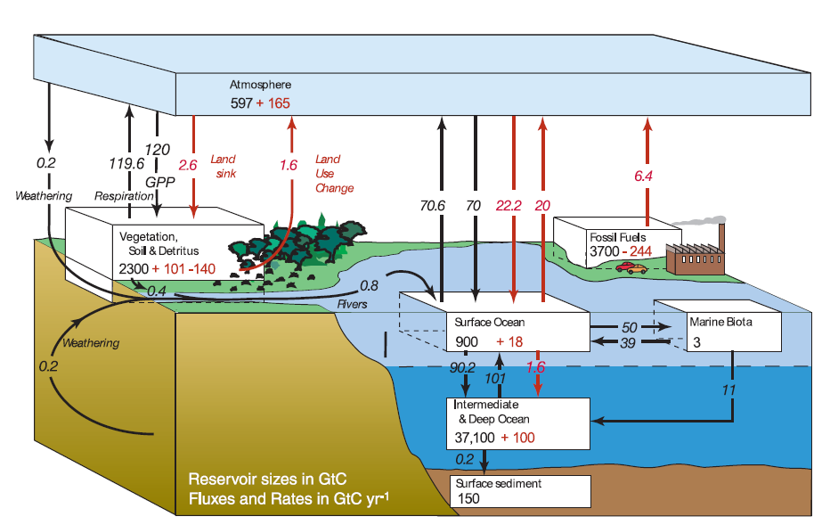
3. Why did we have no tipping points or runaway global warming in the past when the atmospheric carbon dioxide content was hundreds of times higher than now?
4. Why did the five major ice ages start when atmospheric carbon dioxide was far higher than at present?
5. Why does the atmospheric carbon dioxide content increase after a period of natural warming?
Other questions
All models predict warmer temperatures than occur, but less than AGW Hypothesis (it I NOT a theory) projects
Models predict tropical tropospheric warming which has never been detected
Models fail to hindcast or forecast any multi-decadal oscillations such as el Nino
Model projections fail to agree with any balloon and satellite temperature data
Models fail to explain warming pre-1943 when human CO₂ negligible, cooling from 1943 – 78 and from ~1998 when CO₂ was increasing
Models fail to explain high CO₂ during interglacials and subsequent cooling
Models fail to explain drop in hurricane frequency from ~1969 to 1994
Models cannot explain lack of clear trends in rainfall patterns
Models fail to explain how Human CO₂ behaves differently to natural CO₂

Further Questions
- Why was the definition of climate change used as the basis for the IPCC research limited just to human causes when non-human causes (water vapor) clearly dominate?
- Why did the IPCC rely on simple computer models for such a complex when they new that the climate was xxxxxxxxxxxxxxxx

- ( How did this allow them to ignore water vapor, by far the most important and abundant greenhouse gas?)
- Why were they allowed to build computer climates models when they knew the data was inadequate?
- Why was the IPCC membership and participation in Reports limited to only those chosen by bureaucratic members of the WMO?
- Why are almost all the people involved in the IPCC unqualified in climatology?
- Why did the IPCC only examine temperature and warming?
- Why didn’t the IPCC report on the positive effects of warming?
- Why don’t they release the Working Group I (WGI) Physical Science Report first?
- Why did they set up a separate group of politicians and bureaucrats with a few selected scientists to produce the Summary for Policymakers?
- Why was it released before the scientific evidence of WGI?
- Why were the forecasts made in the first IPCC Report in 1990 so wrong?
- Why did the second Report in 1995 stop providing forecasts?
- Why did they switch to providing scenarios or projections after 1990?
- Why did they ignore all the legitimate critiques of the early Reports?
- Why did they finally establish a method of feedbacks and critiques?
- Why did most of these never make it into the Reports?
- Why did approximately 30,000 attend the recent climate conference in Poland?
- Why were a majority of them environmental activists with no qualifications in climatology?
- Why were industry and business so poorly represented from the start?
- Why does that continue at the recent climate conference?
- Why is the IPCC the source of e annual production of human CO2 for their computer models?
- Why does a CO₂ increase cause a temperature increase in their computer models when it doesn’t exist in the empirical data?
- Why are similar computer models unable to forecast weather much beyond 72 hours?
- Why were all the IPCC projections from 1995 to the present incorrect?
- Why has most of the global temperature record been altered?
- Why did all these alterations only change the record in one direction?
- Why did those adjustments only lower early temperatures?
- Why do major agencies that calculate the annual average global temperature get different results?
- Why did sceptics become deniers?
- Where is the evidence that climate change deniers deny climate change?
- Why, in fact, do all the deniers claim that climate change occurs?
- Why do the media never ask Al Gore about his climatology qualifications?
- Why in IPCC AR4 did they provide a completely different definition of climate change that they claimed, falsely, they used in their Reports? They didn’t even use it in the one in which they claimed it.
- Why, if the science is so clear, do most nations act hesitatingly or fail to act?
- Why did the Kyoto Protocol fail?
- What replaced the Kyoto Protocol?
- Why is China entitled to and now demanding $2 billion from the IPCC through the Paris Climate Agreement?

