2019-20 Pre-Budget Submission
Braveheart Freedom Fighters
December 2019

Background

About us – so far

CodeSafe Solutions has pioneered a way of communicating critical information. They are solution architects specialising in the area of worker engagement and knowledge retention using a mobile visual communication platform called QIN (Quality Information Now). They recognise that every business is unique and so are their challenges. CodeSafe collaboratively develops solutions and delivers them via the QIN communication platform to solve an organisation’s unique challenges. (find out more here: https://www.codesafe.com.au/)

Our heart is about honouring people, their learning preferences and equipping people for work, but this overflows into their lives by building confidence, competence and resilience. CodeSafe has identified and measured what is needed to assist organisation’s to minimize and eliminate physical risk. The solutions we have provided around physical risks we can and have started to provide through Braveheart Freedom Fighters for the secondary psychosocial risks. We have started to provide communities, learning institutions and workplaces with meaningful events, programs and resources that empower and equip people, while they are well, to stay well.

The Braveheart Freedom Fighters programme has initially targeted tradies. This group was identified as our highest risk demographic. But it’s not just about their work. It encompasses other social determinants of health. Our work and research have identified four key secondary psychosocial risk areas that contribute to social and emotional stress:

- Exercise and nutrition
- Financial literacy
- Communication
- Purpose

And based on a literature review, Braveheart Freedom Fighters can quickly and easily be adapted to deliver other meaningful resources that address additional secondary psychosocial triggers across all genders and age groups.

You can see the video about what we have achieved here, when A Current Affair did a story on mental health in construction.
https://www.youtube.com/watch?v=f01Mwkju3D8&feature=youtu.be

For more information please contact

David Broadhurst
CEO (Chief Engagement Officer)

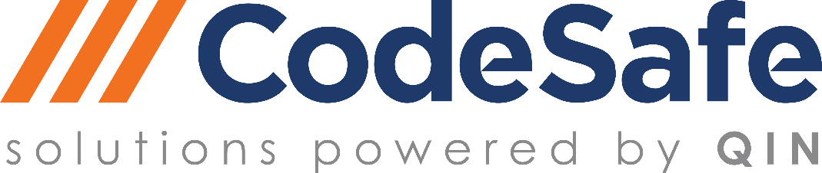
Hallmark Building
10 Caribbean Drive
Scoresby, 3179
VIC, Australia

T: 1300 475 557
M: 0416 051 082
www.codesafe.com.au

Summary

Upstream preventative intervention - Good for everyone

We believe that good individual mental health can and does have a positive flow on for society. Braveheart Freedom Fighters always seeks to provide communities, learning institutions and workplaces with meaningful events, psychosocial programs and resources that empower and equip people, while they are well, to stay well. We act upstream!!

We think our program can help people stay well. We help them identify risks before they happen. And help them to tackle early mental health problems; and sometimes the risks of suicide. We think we can help people to maintain their mental health and reduce their need for future clinical intervention by empowering people while they are well, to stay well.

This isn’t about yet another organisation. We don’t see our work competing with any other organisations but complimenting other initiatives through being able to provide a fully customizable communication platform and app (QIN) that can deliver a more cohesive and engaging mental health strategy. We know especially for young people learning via mobile devices is their learning preference especially visual.

This is about connecting with people when they need support, resources and information by communicating in a way that resonates with them. They will have quick and easy access to the plethora of resources delivered through the communication platform and app. Access isn’t about having to wait until there’s an ill-health outcome, we provide access, when, or hopefully before, its needed. Our approach doesn’t wait for those with ill-health to call support such as lifeline but provides access to these wonderful organisations and supplements what headspace and lifeline do so well. We are about equipping people for life not just for work. Equipping people for life applies to our young people too.

We think there is a gap. In National Mental Health Commission Media release 11 August 2019, The Commission’s CEO Ms. Christine Morgan says of the announcement:

“Investing in prevention and early intervention strategies in early childhood is key to giving our children the best opportunity for good mental health and wellbeing. We know that mental illnesses in adulthood frequently have their onset in childhood. Focusing on the mental wellbeing of our children is not only the right thing to do but is also an imperative.”

Whilst we support the need for an initial specific strategy for 0-12year olds we think an approach is needed now for young adults. Once the Braveheart Freedom Fighters delivery approach is proven we can explore how we go further upstream and tackle the younger age groups.

We believe we can help young adults focus, to keep them engaged and mentally well. What we do is for 16 – 24 year olds, its empowering them, with tools and resources through the QIN communication platform and app. And there is always ongoing self-access. So, they don’t have to decide to seek help, wait to book in with someone (and wait for a suitable time) or break the barriers to connect with an authority in the first instance. They can use their digital environment to seek what’s important to them at that crucial moment. The platform and app is about reaching out and reaching far and wide, when its needed and in a targeted way.

Research shows (below graph) impact of our learning approach that was developed by CodeSafe Solutions is positive. This same approach can be leveraged by Braveheart Freedom Fighters.
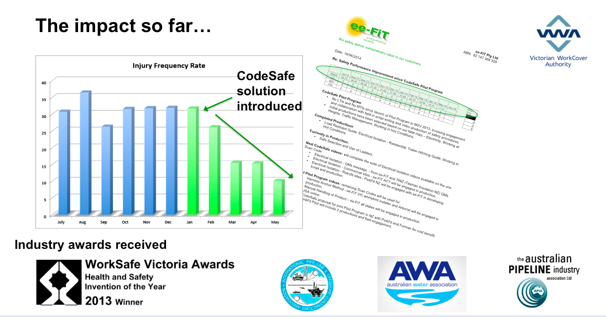

CodeSafe Solutions learning methodology along with QIN, -communication platform and app - has been evaluated by RMIT and received much acclaim for reducing physical risk in the workplace. Braveheart Freedom Fighters is adopting the same approach to reduce psychosocial risk, not only in the workplace but in learning institutions and the wider community.

Research has shown that what we do in workplaces has worked. Early recognition from WorkSafe Victoria and an RMIT University evaluation confirmed that our communication platform and app – based on a proven learning methodology and visual framework – could make a real difference across learning institutions and workplaces. More importantly it’s not about paperwork and manuals.

The Productivity Commission has recently released a draft report on Mental Health as part of its inquiry (Productivity Commission, Mental Health, Draft Report. October 2019). This inquiry is about the mental health and wellbeing of Australia’s population, the prevention and early detection of mental illness, and treatment for those who have a diagnosed condition. We agree prevention is where to start and we think the social determinants of health are wider than simply detecting and treating illness.

In the Overview of this draft report the Productivity Commission notes

The years of 16 to 24 are an important transition point in a person’s life regardless of their mental health. However, of all age groups, young adults have the highest rates of mental ill- health — 26% of 16-24 year olds have an anxiety, mood or substance use disorder — and report relatively high rates of psychological distress. (Productivity Commission Overview Draft Report) (p.35)

That’s our target audience - apprentices and young workers. And we hope to reach year 9 and 10 and primary school age as well, in the future. As all groups develop their life filters, we think we can help prevent early setbacks which can have a lifetime impact.

What’s more we have already started. We have done work with Victorian Civil Contractor’s Federation, Granted Constructions Victoria, O’Brien’s Plumbing and Electrical, Revelation Software Concepts, Stairways Men’s Community Group, Dahlsens Building Group and De La Salle College Malvern – just to name a few.

It’s a big task to make substantial reform of Australia’s mental health system. We support this reform and we also understand there is no quick fix. But we think we can assist and meet the long-term goals. We want to be part of this reform…the upstream part for young and more mature people.

Help us to strengthen and underpin the national mental health strategy. We work collaboratively – that’s our mode of operation, so work with us to prevent ill-health. Support us over 3 years with $1,100,000, with a possible option to seek further funding after first year should the initiative through research prove effective.

As part of the programme we would invite Prof. Helen Lingard from RMIT and Dr. Peta Miller (ex Director SafeWork Australia) to evaluate and show what works. So, the research gets done as well.

We are confident that this works (see comments from users below) and we are ready to help.

Look forward to your support.
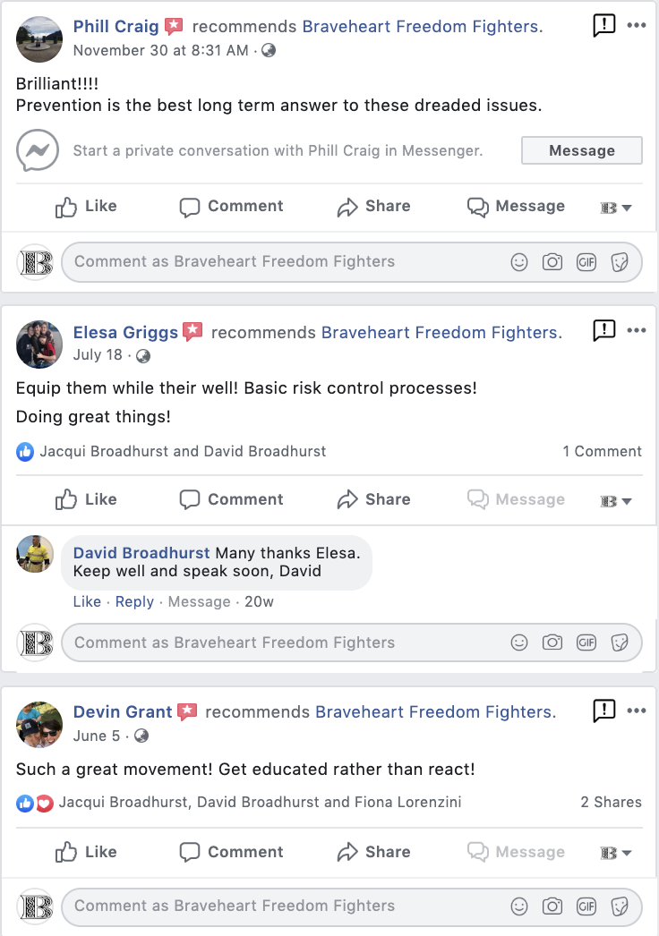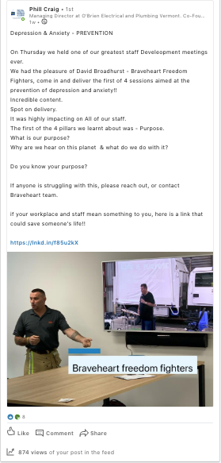

What we offer

We support the national mental health strategy, but we feel we can fill a gap and join some dots. We offer:

- Early intervention – good investment
- Equipping people with skills to minimise social and emotional outcomes (stress)
- Implemented quickly – ready to go delivered through QIN, a proven communication platform and app
- Access and connection – immediate & regional reach, full offline capability
- Monitored and evaluated – full engagement analytics through the platform and app
- Work with us – it’s a good investment

- Early intervention – good investment

The Productivity Commission’s Draft report overview recognises the importance of upstream preventative approaches, and that’s what we do, the earlier the better. It notes

Early intervention — either early in life or early after the detection of risk factors that may lead to mental illness — is important to prevent the onset of illness or curtail a deterioration in mental health. However, some 40% of those with mental ill-health have never accessed mental health services nor seen their GP about their condition, with young people particularly unlikely to seek help. (p.11)

We want to equip young people while they are well, to stay well.
The Report Overview also notes

Mental illness affects people of all ages, but it tends to first emerge in younger Australians — 75% of those who develop mental illness, first experience mental ill-health before the age of 25 years. Improving mental health of Australians requires focussing on what can be done to prevent mental illness from developing, and identifying and intervening early — early in life and early in the development of a condition. (p.4)

This is the target group we are already working with, but we want to deepen our engagement.

The Canadian Mental Health Commission (2017) states

Many mental health problems and illnesses begin in childhood or adolescence. It is therefore not surprising that investing in mental health promotion and early intervention are identified as areas that can stem the tide of economic losses. Equally important, these interventions can lessen the human burden of illnesses that can seriously affect a person’s quality of life – from childhood through to older age.
It’s clear that early intervention is a good investment.

- Equipping those involved with skills of life

The social determinants of health are wide ranging. What we do recognises that it’s not just about clinical health or health outcomes, but it’s about supporting people with basic life skills. This is about re-orienting health and other services to people. Just what was noted in the Productivity Commission’s report.
The onset of problems with mental health early in our lives has lifelong consequences. Early interventions are commonly the most effective. What has been tried with some success in mental health is prevention that targets
1. early child development,
2. fair employment and decent work,
3. social protection, and
4. living environment

This is what we do.

In fact, we think we can help Productivity Commission with its Reform Area 1: prevention and early intervention for mental illness and suicide attempts
- Much is already expected of schools in supporting children’s social and emotional wellbeing, and they should be adequately equipped for this task through: inclusion of training on child social and emotional development in professional requirements for all teachers; proactive outreach services for students disengaged with school because of mental illness; and provision in all schools of an additional senior teacher dedicated to the mental health and wellbeing of students and maintaining links to mental health support services in the local community.
- There is no single measure that would prevent suicides but reducing known risks (for example, through follow-up of people after a suicide attempt) and becoming more systematic in prevention activity are ways forward. (emphasis added)

We equip young people (and mature people without these skills) for these tasks. We do training. We maintain links to existing supports. We don’t intend to recreate these wheels but we do join the dots for the users.

Our experience and methodology have been in systematic prevention and has been proven to work to reduce the risks of physical harm. It has been suggested and identified that we can apply this to secondary psychosocial risks.

We address similar life skills topics as the support programs being undertaken in Scotland. The program in Scotland is still downstream of the triggers as the support is being provided to those already identified as being in distress. This approach that’s been identified globally as a leading approach to the prevention of mental health issues. We feel we provide an enhancement to that program because we are looking at being further upstream and we have access to the QIN communication platform and app. The Braveheart Freedom Fighters initiative enables people to stay well, while they are well. https://www.dbi.scot/general/distress-brief-intervention-programme-overview/

- We are ready to go

Our evidence-based approach has been implemented quickly and easily to provide an upstream and preventative approach to organisations broader mental health strategy.

By leveraging on the success of the mobile-visual micro learning approach used by CodeSafe Solutions, we feel we have a good foundation to start from to achieve significant impact and are now ready to scale.

To see how we can scale quickly and easily, please view the Braveheart Freedom Fighters QIN channel now. BY downloading the QIN/ CodeSafe Solutions app, you will be able to experience first-hand how people can get access to the free support resources.

Braveheart Freedom Fighters Channel on QIN - https://app.qin.world/braveheart/home

- We offer access and connection as well as training

The recent report from the Productivity Commission also highlighted that access is key and current options are not working, especially for young people..

However, some 40% of those with mental ill-health have never accessed mental health services nor seen their GP about their condition, with young people particularly unlikely to seek help. (p.11)

We already offer

- Cohesive online and mobile meaningful resources for quick and easy access.

- Training to educators within secondary and tertiary learning institutions, as well as frontline team leaders and supervisors.

- Wellbeing leader training and support program

- Reach and support in regional areas, through improved online and mobile approaches that have got full offline capability

- Existing visual content library

- Recognising it’s not just about clinical stuff but supporting people around basic life skills.

- Monitoring and Evaluation

We see this program as an enabler for social and emotional programs and we also provide a framework for monitoring, and evaluation. We think this can be basis for research.

Prof Helen Lingard has worked with us before through evaluating the CodeSafe Solutions learning framework and Dr. Peta Miller (who is a world authority on psychosocial risk factors) would work with us and provide much needed research and insight on what works and what doesn’t.

We believe we can help address the following concerns of the Productivity Commission
- difficulties in finding and accessing suitable support, sometimes because the relevant services do not exist in the regions where the people who need them live
- the support people do receive is often well below best practice, is not sustained as their condition evolves and circumstances change, and is often unconnected with the clinical services received
(emphasis added)

In fact, our program addresses these concerns. We link to suitable support in a timely way, anywhere at any time, throughout their lives and as circumstances change. Access is always there.

- Work with us – it’s a good investment

The National Mental Health Commission report 2018 found

The most recent data available indicates that, in 2015–16, the national recurrent expenditure on mental health–related services was around $9.0 billion. Of this 59.8% ($5.4 billion) was funded by state and territory governments, 35.0% ($3.1 billion) by the Australian Government and 5.2% ($466 million) by private health insurance funds. This distribution has remained relatively stable over time; in 2011–12, 60.5% of national spending came from state and territory governments, 35.5% from the Australian Government and 3.9% from private health insurance funds.1 This expenditure data does not include the broader costs of mental illness.

Other Research from Canada suggests that the total economic costs associated with mental illness will increase six-fold over the next 30 years with costs likely to exceed A$2.8 trillion (based on 2015 Australian dollars).

We already have support from the Victorian Tafe’s Association and the Australian Constructors Association along with state regulators and other industry associations and companies like CPB contractors and Victorian OH&S Regulator.

In Australia, for workplace, one of the estimates of a return-on-investment (ROI) in 2014 is $2.30 for every $1invested (PwC). No matter the actual number, clearly, there are benefits.

To expand our work to have greater impact across workplaces, learning institutions and the wider community we feel some initial seed funding support would be required. However, to help lay the foundation, we would be looking for a scaled funding model:

First year $500,000
Second year $350,000
Third year $250,000
Total over 3 years $1,100,000

With option to seek further funding after the first year once the initiative proven to be effective.

We feel because of the services we provide which organisations can adopt as part of their wider mental health strategy; we could develop a self-funded model as we move forward. This would reduce the need for long term government funding in the future.

Join the dots and work with us to help everyone lead contributing lives.

World Health Organisation, Mental Health is ‘a state of well-being in which an individual:
- Realises his or her own potential
- Can cope with the normal stresses of life
- Can work productively and fruitfully, and;
- Is able to make a contribution to her or his community’
This is exactly what we do, equip people for life, not just for work.

Again, we think we can help with another of Productivity Commissions concerns
a lack of clarity across the tiers of government about roles, responsibilities and funding, leads to both persistent wasteful overlaps and yawning gaps in service provision, with limited accountability for mental health outcomes. (p. 6)

We think we can provide a communication platform and app for a more cohesive approach to positive mental health. We want to work with national mental health strategy to achieve this and look forward to your support.

Jenny Muir, 2019, Prioritising the mental wellbeing of Australia’s children is not only the right thing to do but is an essential investment in our future, Australian Government, National Mental Health Commission https://www.mentalhealthcommission.gov.au/news/2019/august/prioritising-the-mental-wellbeing-of-aus-children Accessed August 2019.
Australian Government Productivity Commission, 2019, Mental Health, Productivity Commission Draft Report, Overview & Recommendations https://www.pc.gov.au/inquiries/current/mental-health/draft/mental-health-draft-overview.pdf Accessed 17 December 2019.
Mental Health Commission of Canada Strengthening the Case for Investing in Canada’s Mental Health System: Economic Considerations 2017 https://www.mentalhealthcommission.ca/English/resources/mhcc-reports/case-for-investing Accessed 17 December 2019
National Mental Health Commission, 2018: Monitoring mental health and suicide prevention reform: Fifth National Mental Health and Suicide Prevention Plan, 2018. Published by: National Mental Health Commission, Sydney p9 Accessed December 2019
Doran, CM Kinchin, 2019 A review of the economic impact of mental illness Australian health review 43(1) 43-48 https://doi.org/10.1071/AH16115 Accessed 17 December 2019
Price Waterhouse Cooper (2014). Creating a mentally healthy workplace—Return on investment analysis: https://www.headsup.org.au/docs/default-source/resources/beyondblue_workplaceroi_finalreport_may-2014.pdf Accessed 17 December 2019
Constitution WHO 1948 https://www.who.int/about/mission/en/ Accessed 4 March 2019

