August 25th, 2020

Hon. Josh Frydenberg
Treasurer
Member for Kooyong
PO Box 6022
House of Representatives, Parliament House
CANBERRA ACT 2600

Re: REVISED 2020 BUDGET SUBMISSION

Dear Treasurer,

I hope you are well.

I am writing to you to send our attached 2020 Budget submission which has been revised to take into account the impact of COVID-19.

The submission has been carefully put together by our Advocacy Team and we hope you have the time to read it notwithstanding your busy schedule.

In these challenging times we have provided solutions to some of the biggest issues currently facing older Australians, including:

- The economic recovery
- A fairer retirement income system
- Pension adequacy, and
- Aged care.

Our desire is to work with government to assist older Australians to survive and thrive in the face of COVID-19, both in terms of their health and finances.

We look forward to more dialogue with yourself and your government as we emerge from this crisis and we wish you all the best in handing down this year’s budget.

Yours sincerely,

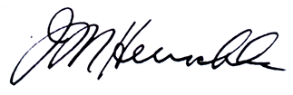

Ian Henschke
Chief Advocate

