

**National Tertiary Education Union (NTEU)**

**2020-21 Pre-Budget Submission**

**Overview**

The NTEU’s 2020-21 pre-Budget submissions demonstartes why the current funding arrangements for higher education are totally unustainable and urgently need to be addressed.

In order to ensure Australia is able mainatin a world class public higher edcation system the NTEU is calling on the current and future government(s) to committ to medium to long term level of public investment in higher education equivalent to 1% of GDP. In addition we are advocating for the introducion of a well-planned and managed and sustainable regulatory and funding frame work based on the use of Public Accountability Agreements.

As the analysis presented in this submission clearly shows increasing the level of public investment in our universities to 1% of GDP would allow for:

* the elimination of student contributions (tuition fees) for domestic undergraduate students,
* a much needed 10% increse in the level of public funding per government supported student or Commonwealth Supported Place (CSP), and
* a number of other important policy issues to be addressed including inadequte research and research training finding and the particpation of underrepresented students such as Indigenous studenst and from regional and remote areas.

The Public Accountability Framework would provide the framework to ensure students, staff and community, including governemnt expectations will be met.

**Contacts**

Alison Barnes NTEU National Presdient ([abranes@nteu.org.au](mailto:abranes@nteu.org.au))

Paul Kniest Director (Policy and Research) ([pkniest@nteu.org.au](mailto:pkniest@nteu.org.au))



**National Tertiary Education Union (NTEU)**

**2020-21 Pre-Budget Submission**

1. **Introduction**

The National Tertiary Education Union (NTEU) represents the industrial and professional interests of some 28,000 people working in Australian tertiary education and research. The NTEU has a direct and ongoing interest in the development and implementation of tertiary education policy because our members are amongst those that directly experience consequences of such policy.

While the NTEU has members working in vocational education and training (VET) in public TAFE institutes/colleges, research institutes and for private providers, the bulk of our members work at Australian public universities and as such the focus of this submission is on the regulation and funding of higher education (HE). That having been said however, the NTEU has long been a supporter of developing a consistent and coherent policy framework to cover both VET and HE. Therefore, we are advocating that the fundamental funding and regulatory framework set out in this submission, while described in the context of HE, should also extend to the tertiary education sector more broadly.

Given recent policy developments, it is clear that higher education remains a vexed and unresolved policy issue for the current Liberal National Party (LNP) government. As is outlined in more detail below the current funding “freeze” with performance based growth funding tied to the 18-64 year old population is totally unsustainable and must be addressed as a matter of urgency. This submission not only includes the NTEU’s diagnosis of the inherent difficulties of the current policy setting but also sets out our proposal for a well-planned and managed and importantly, sustainable education funding and regulatory framework.

As outlined in more detail below, the persistent cuts to public investment in our universities has had a profound impact on the level and nature of employment at our universities. The NTEU’s detailed analysis of university staffing (NTEU [Flood of Insecure Employment](https://www.nteu.org.au/library/view/id/8988)) shows that:

* in 2018, less than half of university full-time equivalent (FTE) jobs are secure ongoing (tenurial) positions;
* the number of FTE specialist, teaching-only and research-only, academic positions are now higher than the number of traditional ‘teaching and research’ academics;
* more than half of all teaching at our universities is delivered by casual staff;
* eight of ten teaching-only academic FTE are casual positions;
* eight of ten research-only academic FTE are on limited term contracts;
* the reluctance of universities to offer tenured jobs is making academia an increasingly unattractive proposition.

As will be evident from this submission, NTEU members and staff are being expected to continue to deliver world class teaching, research and community service with fewer and fewer resources. This is unsustainable.

As noted above the focus of this submission relates primarily to higher education funding and regulation policy, and provides:

* a brief overview of major shifts in tertiary education policy over recent decades,
* a detailed analysis of the inherent unsustainability of the current funding arrangements for enrolments, and
* NTEU’s proposal for a sustainable funding and regulatory framework for higher education.

1. **Overview of higher education policy developments since WWII**

***Menzies to Rudd/Gillard***

HE policy has undergone very significant shifts over recent decades. Prior to WWII funding of tertiary education was essentially the responsibility of State governments. In the 1950s the Menzies government increased spending on universities significantly by providing grants to universities as well as introducing Commonwealth scholarships. In the 1970s Whitlam reached an agreement with the States whereby the Commonwealth took over the primary responsibility for funding our universities. At the same time he abolished tuition fees for domestic students.

The next major policy change came under the Hawke Labor government in the late 1980s with the so-called Dawkins reforms. These reforms included the establishment of a Unified National System, which saw the removal of the distinction between universities, teachers colleges, colleges of advanced education and technical institutions. In what is jarringly referred to as the ‘massification’ of higher education, the Dawkins reforms also re-introduced tuition fees for undergraduate students, together with the world renowned government guaranteed, income contingent loans initially called the Higher Education Contribution Scheme (HECS). Under this framework each university was allocated a number or quota of Commonwealth Supported Places (CSPs) for which they received a Commonwealth subsidy. The value of the student contribution was initially set at $1,800 for all full time students, which represented about 20% of the average cost of a university education.

While there were a number of significant tweaks (including the introduction of three tier HECS resulting in increased student contribution amounts and the lowering of income threshold levels for debt repayments) the fundamental architecture of the higher education funding framework remained intact until the introduction of the demand driven system (DDS) which was first announced in 2009 and fully phased in by 2012 under the first Rudd Labor government in which Julia Gillard was Education Minister. The major difference under the DDS was that universities were free to enrol as many CSPs as they liked. This was seen as not only providing universities with greater ability to respond to changing patterns of student demand but also to overcome substantial public unrest with increasing levels of unmet demand.

***Abbott/Turnbull failed policy attempts***

Despite promises leading up to the 2013 Federal election to not cut education, the Abbott/ Turnbull LNP governments from their very first Budget in 2014 have targeted higher education as little more than a potential source of very significant budgetary savings.

Former Education Minister Christopher Pyne’s attempts to fully deregulate university fees for domestic undergraduate students, which would have resulted in some domestic students paying $100,000 or more for a degree, were rejected twice by the Senate. This was followed by Senator Simon Birmingham’s 2017 so-described “fair” and “reasonable” reforms which included a 2.5% reduction in public funding per student and a 7.5% increase in student contributions. This policy would have slashed in excess of $2billion of public investment from our universities and shifted the burden of funding away from the Commonwealth and on to the shoulders of students and their families. When Dawkins first introduced student contributions under HECS, the fee ($1,800) was set at a rate that was 20% of the average cost of a university degree. Over the years the share of fees paid by students has doubled, with the average contribution today being in the order of 40%. Birmingham’s objective was to lift student contributions to 50%. Under this policy students would literally be asked to pay more for their degree while universities would receive less because of the imposition of the efficiency dividend on the government’s contributions. This also failed to gain parliamentary support.

***Funding freeze***

As part of the December 2017 Mid-Year Economic and Fiscal Outlook (MYEFO) Senator Birmingham announced that his government would use what was meant to be a safety valve provision in the Higher Education Support Act (HESA) 2003 and imposed a freeze on government funding for CSPs. This announcement underlined the fact that the LNP government agenda had nothing to do with higher education reform and everything to do with saving billions of dollars in government expenditure to help bring the Budget into surplus.

Under the funding freeze the maximum amount of Commnowealth Grants Scheme (CGS) and associated funding for domestic undergraduate students that each university was eligible to receive was capped at 2017 levels for 2018 and 2019. While the policy did not place a cap on CSP enrolments, it effectively abandoned the demand driven system (DDS) by cutting the link between the level of funding each university received for the education of government supported students to the number of such students each university enrolled. While total CSP funding beyond 2020 would grow in line with the growth in the 18-64 year old population, this growth funding is not to be distributed on the basis of enrolments but rather as performance based funding.

As the following analysis demonstrates, this policy framework is totally unsustainable and needs to be addressed as a matter of urgency.

1. **Funding of Commonwealth Supported Places (CSPs)**

Figure 1 shows the nominal and real (2018 value) total value of Commonwealth Grants Scheme (CGS) and associated loading that the Commonwealth provided to universities for Commonwealth Supported Places (CPS) from 2012 to 2018. The nominal level of funding increased from $5.8billion in 2012 to $7.1billion in 2018 – an increase of 21.6% or about 2.5% per annum. This significant increase in funding is claimed to have been as a direct result of the introduction of the DDS, and is essentially the rationale used by the government to justify the current funding freeze. Figure 1 also shows the NTEU’s estimates of what total CGS funding would have been had the DDS continued (projected at indexation (CPI) plus 2% per annum enrolment growth) as well as the Parliamentary Budget Office (PBO) projection of CGS funding [Nom PBO] under the current funding policy.

Figure 1 clearly shows that the introduction of the funding freeze delivers the government very significant savings, which at the time of their announcement were in the order of $2billion over the four year forward estimates.

Figure

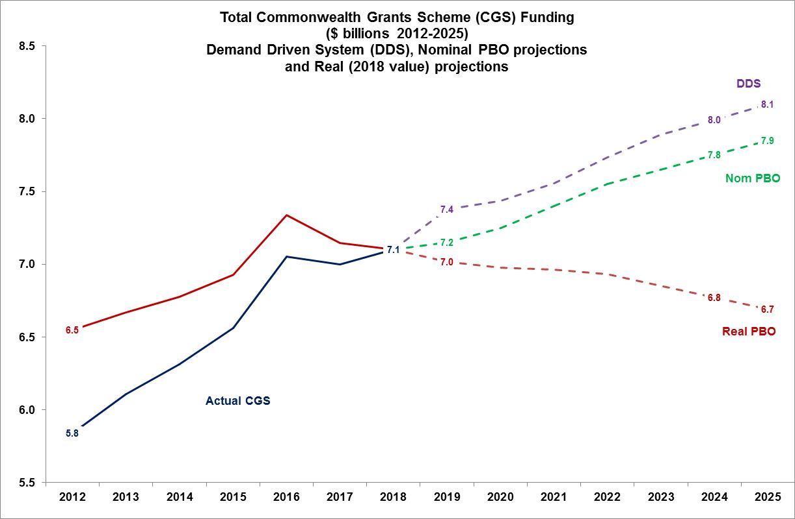

In addition to nominal values of CGS funding, Figure 1 also shows the real value (2018 values) of the PBO’s projections of CGS funding up to 2025. While the government is consistently claiming that the nominal value of public funding for the support of government supported students will continue to grow every year, this is most certainly not the case when the value of those grants is adjusted for expected price rises. In real terms the value of CGS grants are expected to decline by some $400m (2018 values) or 5.8% between 2018 and 2025. In other words, the imposition of the funding freeze and subsequent performance based growth funding is not even sufficient to cover rising prices or costs.

The unsustainability of the current funding arrangements is brought into much sharper relief when examining the real level of Commonwealth spending per CSP. While the current funding arrangements place a cap on the total level of public spending to educate CSPs (effectively setting a maximum CGS grant for each university) it does not place any restrictions on the number of CSPs universities are allowed to enrol. Universities are free to enrol as many CSPs as they like. They can even opt to reduce enrolments and still maintain the maximum CGS funding. While there is an infinite number of enrolment possibilities, for illustrative purposes we will consider four different scenarios, which are illustrated in Figure 2. These scenarios are:

1. Increasing enrolments in line with growth funding (18-64 year old population), which would result in an increase in CSP enrolments of some 9.3% between 2018 and 2025.
2. Increasing enrolments in line with school leaver age (17-18 year population) - increase in CSP of about 14%.
3. Keeping enrolments at current levels (zero growth).
4. Reducing enrolments in order to maintain the real level of government funding per student (Real$/CSP) which equates to a reduction in CSP enrolments of about 5.8% between 2018 and 2025 (depending on changes to discipline composition).

Figure

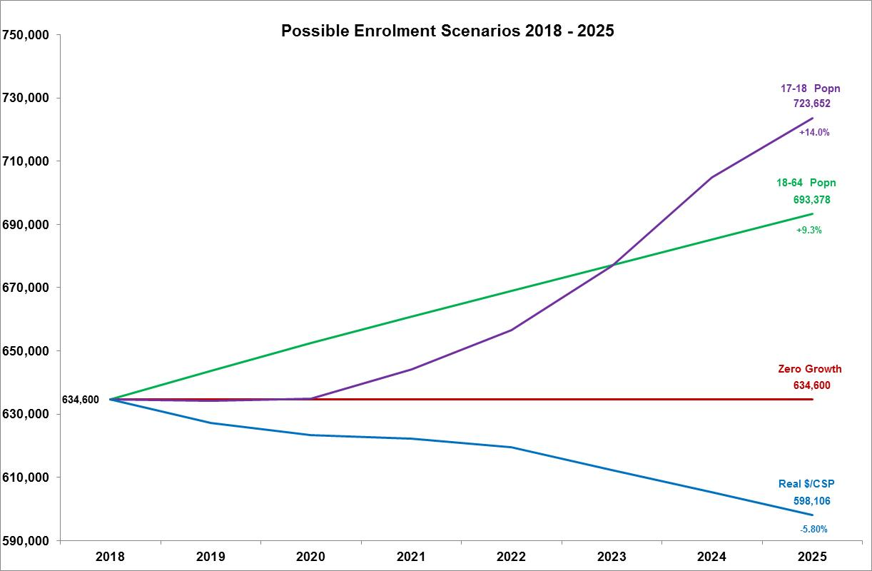

The financial implications for universities (the level of real Commonwealth funding per CSP) for these enrolment scenarios are shown in Figure 3. Figure 3 shows that even if universities were to maintain enrolments at current levels (scenario 3) they would still experience a 5.8% reduction in real funding per CSP. If they choose to increase enrolments in line with the 18-64 year old population (effectively maintaining the participation rate for that age cohort), the reduction in real funding per CSP would be 13.7%. The situation would be even worse if universities responded to the upcoming ‘Costello baby boom’ sudden surge in school leavers (see Figure 4). Under this scenario the reduction in real funding per CSP funding would be in the order of 17.3%.

Figure

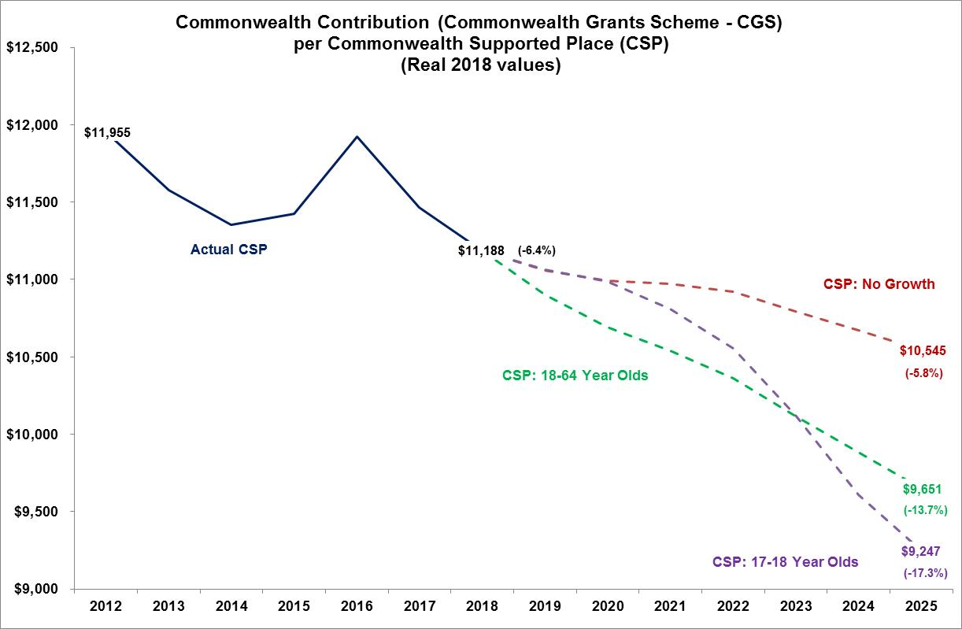

Figure

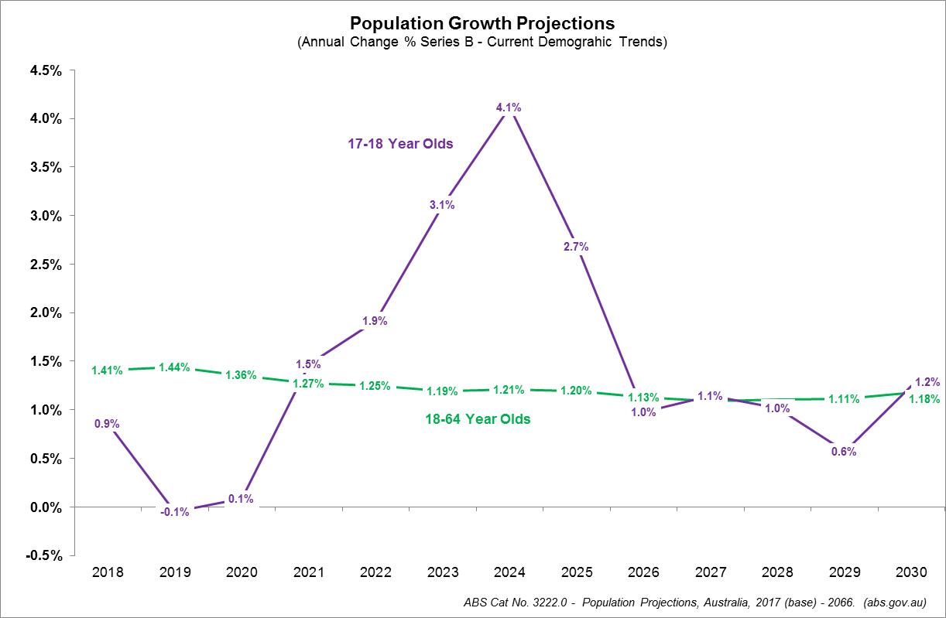

Reductions in the level of real funding per CSP of this magnitude have very real and serious consequences for the way in which our universities educate these students. For students such cuts mean either increased class sizes, and/or fewer class hours and/or fewer support services. For staff the implication is increasing student staff ratios. As shown by the NTEU analysis of recent staffing trends this policy has resulted in heavier workloads and greater reliance on casual staff to undertake teaching, and staff on short term contracts to undertake research (NTEU [Flood of Insecure Employment](https://www.nteu.org.au/library/view/id/8988)).

1. **Unmet demand**

As noted above, despite the total level of funding being capped, there is are no restrictions on the number of CSP enrolments. Universities are free to enrol as many students as they like. However if they increase enrolments by more than the number covered in scenarios discussed above, the decline in real funding per CSP would be even higher than those shown in Figure 3. But universities are also free to freeze or even cut enrolments. The NTEU estimates (assuming no significant changes in discipline mix) that universities could cut their enrolments by some 5.8% below 2018 levels and still receive the maximum CGS funding. Reducing or even freezing the level of enrolments will however mean that many eligible students would miss out on a government supported (CSP) place at an Australian public university.

Figure 5 shows estimates of the number of students missing out on a place, or the level of unmet demand. This is measured against the level of enrolments if they had grown in line with 18-64 year old population and thereby maintaining the participation rate for that age-group. The data shows that if universities froze the level of CSP enrolments at 2018 numbers, the level of unmet demand would quickly escalate from about 10,000 to almost 60,000 students by 2025. The data also shows that if universities reduced their enrolments to maintain the real value of CGS funding per CSP, then the level of unmet demand would be much higher, rising from 16,000 to 95,000.

Such a situation is not only highly problematic for those tens of thousands of students missing out on a CSP, it will also create significant political challenges for the government, similar to the rising levels of unmet demand that was the impetus for the introduction of the DDS.

Figure

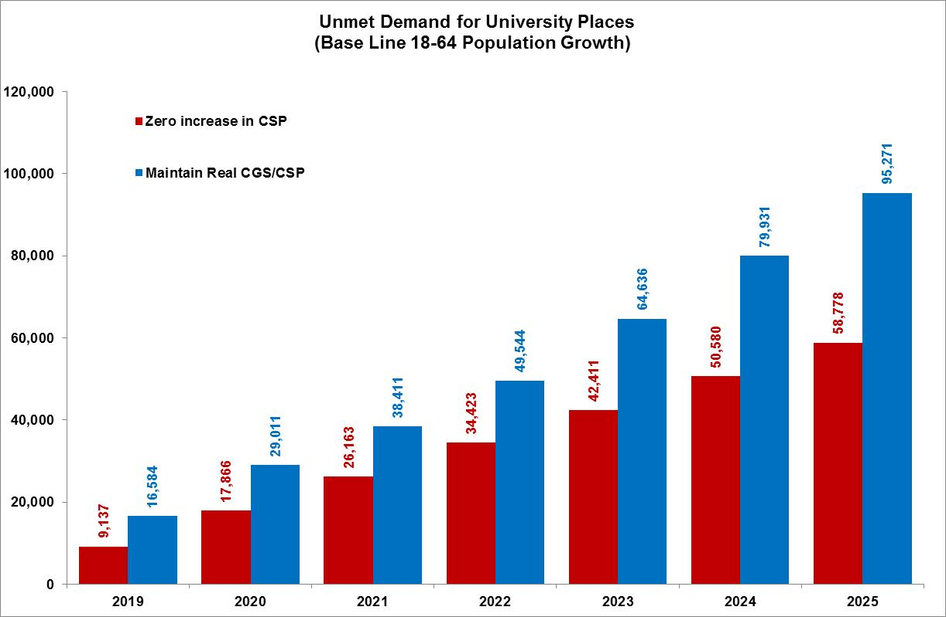

1. **Financial disincentives**

As noted, the above assumes that the discipline mix of students remains reasonably stable. The current freeze on funding only applies to the government contributions. Student contribution amounts (fees) will continue to rise in line with inflation (CPI). However, because the relative value of contributions made by students and the Commonwealth differs between discipline groups, this means that the freeze may well provide a strong financial incentive for universities to change the discipline mix of their CSP enrolments. Universities will minimise the financial impact of any future enrolments by favouring the enrolment of students with relatively low government contributions and high student contributions.

The data in Table 1 shows the level of funding a university received per CSP by discipline clusters in 2017 as well as in 2020 (assuming no freeze – original values) and with the freeze on the government contribution. It also shows the value of lost funding per student as a consequence of the freeze by discipline. In the case of students studying law, business and administration the value of lost funding between 2017 and 2020 would be the equivalent of about $110 per student. On the other hand the value of lost funding for medical and agricultural students is in excess of $1,200 per student. Under these circumstances, a university wanting to grow enrolments would have a strong financial incentive to do so by recruiting students into business, accounting and economic degrees rather that students in agriculture, engineering or science.

Therefore not only does the current policy framework have serious implications for the real level of funding per students and/or level of unmet demand, they will also introduce even greater financial distortions in favour of enrolling students in some disciplines over others. The only real question that remains is the relative magnitude of each of these intersecting adverse consequences. This will largely depend on how universities respond, in terms of the level and patterns of future CSP enrolments.

The current funding arrangements are totally unsustainable and must be addressed as a matter of urgency.

Table



1. **Total level of public investment in higher education**

As the NTEU pointed out in our [2019-20 Pre-Budget Submission](http://www.nteu.org.au/library/view/id/9554), the funding freeze is only a relatively small component of a much larger higher education ‘hit list’ of budgetary savings under both the Labor and LNP governments over the last decade or so, which have included:

* $1.4 billion from converting Student Start-up Scholarship to loans;
* $698 million from abolishing performance funding for universities;
* $648 million in cuts to the Sustainable Research Excellence (SRE) scheme;
* $298 million from abolishing the Capital Development Pool;
* $90.7 million from the Higher Education Participation and Partnerships Program;
* $328 million from growth adjustments/freezing of research block grants;
* $35 million from cost recovery from providers in relation to costs of the Higher Education Loans Program (HELP) and the Tertiary Education Quality and Standards Agency (TEQSA); and
* $3.7 billion for university infrastructure in the Education Investment Fund (EIF), re-purposed to National Disability Insurance Scheme (NDIS).

*Source: Universities Australia* *The Facts on University Funding* *and 2018-19 and 2019-20 Budget and MYEFO papers.*

Therefore when looking at public investment in higher education, we need to look at more than just the funding of CSPs through the Commonwealth Grants Scheme (CGS), which as the data in Figure 1 shows is currently in the order $7billion per annum. There are however, other Commonwealth funding streams to cover research training, research support and research project grants as well as student support services, regional campus funding and so on. The bulk of funding going to our universities[1] is sourced from the Commonwealth Department of Education. The major exception to that rule is the value of National Health and Medical Research Council (NHMRC) grants which fall under the auspices of the Commonwealth Department of Health.

Figure 6 shows the total level of Commonwealth spending on higher education, which is broken down by total Department of Education expenditure (actual and forecast ) which is from the Department’s [Budget Portfolio Statements](https://www.education.gov.au/budget) for Outcome 2 (but excludes the Skills component) as well as the level of NHRMC grants awarded to universities as reported in the Department of Industry, Innovation and Science – [Science Research and Innovation (SRI) tables](https://www.industry.gov.au/data-and-publications/science-research-and-innovation-sri-budget-tables).

Figure 6 shows the extent to which our universities have been affected by recent public funding cuts, with the total level of public spending falling from about $12.8 billion in 2015-16 to $11.4 billion in 2018-19. For a more detailed analysis of these recent trends please refer to NTEU’s [2019-20 Pre-Budget Submission](http://www.nteu.org.au/library/view/id/9554) which includes a detailed analysis of funding including significant cuts to research funding. While the level of funding in nominal terms is forecast to increase slightly over the next two to three years, this is not the case when examining the level of funding when expressed as a share of total government spending or GDP as shown in Figure 7.

Figure

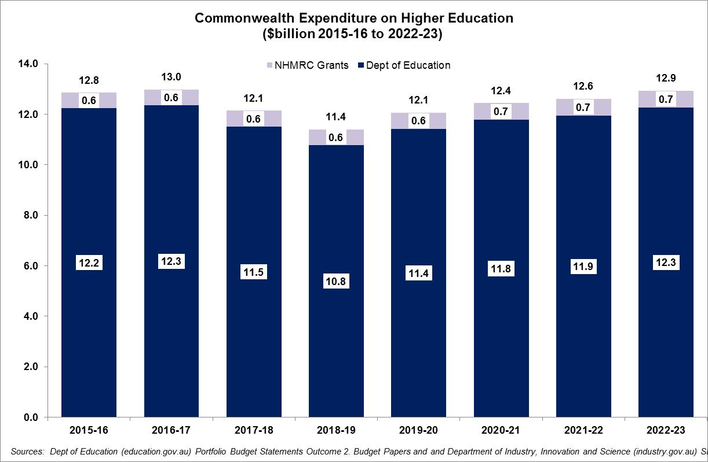

Figure

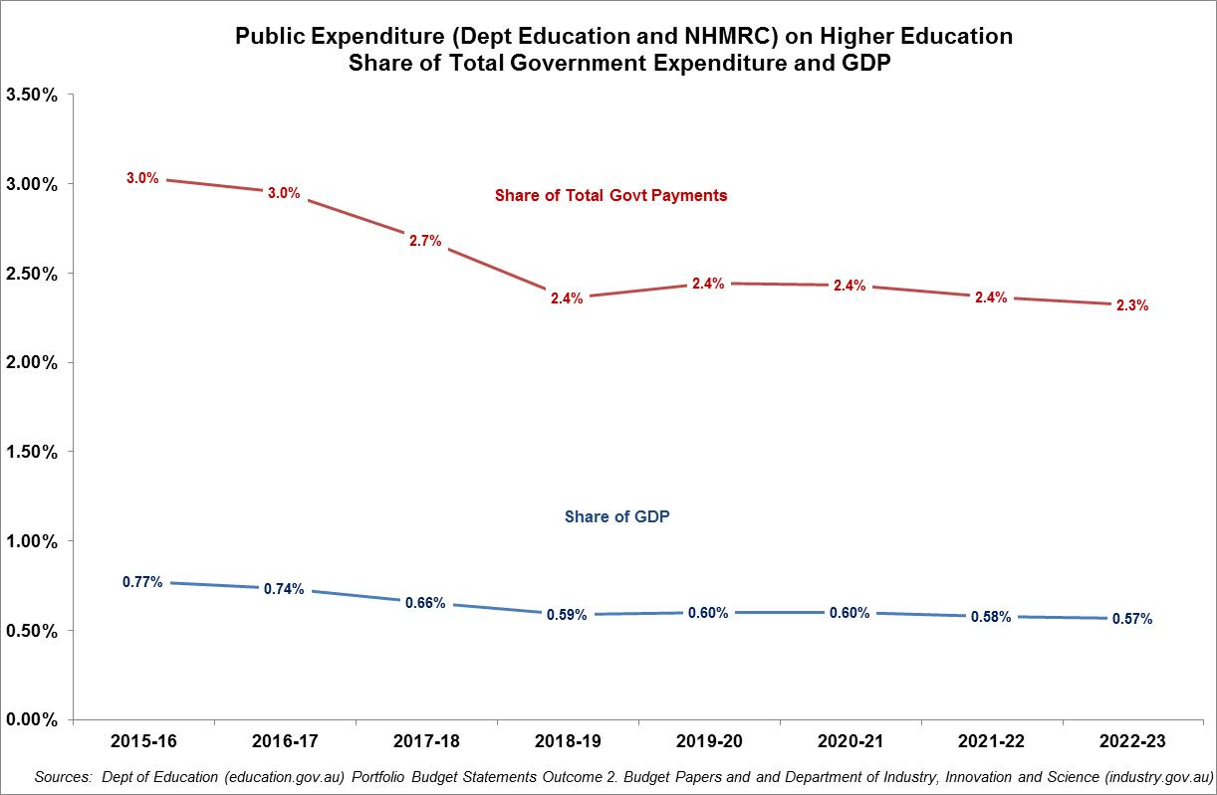

From the NTEU’s perspective the downward trajectory of higher education spending both as a share of total government spending and as a share of total national income (GDP) is an indication of the lack of government commitment to supporting and maintaining a world class higher education system. This lack of commitment looks even worse when you consider that Australia already has one of the lowest levels of public investment in tertiary education in the developed world. As the data in Figure 8 shows, Australia’s level of public investment in tertiary education (0.75% of GDP in 2016) is amongst the lowest in the OECD and well below the OECD average (0.93% of GDP).

Figure

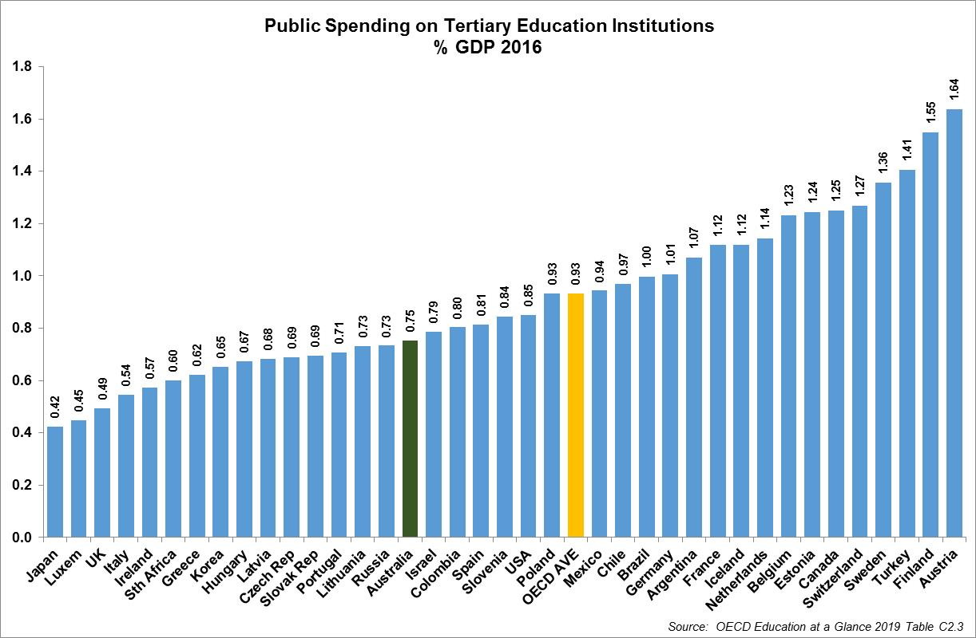

Figure

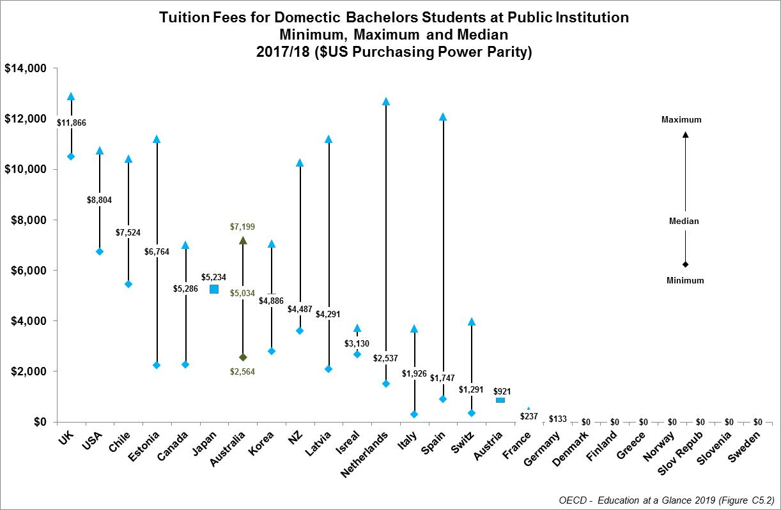

As Figure 9 shows, not only is Australia’s public investment in higher education among the lowest in industrialised economies, domestic students studying at a public university pay amongst the highest fees in the OECD.

1. **Australia needs a well-planned, managed & sustainable higher education sector**

As outlined above, since the introduction of the so-called Dawkins reforms in 1989, the Australian higher education sector funding and regulatory framework has undergone a number of very significant changes. As outlined above the most recent changes to funding of CSPs are totally unsustainable.

Unfortunately governments of both political persuasions have come to see tertiary education in purely transaction terms. Every dollar of public expenditure on HE or VET is seen as adding to the size of the budget deficit, or subtracting from a surplus.

Australia needs a well-planned, managed and funded tertiary education sector. We do not need the uncertainty and instability caused by recent policy changes. And we certainly do not need the utter chaos inflicted on the VET sector in recent years. This included attempts to deregulate the VET sector with the introduction of a market based framework of contestable funding between public and private providers, together with the expansion of income contingent loans (VET FEE HELP) to more providers and qualifications. This utterly discredited and failed policy experiment not only saw a massive increase in the cost of obtaining a VET qualification, it also undermined the viability of many public TAFE providers, as well as resulting in tens of thousands of vulnerable students being exploited by unethical for-profit providers.

If Australia wants to maintain a world class tertiary education system, it is critical that public expenditure on HE and VET not be seen as a short term budgetary cost but rather as an medium to long term investment in and for the public good from which individuals, businesses, governments and the broader society benefit.

This will require:

* a medium to long term commitment to a level of public investment which will ensure our public universities are able to continue to offer world class education, research and community service, and
* a regulatory framework which is:
  + - at arm’s length from day to day political decisions making,
    - provides sufficient flexibility to respond to changing student and or workforce demands, and
    - ensures our public universities are fully accountable to their students, staff and the communities they serve.

1. **Public Investment in higher education**

In order to be able to continue to offer world class teaching, research and community service our public universities require a sustainable and stable level of public investment.

The NTEU is calling on the government to make a medium to long term commitment to increasing and sustaining public investment in our universities at 1% of GDP. This would move Australia from being at the bottom the OECD public investment in tertiary education league tables to above the OECD average.

Figure 10 shows the actual and projected levels of public spending on higher education (based on data in Figure 6) expressed as a share of GDP. The data shows that the current trajectory is for this level of public investment to decline from its already relatively low level.

The NTEU proposes that the current level of public investment be ramped up from its current level of about 0.6% of GDP to 1% of GDP by 2024 as shown in Figure 10.

Figure

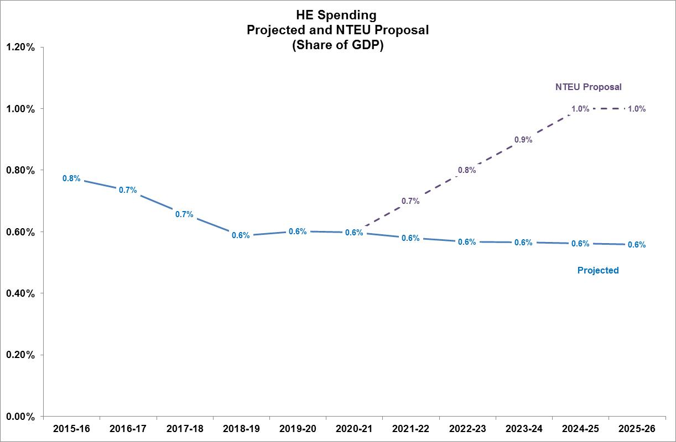

Figure 11 shows the same data, but expressed in actual dollars terms. It also shows the value of the additional public expenditure that would be needed to raise the level of public investment in higher education to 1% of GDP. By 2025-26 we estimate this will cost in the order of $10.7billion per annum.

This is the level of commitment the NTEU believes is necessary for a sustainable higher education sector and would allow for a number of important policy initiatives which the NTEU has been proposing for some time, including allowing for:

* student contributions (tuition fees) for domestic undergraduate students to be phased out;
* the level of real funding per Commonwealth supported place (CSP) to be increased by 10%; and
* public investment in research, research training and student support and equity programmes to be substantially increased.

Figure

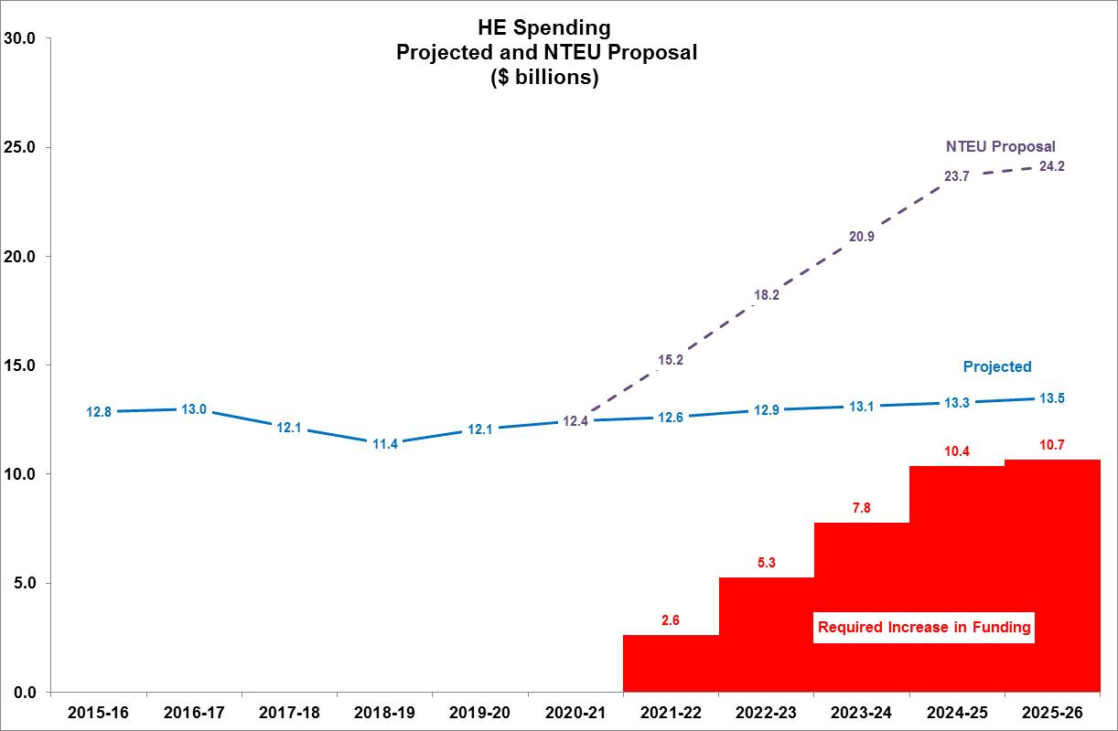

1. **Phasing out student contribution (fees)**

There are currently three tiers or bands of student contributions for CSPs - $11,555, $9,527 and $6,684, as shown in Table 2. In 2020 it is estimated that the ‘average’ student contribution is currently 42%, but as Table 2 shows this varies considerably between disciplines.

Table



NTEU’s policy position is that the student contribution amounts (tuition fees) for domestic undergraduate students should be eliminated. We are proposing that they be phased out over the same time frame that total public expenditure on higher education is ramped up to 1% of GDP as shown in Figure 11.

Our proposed schedule for the phased reduction of student contribution amounts is shown in Table 3. In essence we are proposing that the higher contribution amounts (Bands 1 and 2) be reduced to Band 3 after which the fees will be reduced to zero. Table 3 also shows what impact this would have on average student contributions, based on our estimates of CSP student load by discipline. This is then used to estimate the costs of the phased reduction which are shown in Figure 12. As student contributions are phased out the government’s contributions through the CGS will need to increase to offset these reductions. The cost of these additional CGS payments, if introduced in accordance with the schedule in Table 3 are estimated to increase from about $0.1billion for Step 1 to about $5.1billion per annum when fully implemented.

Table



1. **Increasing government contributions by 10% per CSP**

As outlined in some detail in our 2019-20 Budget submission, current total funding rates per CSP are insufficient to cover the full costs of educating research and sustaining basic scholarly capacity at our universities. Therefore the NTEU continues to call for government contributions per CSP to rise by 10%. The cost of this proposal is also shown in Figure 12. This will increase in cost from some $0.7billion per annum to $1.2billion per annum once student contributions have been fully eliminated.

Figure

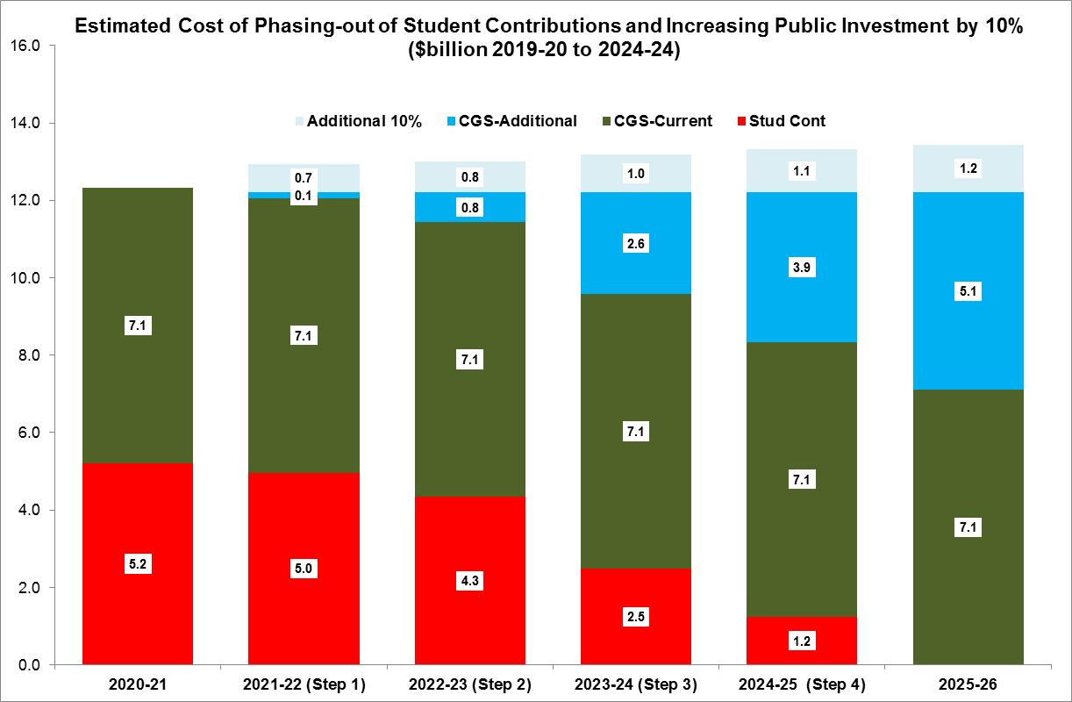

As the data in Figures 11 and 12 clearly show the resources available from ramping up public investment to 1% of GDP is more than sufficient to offset the additional costs of eliminating students fees and increasing government funding by 10% per student. We estimate this strategy would leave the government with between $1.8billion to $4.4billion (once you reach investment equal to 1% of GDP), which gives the government the financial capacity to address a number of other important policy issues, including but not limited to:

* meeting changing patterns of student and workforce demand,
* the adequate funding of research and research,
* participation of underrepresented student cohorts including those regional and remote areas and Indigenous students,
* addressing quality issues as a result of increased reliance on casual and short term contract staff.

In order to achieve this outcome the NTEU believes the government needs to implement a regulatory framework based on what the NTEU calls Public Accountability Agreements.

1. **An alternative funding policy framework**

The following provides a brief overview of the NTEU’s proposed alternative public accountability framework. A more detailed description can be found in the to NTEU’s 2015 Federal Budget Submission [Towards a sustainable policy framework for Australian higher education.](https://www.nteu.org.au/library/view/id/6021)

While the NTEU believes that current funding arrangements are unsustainable we do not support a return to the pre-2012 situation where the Commonwealth allocates the number of Commonwealth Supported Places (CSPs) to each university. Nor do we support a return to totally unplanned and largely unmanaged DDS.

Rather the NTEU is proposing the development of a flexible but coordinated model for the allocation of CSPs. Within such a framework universities exercise control over how many students they enrol while the Commonwealth would be assured that all students enrolling in a public university receive a high quality education and the opportunity to succeed.

The NTEU is proposing that excessive red tape associated with the funding and regulation of universities would be reduced by replacing a number of existing planning and funding agreements including strategic plans, Mission Based Compacts and Institutional Performance Portfolios with **Public Accountability Agreements (PAAs)**. PAAs would be negotiated and administered by an independent agency or council with statutory planning and funding responsibilities. PAAs are a mechanism whereby funding for Commonwealth Supported Places (CSPs) would be contingent on a university being able to clearly demonstrate its capacity to deliver on a set of key performance indicators directly related to the quality of education and support offered to its students.

For example, a PAA would require each university that wished to increase its student load by more than a specified amount must demonstrate:

1. its current students are satisfied with the quality of their education and have achieved appropriate performance benchmarks in terms of the proportion of staff with ongoing jobs, student attrition and employment outcomes, and
2. how the planned expansion would meet a set of capacity related, risk or performance criteria.

The requirements, risks and/or performance indicators would differ between institutions based on their specific circumstances, and without being prescriptive or comprehensive, might include:

* physical capacity and appropriateness of teaching support facilities,
* capacity to provide each student with a practicum placement where this is required for professional registration,
* impact on staff to student ratios,
* having enough appropriately qualified staff,
* the proportion of teaching undertaken by casually employed academic staff,
* the impact on student entry requirements, attrition/progression rates and completions, and
* the employment or other destination prospects of graduates.

The higher education funding agency would not consider each PAA in isolation but would be expected to ensure there is some degree of coordination or even cooperation between individual universities. For example, if one university was proposing to stop offering a certain course, the agency might want to satisfy itself that potential students would have viable alternative options. Likewise if all the universities wanted to increase enrolments in a particular discipline but it was determined there was not sufficient labour market demand, the agency could facilitate coordination and negotiation between individual universities to prevent such an outcome.

PAAs would also be used as a mechanism to help achieve other goals and objectives that a university or the government may determine as being critical, such as addressing important equity issues, especially amongst under represented student groups.

1. **Conclusion**

In summary the NTEU believes that an increase in public investment to 1% of GDP along with the introduction of regulatory and funding framework based on PAAs would:

* give the government a greater level of fiscal certainty;
* provide universities with greater certainty over enrolments as well as in terms of what they are expected to deliver for students, staff and the communities they serve; and
* afford potential students and employers with the confidence that our universities will be accountable for delivering world class education, research and community service.

**--- END of SUBMISSION ---**

1. This does not include student income support payments or value of HELP loans.