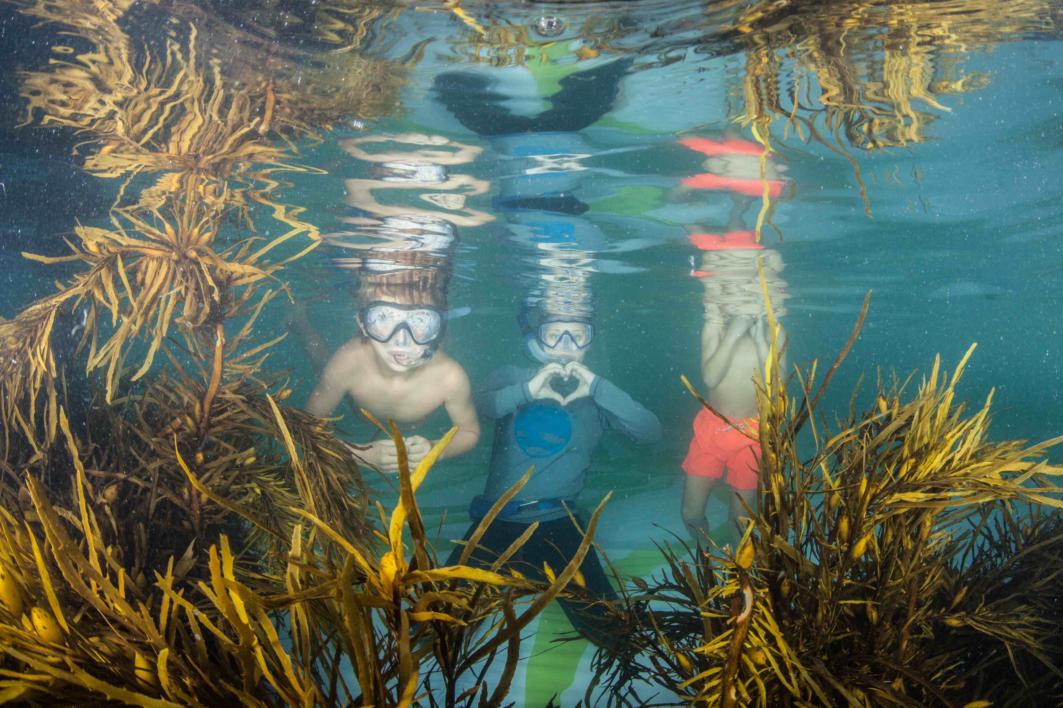

PRE-BUDGET 2020-21 SUBMISSION

Creating a new national conversation on ocean health

ABOUT US

Ocean Lovers is an Australian not-for-profit organisation with a track record staging impact events that reach wide audiences to engage and educate them particularly on ocean issues and solutions and drive community support and business innovation collaborations for clean seas and restored eco-systems.

INTRODUCTION

With the support of our local Member, Dave Sharma in 2020, we have built on our previous success to create an accessible way to empower everyday Australian’s to find out how they can help the oceans and better protect them for the future.

We know Australia is combatting marine plastic pollution and pursuing sustainable ocean practices, yet Australians are saying environmental issues are among their top concerns and that sentiment is rapidly increasing. Numerous surveys point to the high levels with which Australia regard their natural environment and our oceans are a particular source of joy in our national psyche. However oceans are bearing much of the brunt of environmental impacts – a largely out of sight issue that is starting to become the frontier in environmental awareness.

It is evident how passionate Australians are about their coast and waterways and our project aims to help them better understand the issues the oceans are facing and to provide clear signs of hope for how our scientific, government, entrepreneurial and everyday community are delivering positive solutions to ocean issues.

Numerous high-profile Australians including the Prime Minister and people like Andrew Forrest have made the eradication of ocean litter and health of our marine environment a top priority.

Our organisation has created an Ocean Lovers Festival that has already proven to deliver a platform for the community to connect with these projects and ocean experts. In 2019 we connected over 1 million people with our activity on digital channels and thousands attending the inaugural event.

Beyond inspiring action and behavioural change, the festival environment is a place providing hope and positive messaging contrary to overwhelming and confusing commentary and news reports. Our tag is #iseachange.

We showcase real life successful marine projects restoring the coastal ecology, we hero ocean innovating entrepreneurs and we give a platform to government initiatives, ocean champions, marine scientists and community groups.

It is an all ages, all access free and fun event to attract audiences and deliver a much-needed source of information and access to action.

The Government’s recent commitment and focus on ocean health is timely and our model is well aligned to take around Australia quickly as a vehicle for this message and action.

Our festival concept boasts some uniquely Australian elements like “Science in your Swimmers” for example – encouraging people to dive into exhibits like the Crayweed Forest and Living Seawall tile projects by the Sydney Institute of Marine Science that we showcase in the Bondi Icebergs Pool, and all ages workshops and science talks you can literally walk of the beach in your swimmers to attend.

Our goal is to engage Australians with what they can do and support behavior changes and knowledge acquiring. With the urgency now emerging in a concerned community, we are seeking budget support to expand our footprint nationally with a rapid replication of our festival model.

As the place to “Sea Change”, our festival concept is accessible and interactive enabling us to attract and showcase to a wide-ranging audience and encourage people to make tangible and helpful changes in their own lives.

We believe that science, technology and entrepreneurship will provide the necessary leverage points to address the challenges facing our oceans. As the Prime Minister has said “To protect our oceans, Australia is committed to leading urgent action to combat plastic pollution choking our oceans…”

SOME CONTEXT

- The annual value of the global Ocean’s economy is estimated at $1.5 trillion and expected to grow substantially to double by 2030.

- The Australian Institute and Marine Science (AIMS) says Australia’s Blue economy will be worth $100 billion by 2025

- Additionally, AIMS identifies that this economic wealth is equalled by its environmental value as well as being an undisputed source of our security, safety as well as our recreation, food and overall wellbeing.

- In a time when grappling with weather impacts is virtually the number one agenda item – Oceans are recognised as the key drivers of both climate and weather

- Environment is clearly the top issue facing Australia (IPSOS January 2020 Australian pole). The research indicates environmental concerns are high across all demographics. Waste, Consumption and plastics rate highly.

- The IPSOS issues monitor on Life in Australia says Australians place a very high value on being able to access the natural environment.

- An Independent survey of 1000 Australians by Sevens Communication in February 2019 asked what impacts concerned them most. Out of 25 concerns, marine and waterway health was number one!

- Sources of ocean pollution:
- Discarded litter at the beach – 18%
- Sewage (e.g.: microplastics from laundry, bathroom, toilets) – 27%
- Stormwater runoff – 24%

- Ocean related concerns feature in the top environmental concerns (according to community research by Healthy Land and Water & QUT 2018). Numerous recent research studies rank environment as the fastest rising concern in the Australian community.

- 7 out of 10 adults in Australia have modified their behavior out of concern about climate

The Ocean Foundation report:
- Oceans make up 71% of the planet providing services to human communities
- Ocean currents regulate the global climate
- Mitigating weather extremes
- Generating oxygen (greater than the Amazones)
- Producing food
- Storing excess carbon dioxide (carbon sink)
- Oceans and carbon are inextricably linked
- Oceans bares the grunt of climate change
- Almost all rain the drops on land comes from the sea
- Oceans are home to the greatest abundance of life on the planet

Ocean Health is vital to human and planetary existence.

Entrepreneurs, government and community are key to driving the ocean recovery needed to relieve the stress on the ocean ecosystems.

A PROJECT OF HOPE

Most of the population never truly get to see under the surface of the Sea. The Ocean Lovers Festival is an access point that specifically provides a myriad of ways to show people what is important to protect and why and how. An easy formula when we engage the public in a festival environment.

The Ocean Lovers Festival is designed to empower the public, encourage businesses and entrepreneurs to collaborate, promote sustainable business practices and demonstrate the economic viability of a blue economy.

It is very much aligned with the Government’s agenda on oceans and reducing plastic waste and aims to empower the next generation of ocean advocates through revived passion, education and action through their communities.
The Ocean Lovers Festival is a genuine Australian response to the global plight of the oceans – focused on Australians love of oceans and beach culture – bundled in a fun festival of Ideas, Art+Music and Actions for our oceans.

Key elements

The Blue Date Day – a networking and knowledge sharing event to incubate new collaborations and ideas between science, innovators, entrepreneurs and government

Science in your Swimmers – multi-channel showcase of positive ocean science projects leading restoration of ecosystems, plus hands on science workshops for kids and adults and talks from a wide range of marine scientists and university faculties

Ocean impact films and art exhibitions to enhance understanding and engagement including Virtual Reality underwater expeditions

Ocean loving music program to engage diverse and youthful audiences

Interactive ways to participate and try out ocean actions like a beach clean, paddle, coastal care tours, underwater drone tours, swim lap and more

Ideas generated with Fish Tank – a showcase of innovative concepts for the oceans presented with prizes

The Festival is an incubator for courageous ideas that drive impactful change and connects them with everyday Australians seeking out information, empowerment and action.

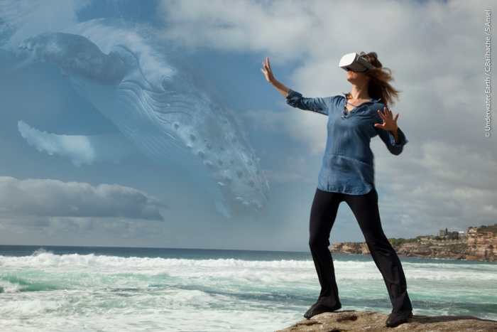

OPPORTUNITY

To replicate the existing model, unique concepts and established networks to rapidly scale up a successful national roll-out of a Federally government backed series of Ocean Lovers Festivals.

Deliver an event in every State and Territory for audiences to “See Change” and participate in ocean protection and revitalisation.

Scientist Dr Vanessa Pirotta pioneering drone science with marine mammals

2019 EVENT SUMMARY

The first Ocean Lovers Festival was successfully staged from April 11 to 14, 2019 – with a range of ocean loving events, exhibitions and public activities in Bondi. Some 15,000 people engaged in festival elements for free and all aimed at promoting eco and sustainable practices to protect our oceans, with mainstream and digital media channels each exceeding a reach of 1 million.

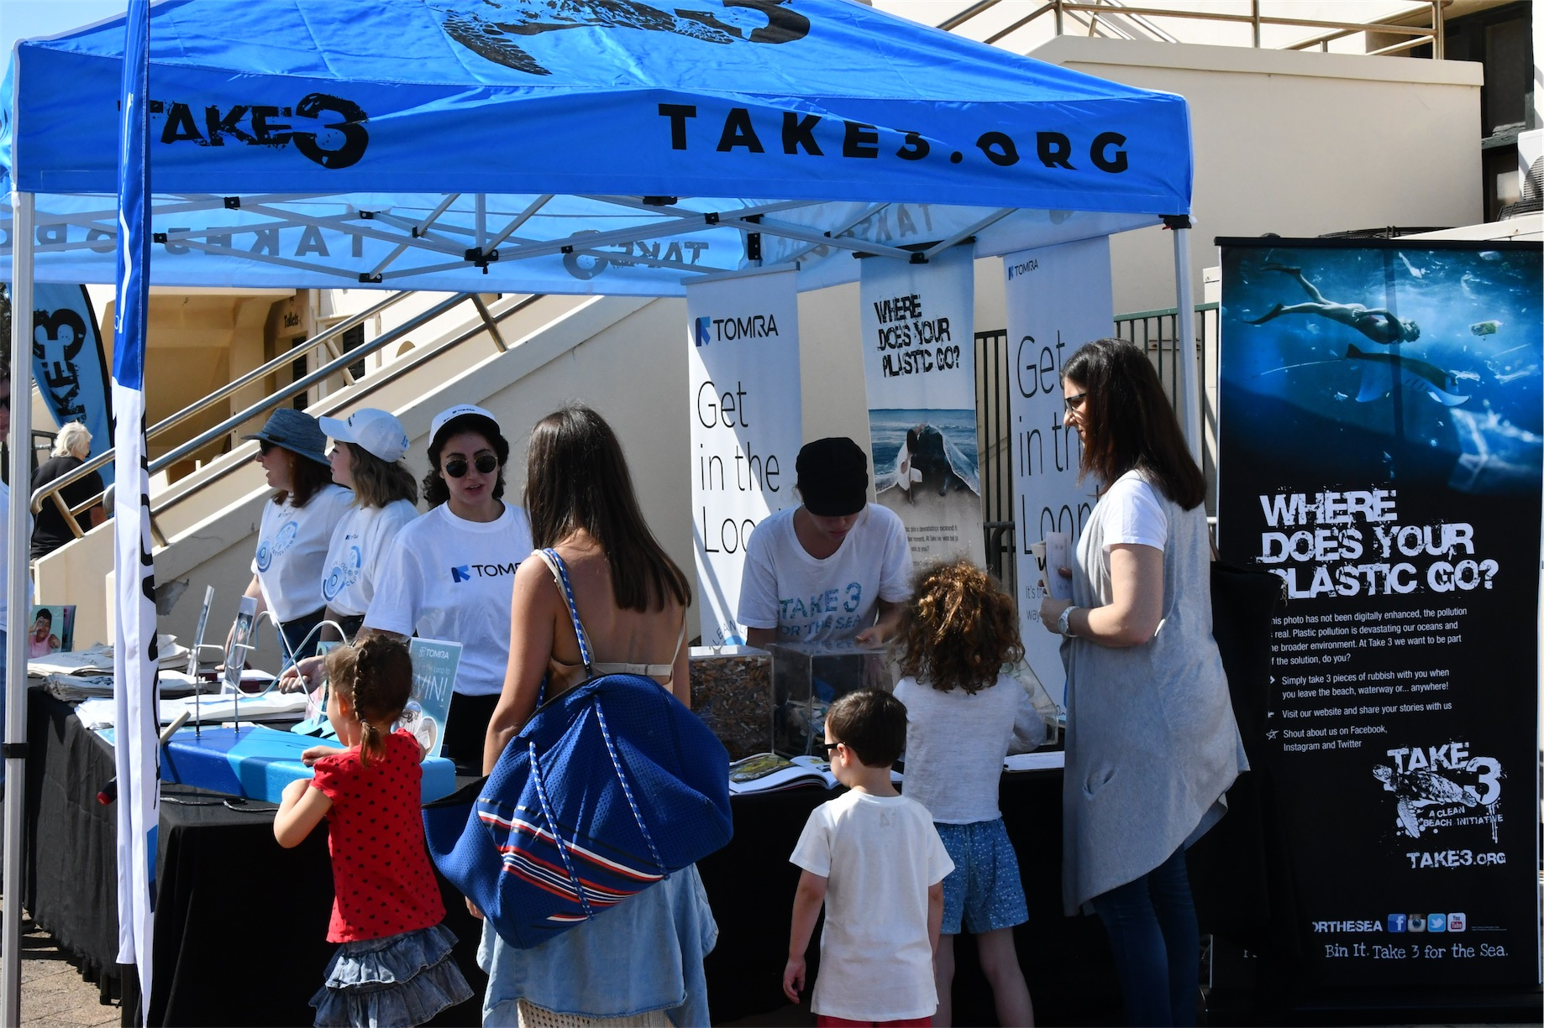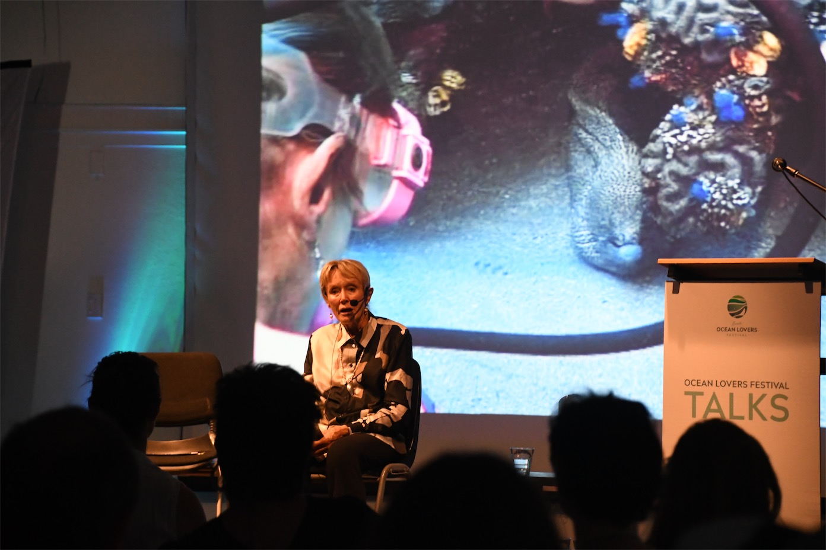
Eco Expo Talks and Films

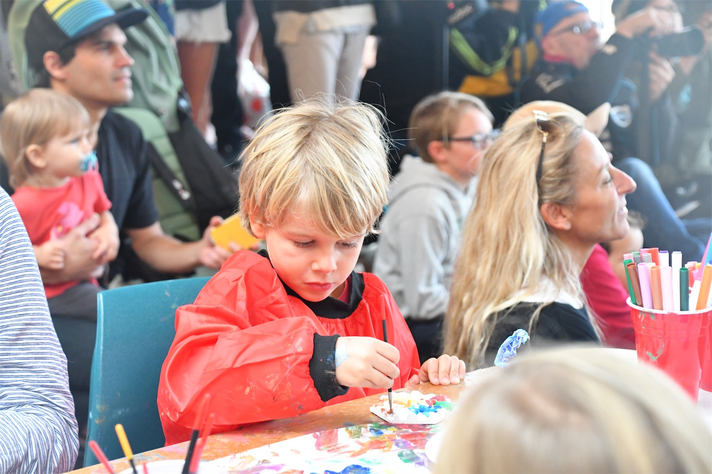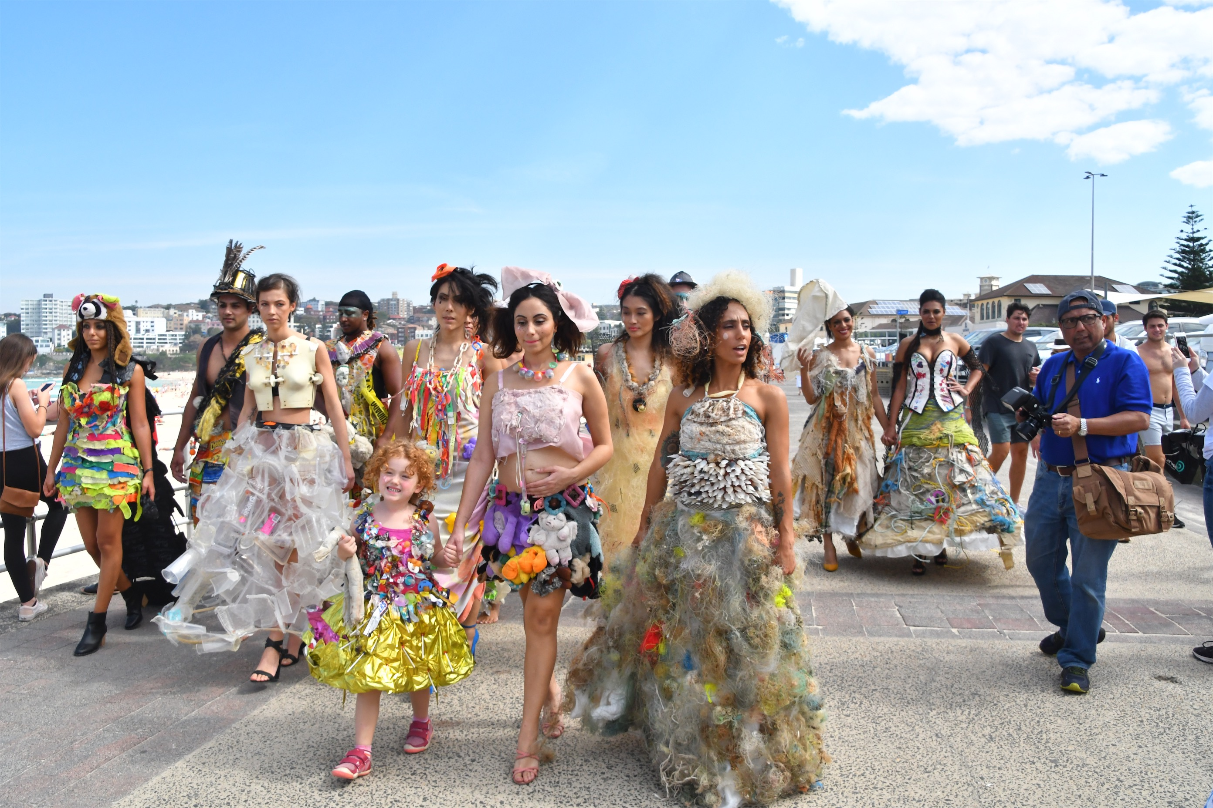
Workshops Parades and more

The Ocean Lovers Festival has filled a void by providing an upbeat, entertaining and hopeful opportunity for the public to engage in ocean issues and find out how to better protect our oceans. The Festival is the where people can interact with positive ocean recovery projects and hear and see new ideas for everyday living as an ocean lover.

View video: https://www.oceanloversfestival.com/videos

BENEFITS

- The festival is hopeful, accessible and solutions focused
- It can showcase Government initiatives and quickly be replicated and scaled to a national series of events
- Key elements like our Fish Tank pitch fest can provide new ideas to help our oceans from communities around Australia and for all ages
- Our Blue Date Day is a business networking event for innovators and eco entrepreneurs to engage with business leaders and government
- An enriching opportunity for community to participate in arts & culture
- Cross-cultural activity with local partners to tailor each festival to local issues and community concerns
- A strong and embedded incorporation of local indigenous culture
- Enhanced commerce through association with local businesses and promoting them in the festival
- Innovative channels to educate, engage and inspire residents in sustainability practices including Films, Science in your Swimmers talks, Beach Clean, Showcases, Environmental Art, Science in Action workshops
- Advocacy for litter reduction, eradicating single use plastic and recycling
- A plastic free event encouraging participating businesses to join the movement and further improve their sustainability practices
- Engaging with local schools in recycling and sustainability through art and indigenous coastal care and culture with invitations to events
- Utilising #iseachange and digital campaigns year-round we can engage millions of Australians in a movement to help the oceans

PROJECT CRITERIA

Hope:
Positive projects, innovations and activities that bring hope for the oceans through real solutions and practical change

Trust:
A platform to engage the public and a trusted and authentic source of information

Creation:
A hothouse for new ideas to be revealed, collaborations explored, creative solutions proposed and love of the oceans encouraged

Entertain:
Engage through an entertaining, attractive and relevant program

Conversation:
A place for conversation, revelations, practical advice, innovation and transition demonstrated

Showcase:
Government Initiatives, Pioneering Businesses, Eco Innovators, Indigenous Stewards, Film Makers, Musicians, Artists and Scientists

Business builders:
Innovators and Incubators, Change Makers and Idea Seekers, Networkers and Collaborators, Future Proofers

CURRENT PARTNERS

Project supporters, stakeholders and participants
- Member for Wentworth, Dave Sharma (fed Gov – CEP Grant)
- UNSW
- University of Technology
- Southern Cross University
- Macquarie University
- Sydney Institute of Marine Science
- United Nations Association of Australia, NSW
- Australian Geographic
- Waverley Council
- Inspiring Australia
- Sydney Coastal Councils Group
- Volvo Australia
- TOMRA
- Ocean Protect
- Surf Lifesaving Australia Clubs
- The Surfrider Foundation
- Bondi Icebergs
- Australian National Maritime Museum
- DNSW and Tourism Australia marketing
- The Vine Foundation
- Justin Miller Art
- Charitable Partner Underwater Earth
- Plastic Oceans Australia
- Minderoo Foundation
- Mission Blue
- Prince Albert II of Monaco Foundation
- Oceanographic Museum of Monaco

Inaugural ambassadors included legendary filmmaker George Miller, World Champion Surfer Tom Carroll, Ironwoman Lizzy Wellborn, sailors Bobby Wilmot, Stacey Jackson, Lisa Blair and Keith Musto and ocean campaigners Valerie Taylor and Sylvia Earle, chef Jessie McTavish, science communicator and model Laura Wells, ocean swimmer Maev Kerri Fitzpatrick and champion windsurfer Federico Infantino, artists John Dahlsen and Marina Debris, and indigenous custodians Tim Ella and Rhoda Roberts.

EXPANSION

Our vision is to bring attention and action for the oceans to the widest possible audience to deliver positive impacts. The goal is to roll out a festival in three years to every State and Territory in Australia making contact with hundreds of thousands of Australians.

Expansion 2020 with funding
- Document and model the festival elements from the March 2020 NSW festival to provide to other Australian State and Territory locations to scope ideal locations and timing
- Invite key potential national partners to attend in 2020
- Scope plans and build national network timetable
- Activate potential new festivals in 2020 as per budget availability with local partners and sponsors
- Activate national digital and media marketing to engage the public

Expansion 2021
- Identify and activate with local knowledge empowerment a roll-out of festivals across the country
- Undertake a national schools engagement project alongside
- Deliver national marketing and communications for the Festivals and the content with economies of scale
- Engage a range of Federal, state and territory agencies and local government to support the festivals and content to the public
- Model a zero-waste carbon neutral and engaging event to other states and territories invited to attend and sign up for future events
- Build capacity to locally organise and replicate the model

THE TEAM IN BRIEF

Anita Kolni is the Founder of the Ocean Lovers Festival and comes from generations of ocean lovers with her father and uncle being world-class sailors representing Sweden in several Olympic Games. She is a born communicator and networker and has worked on events such as the Cannes Film Festival, Monte Carlo Grand Prix and the Monte Carlo ATP Tennis Tournament. She has a knack for networking and bringing people together.

Carolyn Grant is fellow founder and established Avviso, an award winning PR agency specialising in major events and festivals as well as tourism, arts and the not for profit sector. She was instrumental in the creation of Vivid Sydney and Sydney New Year’s Eve celebrations as well as the Lights of Christmas and Australia Day celebrations. She has conducted national campaigns for Tourism Australia and the likes of Walk to School Day, Homelessness Week, National Child Protection Week, International Disability Day among many others.

Rhoda Roberts is indigenous curator at the Sydney Opera House, and has been artistic director on Sydney New Year’s Eve, Vivid Sydney, Sydney Dreaming Woodford festival and the Boomerang Festival. She has been an adviser for the festival on Indigenous integration and culture and has conceived an Opening Ceremony.

Lorna Parry is co founder of Underwater Earth and has a history in marketing and advertising with a mission to reveal the ocean to the world using a combination of creative storytelling and innovative technology. She is part of the team behind underwater Google Street View, the XL Catlin Seaview Survey - an extensive scientific survey of coral reefs around the globe and building the Ocean Lovers education outreach program taking the ocean in Virtual Reality into the classroom.

FUNDING REQUEST

A two-year program to develop and deliver the Festivals nationally and build a self-sustaining model and year-round national marketing.
Year 1 – 2020 with Federal support - $1m to develop the 2020 festival model to expand nationally. Funds include staging cost of two new festivals in 2020 at a cost of $450,000 each fully funded, plus $100,000 marketing support to create the travelling model and invite each State and Territory to attend and engage in the roll-out plan.
Year 2 – 2021 – Federally supported delivery of the Festival in new States & Territories – Allocating $500,000 for national marketing support across all events and the year-round program.
Allocating $450,000 per festival to be staged (pending numbers accepting) Potential offset by local sponsorship and contributions to build local capacity. Budget provision for estimate five additional new festivals nationally = $2.25 million.
Total funding request for two years - $3.75m

