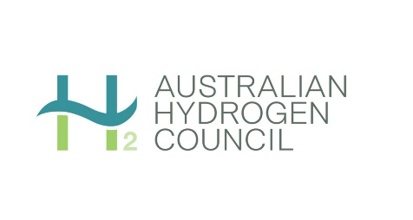

Pre-Budget Submission

Australian Hydrogen Council
29 January 2021
Submission to the Australian Government

Dr Fiona Simon
Chief Executive Officer
Australian Hydrogen Council
m: +61 474 028 740
e: fsimon@H2council.com.au
w: H2council.com.au

Contents
About the Australian Hydrogen Council 3
Hydrogen’s role in future energy systems 4
Summary of recommendations 5
Recommendations in detail 7
Planning for the energy transition 7
Resourcing and coordination 9
Supporting hydrogen infrastructure and driving demand 10
Replacing diesel in remote applications 12
Replacing natural gas 13
Transport applications 13
Conclusion 14

About the Australian Hydrogen Council

The Australian Hydrogen Council is the peak body for the hydrogen industry, with 64 members from across the hydrogen value chain.
Our members are at the forefront of Australia’s hydrogen industry, developing the technology, skills and partnerships necessary to build Australia’s hydrogen economy.

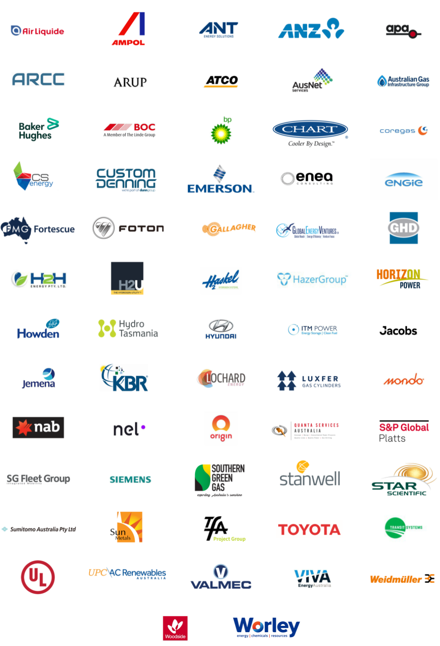

Hydrogen’s role in future energy systems
Hydrogen provides the versatility required by future energy systems in a carbon constrained world. With its long-term energy storage potential, hydrogen is the perfect complement for variable renewable electricity and batteries. Hydrogen can also be exported, which means potential new markets.
The versatility of hydrogen also allows it to connect different sectors of the economy, supporting Australia’s economic and energy security.
We have an enormous opportunity in this country to create a vibrant hydrogen industry, both for domestic and export use. Australia has the renewable energy resources, the technical skills, and the track record with international partners to become a global hydrogen leader.
We are already seeing significant investment from local and international businesses, and the National Hydrogen Strategy (NHS) and jurisdictional announcements have signalled the value that the Australian Government and states and territories see in the developing industry. Work for the NHS estimated potential benefits to Australia could be as high as $26 billion a year in additional GDP and 16,900 new jobs by 2050.
The opportunity is real, but it will not exist forever. Competing hydrogen producers across the globe seek a share of the export pie and are scaling up hydrogen production in their respective countries to supply the Japanese, Korean and Chinese markets as soon as 2025. These competitors include Brunei, Qatar, UAE and Norway, and in the longer‐term, market entrants such as the United States, Brazil, Chile and New Zealand.
Many of these countries have similar strengths to Australia, including abundant renewable resources, access to low‐cost gas for blue hydrogen production, carbon capture and storage capabilities, large areas of land for solar installations, and proximity to key hydrogen export markets.
The objectives of the NHS – and in 2020, the ‘H2 under $2’ target set in the Government’s Low Emissions Technology Statement – are considerable. They require a further significant demonstration of government commitment to implementation and market development.
This is not a technology matter; it is an economic matter. Hydrogen is competing with incumbent fuels that are cheaper – they are subsidised by governments and the carbon costs are not valued. It is also not about leaving market development to the private sector – this would mean we are asking an industry to create itself at a loss.
Meeting Australia’s stated hydrogen objectives requires strong national leadership to plan, collaborate and communicate with partners and stakeholders. Government must drive and lead the creation of the clean hydrogen industry. With the world moving to net zero there is no real alternative.
This submission proposes some ways for the Australian Government to demonstrate its seriousness in growing our clean hydrogen industry in line with the NHS and ‘H2 under $2’ target.

Summary of recommendations
Recommendation 1
The Australian Government urgently commences a Hydrogen Market Development Plan that:
- Explicitly adopts 2030 as the ‘H2 under $2’ target date.
- Identifies the minimum number and likely size of hydrogen production projects to reach this target under different scenarios. This work should inform an export target, which would complement the price target.
- Drives regulatory co-ordination and is informed by a cross-jurisdictional group of regulators.
- Addresses public perceptions of hydrogen risks and issues, as well as workforces and regions that are vulnerable to changes in energy production and use.
Recommendation 2
The Australian Government explicitly funds a division of the DISER or a separate agency (to at least $5 million a year, and more where further consultant support is required to support major policy projects in any one year) to:
- Deliver the NHS on behalf of the Australian and jurisdictional governments.
- Develop and publish an implementation plan, including allocating work to state and territory governments as reasonable and necessary.
- Allocate federal funding to state and territory governments to deliver as reasonable and necessary, or to direct and track other governments’ work to deliver the NHS.
- Publicly engage with stakeholders, including delivering greater transparency on timeframes and decision-making.
Recommendation 3
The Australian Government commits funding of sufficient scale to meet the likely outcome of the proposed Hydrogen Market Development Plan. The ARENA funding is likely to be insufficient for this purpose but this will become clearer through the planning process.
Recommendation 4
The Australian Government investigates further opportunities to form arrangements with the states and territories to support regional hydrogen offtake.
Recommendation 5
The Australian Government encourages private investment in hydrogen through the tax system, such as:
- Treating any grant funding from ARENA as assessable over the life of the project rather than in the year the grant funding is received.
- Providing tax credits/incentives for investing in export hydrogen production and distribution where any Research, Development or Demonstration (RD&D) is undertaken.
- Reducing tax write-off periods for hydrogen infrastructure (perhaps 1-3 years).
- Increasing the effective rate of tax offsets (from the current rate of 8.5% to 20%) and expenditure thresholds (beyond the A$100 million cap to A$500 million).
- Legislating for the immediate tax deductibility for all salary and wage costs for the construction of hydrogen production and distribution projects. These are a significant expense and requiring them to be capitalised for tax purposes acts as a disincentive to employment and infrastructure development.
- Treating front-end engineering design costs for hydrogen projects as immediately deductible under Division 40-730 of the Income Tax Assessment Act, 1997, rather than being capitalised.
Adapting the excise regime over time to apply a levy to fuel consumed in Australia based on its carbon content. Initially (say over a 5-year period), credits for businesses could be phased out to allow for a transition to new energy technologies.
Recommendation 6
The Australian Government considers a new direct compensation measure to replace diesel standalone power systems.
Recommendation 7
The Australian Government sets a natural gas blending target of 10% and instructs the Australian Energy Market Commission to investigate possible rule changes to allow for and value hydrogen blending into natural gas networks.
Recommendation 8
The Australian Government implements vehicles emissions standards:
- Light vehicle CO₂ emissions standard suitable for the Australian new vehicle market.
- CO₂ emissions standard for new heavy vehicles (buses, trucks) to bring vehicles to Australia. For example, the EU target is for new heavy-duty vehicle CO2 emissions (average) to reduce by 15% in 2025 and by 30% in 2030, both relative to a 2019 baseline.
- Euro 6 noxious emissions standards for light and heavy vehicles.
Recommendation 9
The Australian Government sets a 50% zero emissions vehicle target for fleets of cars, buses and ancillary vehicles for 2030. This would include privately operated public transport fleets and government owned logistics providers.

Recommendations in detail

Planning for the energy transition
The 57 actions in the NHS have been endorsed by the Australian Government and each state and territory. The challenge remains to flesh out the detail of the NHS and take action to implement the actions.
Collectively, in Australia, we do have huge enthusiasm and appetite to test the waters, but we do not yet have the means to harness this to get to scale, such as through targets that provide bankable support for investors, so we can get major projects deployed.
It becomes even more important to get this deployment when we consider the long-term risk of having an economy tightly coupled to fossil fuels in a decarbonising world. We need to diversify how we produce, use and export energy, and hydrogen allows us to do this.
In the view of the Australian Hydrogen Council, the next step in developing a world-scale hydrogen industry in Australia, building on the National Hydrogen Strategy and Low Emissions Technology Statement, is to develop a comprehensive and actionable Hydrogen Market Development Plan. The plan should go to 2030 at the least.
While no long-term plan can predict exactly what will need to be built, and where and when it should be built, it is possible to use market information and credible inputs to develop plausible scenarios. Those scenarios can inform the early decisions which have to be made to get the investment ball rolling.
There are three key elements for planning purposes.
- Planning for ‘H2 under 2’
First, we need to flesh out the stretch target of $2 Australian per kilogram of hydrogen produced, as set out in the Low Emissions Technology Statement. This target is not associated with a date at this stage.
The Australian Hydrogen Council encourages the Australian Government to adopt 2030 as the ‘H2 under $2’ target date.
We suggest 2030 because the National Hydrogen Strategy states an objective where Australia is a top three exporter to Asian markets by that time. Japan has also indicated that it is seeking hydrogen at a production price of $2 Australian a kilo post-2030, and Korea has proposed around $1.70 to $2 a kilo by 2030 as well.
The Hydrogen Market Development Plan should ideally identify the minimum number and likely size of hydrogen production projects to reach the ‘H2 under $2’ target by 2030, under different scenarios. This work should inform an export target, which would complement the price target.
This helps establish basic expectations about what is required to meet our objectives, which in turn help shape government and industry planning and investment in the detail.
We need to do this soon though, because very large projects take years to plan and build – in fact, most of the time that we have to 2030.
- Scoping an appropriate regulatory framework
The second key element of our proposed Hydrogen Market Development Plan is regulation, where relevant regulations include hydrogen certification, safety regulations for a range of purposes, environmental regulations, consumer protections and local government approvals.
Customers, communities, investors and trading partners will be looking for some degree of regulatory certainty and consistency.
Major hydrogen projects also need a degree of regulatory certainty to start planning for multi-year construction. If we expect very large projects are required to get to ‘H2 under $2’ by 2030 – and we do – there will be a need for regulatory clarity within the next 18 months or so.
None of this is impossible, and there are existing regulatory regimes that can be used.
However, the task is still complex and is made more complex by one of the great benefits of hydrogen, which is its versatility. Connecting different sectors of the economy is a good thing for energy diversity and economic resilience to shock. But it also has the effect of connecting separate regulatory regimes, which vary further over different layers of government and multiple jurisdictions.
The Australian Hydrogen Council is asking for regulatory coordination across the jurisdictions. This should involve a cross-jurisdictional group of regulators, to inform and help deliver the regulatory aspect of the Hydrogen Market Development Plan.
As with the Hydrogen Market Development Plan itself, this work should be led by the Australian Government, with a focus on how to make it easier to do business in the emerging hydrogen industry. This includes the needs of international companies who want to invest in Australia.
This work also needs to start now. Regulatory change is rarely straightforward or fast, and we need to know what changes are required as soon as possible.
- Engaging with communities and consumers about change
Third, the proposed Hydrogen Market Development Plan should also have a way to scope and deliver engagement with communities and consumers about change.
The hydrogen industry, as envisaged in the NHS, will have unprecedented scale.
Sizeable land areas will be developed as wind and solar farms and transmission lines. Hydrogen pipelines will be required (some of which may be converted gas pipelines) as well as water pipelines to supply electrolysers. Industrial and port facilities will also need to be developed to process and export hydrogen.
This will in turn require Australian communities to accept new infrastructure in their midst, prepare for new opportunities arising from job creation/transition, and to feel comfortable introducing new fuels and technologies in their homes.
We can see that there is a need for respectful and constructive engagement with consumers and communities about the road ahead. This is clearly a role for industry, and the Australian Hydrogen Council is developing principles and commitments to this effect.
There is also a much larger task here for governments to sponsor a public discussion about hydrogen. This could start with looking at public perceptions of hydrogen risks and issues, and research into workforces and regions that are vulnerable to changes in energy production and use.
In our view, the Hydrogen Market Development Plan must address community engagement and regional adjustment, and to consider these as priorities from the outset.
Recommendation 1
The Australian Government urgently commences a Hydrogen Market Development Plan that:
- Explicitly adopts 2030 as the ‘H2 under $2’ target date.
- Identifies the minimum number and likely size of hydrogen production projects to reach this target under different scenarios. This work should inform an export target, which would complement the price target.
- Drives regulatory co-ordination and is informed by a cross-jurisdictional group of regulators.
- Addresses public perceptions of hydrogen risks and issues, as well as workforces and regions that are vulnerable to changes in energy production and use.

Resourcing and coordination
There is significant work required to coordinate and implement the actions under the NHS, and we have some concern that this workload has not been reflected in departmental resourcing and processes to date.
There needs to be a strong advocate for the NHS through government, where the body has been appropriately authorised and resourced to deliver the NHS with some urgency.
We would expect funding to deliver the NHS would be in the region of at least five million dollars a year.
Recommendation 2
The Australian Government explicitly funds a division of the DISER or a separate agency (to at least $5 million a year, and more where further consultant support is required to support major policy projects in any one year) to:
- Deliver the NHS on behalf of the Australian and jurisdictional governments.
- Develop and publish an implementation plan, including allocating work to state and territory governments as reasonable and necessary.
- Allocate federal funding to state and territory governments to deliver as reasonable and necessary, or to direct and track other governments’ work to deliver the NHS.
- Publicly engage with stakeholders, including delivering greater transparency on timeframes and decision-making.

Supporting hydrogen infrastructure and driving demand
Until the industry has reached commercial scale, grant funding is essential.
We welcome the recent announcement that ARENA would receive guaranteed baseline funding of $1.43 billion over 10 years, and we observe that hydrogen remains a clear ARENA priority.
However, we note that hydrogen still competes with subsidised fossil fuels, and that hydrogen commitments from other governments have been particularly strong.
For example, the German hydrogen strategy includes an investment of 9 billion euros, and France recently announced 7 billion euros to be spent by 2030 to develop green hydrogen.
France and Germany do have larger GDPs than Australia – which implies each country can provide greater investment in hydrogen. Nonetheless, their contributions indicate the magnitude of government support required to meaningfully activate the hydrogen industry. And we have a larger export prize to strive for.
This matter connects with Recommendation 1, which is the plan to set the target and likely pathways to 2030. This should also demonstrate the scale of funding required.
To provide some context: the Hydrogen Council’s 2020 Path to hydrogen competitiveness report (supported by McKinsey analysis) estimates that US$70bn (A$100bn) of investment in hydrogen is required across the globe by 2030 to meaningfully activate the global hydrogen economy:
Reaching the scale required will call for funding an economic gap until a break-even point is reached – an investment to offset the initially higher costs of hydrogen as a fuel and of hydrogen equipment compared to alternatives. Instead of being perceived as costs, this should be seen as an investment to shift the energy system and industry to low-carbon technology.
BNEF analysis goes further, estimating that US$150 billion (A$214 billion) will be needed globally until 2030 to bridge the cost gap between hydrogen and the cheapest fossil fuels, not just the cheapest low-carbon alternative.
Public investments and policies to fill the gap can then unlock several times their value from the private sector. Assuming all else is equal, figures from ARENA and CEFC suggest that government funding in hydrogen might be expected to unlock at least three times as much private investment.
A real opportunity exists to build on the success of the renewables revolution in Australia and channel funding towards developing a hydrogen industry.
We also note that private sector financing can also be incentivised through governments acting as offtakers to hydrogen projects. While these arrangements usually sit with the states and territories, the Australian Government can play an important role. The NSW Energy Package MOU from January 2020 is an excellent example, where the two governments are funding over $2 billion in energy and emissions reduction initiatives to help NSW meet its target of net zero emissions by 2050.
Further, while changing tax laws cannot close the hydrogen investment gap, the tax system can play a role. The existing tax laws are largely in place and could be tailored relatively easily to capture hydrogen projects of national significance.
Recommendation 3
The Australian Government commits funding of sufficient scale to meet the likely outcome of the proposed Hydrogen Market Development Plan. The ARENA funding is likely to be insufficient for this purpose but this will become clearer through the planning process.
Recommendation 4
The Australian Government investigates further opportunities to form arrangements with the states and territories to support regional hydrogen offtake.
Recommendation 5
The Australian Government encourages private investment in hydrogen through the tax system, such as:
- Treating any grant funding from ARENA as assessable over the life of the project rather than in the year the grant funding is received.
- Providing tax credits/incentives for investing in export hydrogen production and distribution where any Research, Development or Demonstration (RD&D) is undertaken.
- Reducing tax write-off periods for hydrogen infrastructure (perhaps 1-3 years).
- Increasing the effective rate of tax offsets (from the current rate of 8.5% to 20%) and expenditure thresholds (beyond the A$100 million cap to A$500 million).
- Legislating for the immediate tax deductibility for all salary and wage costs for the construction of hydrogen production and distribution projects. These are a significant expense and requiring them to be capitalised for tax purposes acts as a disincentive to employment and infrastructure development.
- Treating front-end engineering design costs for hydrogen projects as immediately deductible under Division 40-730 of the Income Tax Assessment Act, 1997, rather than being capitalised.
- Adapting the excise regime over time to apply a levy to fuel consumed in Australia based on its carbon content. Initially (say over a 5-year period), credits for businesses could be phased out to allow for a transition to new energy technologies.

Replacing diesel in remote applications
Diesel is currently used extensively in mining and agriculture, and to power remote communities. Developing hydrogen remote area power systems (RAPS) can reduce Australia’s reliance on imported diesel and support decarbonisation in these sectors and communities. The development of hydrogen remote applications would also generate jobs in the design, construction and operation of hydrogen systems and provide a much-needed training ground to develop local knowledge and experience in the industry.
From a cost comparison perspective, hydrogen can replace diesel as a fuel right now. However, the issue remains how to replace existing infrastructure (including vehicles, which we return to below) and how to produce the hydrogen at scale in a pre-commercial environment.
Hydrogen is also competing against a heavily subsidised fossil fuels industry. A 2019 International Monetary Fund paper calculated Australia’s post-tax fossil fuel subsidies in 2015 as US$19 billion (A$28 billion), or US$1,198 per capita (A$1745). Post-tax subsidies were defined as the differences between “actual consumer fuel prices and how much consumers would pay if prices fully reflected supply costs plus the taxes needed to reflect environmental costs and revenue requirements”.
This supported further by the work of the Organisation for Economic Co-operation and Development (OECD). It has been found that 70% of energy-related CO₂ emissions from advanced and emerging economies are entirely untaxed. This indicates there is scope for policy reform to make a meaningful impact. Recommendation 6 can be seen as complementary to Recommendation 5 above.
Recommendation 6
The Australian Government considers a new direct compensation measure to replace diesel standalone power systems.

Replacing natural gas
Besides the obvious benefits of decarbonising Australia’s gas use, the use of hydrogen in the natural gas networks can provide important domestic offtake support to the emerging hydrogen export industry. This can also occur without significant additional investment in infrastructure.
However, explicit government policy support is required, as the gas networks cannot effectively make rate cases to their regulator without policy endorsement for expenditure. The most valuable support at this stage is for the Australian Government to set targets for hydrogen blending into the gas distribution networks. This is a ‘pen ready’ market stimulus opportunity.
Also, the current national regulatory framework does not account for hydrogen, which has created uncertainty for gas networks seeking to pursue hydrogen blending.

Recommendation 7
The Australian Government sets a natural gas blending target of 10% and instructs the Australian Energy Market Commission to investigate possible rule changes to allow for and value hydrogen blending into natural gas networks.

Transport applications
Decarbonisation of Australia’s transport sector is becoming increasingly urgent. Transport is Australia’s second largest emitter, making up 19% of current greenhouse emissions.
Decarbonising transport will only occur with a mix of batteries and hydrogen fuel cells. While both can be used for light vehicles, hydrogen has particular value in the heavy transport sector. As noted in the NHS, hydrogen fuel carries significantly more energy than the equivalent weight of batteries. This is particularly useful for buses, trucks and ships that carry heavy loads and can travel long distances. Even with improvements battery efficiency the heavy transport sector remains very hard to decarbonise without clean molecules like hydrogen.
As with gas blending opportunities, transport also provides significant hydrogen offtake potential. Transport uses are more piecemeal than gas blending but have the advantage of having a public profile and can also replace diesel now.
Hydrogen can also bring new design and manufacturing opportunities to Australia in fuel cell technologies, to be used in the automotive, mining, aviation and marine industries.
Governments can provide the right signals by setting targets and reducing unnecessary barriers to uptake for vehicles. They can help create the demand that will draw through private investment in vehicles and infrastructure. This will give certainty to manufacturers and investors in the early stages.
Recommendation 8
The Australian Government implements vehicles emissions standards:
- Light vehicle CO₂ emissions standard suitable for the Australian new vehicle market.
- CO₂ emissions standard for new heavy vehicles (buses, trucks) to bring vehicles to Australia. For example, the EU target is for new heavy-duty vehicle CO2 emissions (average) to reduce by 15% in 2025 and by 30% in 2030, both relative to a 2019 baseline.
- Euro 6 noxious emissions standards for light and heavy vehicles.
Recommendation 9
The Australian Government sets a 50% zero emissions vehicle target for fleets of cars, buses and ancillary vehicles for 2030. This would include privately operated public transport fleets and government owned logistics providers.

Conclusion
Considering the current economic conditions and the opportunity that hydrogen presents, the 2021/22 budget presents an excellent opportunity for the Australian Government to implement the recommendations outlined in this submission in order to reap the benefits of a local hydrogen industry.
The Australian Hydrogen Council would welcome the opportunity to provide further detail about any of the recommendations made in this submission via CEO Dr Fiona Simon who can be contacted by email on fsimon@H2council.com.au or telephone 0474 028 740.

Deloitte (2019) Australian and global hydrogen demand growth scenario analysis; COAG Energy Council – National Hydrogen Strategy Taskforce, November, p 1, http://www.coagenergycouncil.gov.au/sites/prod.energycouncil/files/publications/documents/nhs-australian-and-global-hydrogen-demand-growth-scenario-analysis-report-2019_1.pdf
ACIL Allen consulting (for ARENA) (2018), Opportunities for Australia from Hydrogen Exports, page 15.
This is aligned to a concept proposed by the CSIRO.
Alternatively, an investment allowance (say 50%) could be granted without changing tax depreciation schedules.
Hydrogen Council (2020) Path to hydrogen competitiveness: a cost perspective, p.66, https://hydrogencouncil.com/en/path-to-hydrogen-competitiveness-a-cost-perspective
BNEF (2020) Hydrogen Economy Outlook: key messages, March 30, pp. 4-5, https://data.bloomberglp.com/professional/sites/24/BNEF-Hydrogen-Economy-Outlook-Key-Messages-30-Mar-2020.pdf
De Atholia, T., Flannigan, G. and S. Lai (2020) ‘Renewable energy investment in Australia’, Reserve Bank of Australia https://www.rba.gov.au/publications/bulletin/2020/mar/pdf/renewable-energy-investment-in-australia.pdf. Further, if we take advice from the Hydrogen Council across two recent reports, a similar expectation of the ratio of public to private funds emerges: the 2020 report says around US$70 billion is required from government, and in a 2017 report the Council states that ‘building the hydrogen economy would require annual investments of [US]$20 to 25 billion for a total of about [US]$280 billion until 2030’ (p. 66). See Hydrogen Council (2017) Hydrogen Scaling Up: A Sustainable Pathway for the Global Energy Transition, November, https://hydrogencouncil.com/en/study-hydrogen-scaling-up/
This is aligned to a concept proposed by the CSIRO.
Alternatively, an investment allowance (say 50%) could be granted without changing tax depreciation schedules.
Coady, D., Parry, I., Le, N-P., and B. Shang (2019) Global Fossil Fuel Subsidies Remain Large: An Update Based on Country-Level Estimates, IMF Working Paper, Fiscal Affairs Department, WP/19/89.
Ibid., pp. 7-8.
OECD (2019) Taxing Energy Use 2019 – Using Taxes for Climate Action, October.

