2021-22 Pre Budget Submission to the Minister for Housing and Assistant Treasurer

Regenerating Indigenous Business post COVID-19
27 January 2021

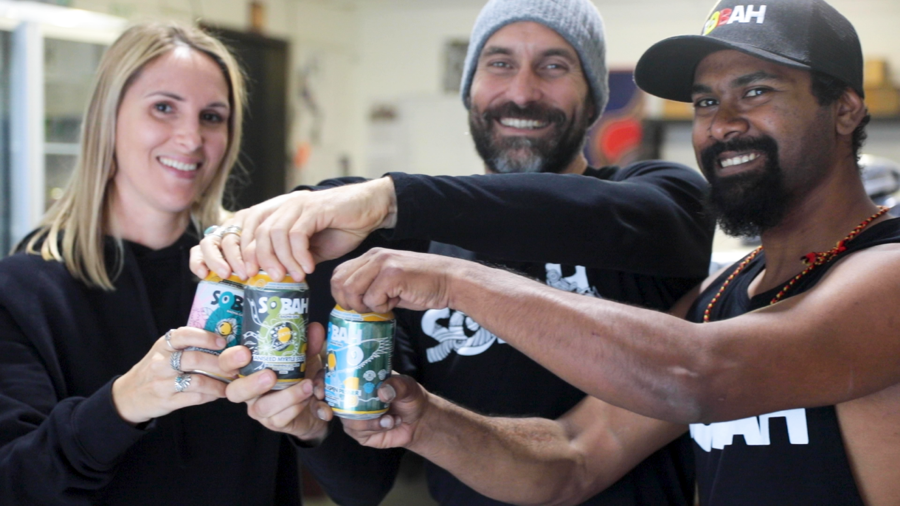
Sobah Beverages

Summary of Recommendations:
This submission outlines recommendations to the Australian government to meet objectives under the National Agreement to Closing the Gap –“Priority Reforms that focus on changing the way governments work with Aboriginal and Torres Strait Islander people. Reforms to Strengthen and establish formal partnerships and shared decision-making and Build the Aboriginal and Torres Strait Islander community-controlled sector” particularly in addressing Indigenous economic and business advancement.
Recommendation 1: The Australian Government match funding to create a 3P – Public Philanthropic Private Partnership and provide catalytic capital to the FAC Impact Enterprise Fund to support Indigenous enterprises.
Recommendation 2: The Australian government provide funding to FAC to continue to provide capacity development to Indigenous businesses dealing with the impact of COVID.
Budget Recommendation:
The Australian government provide $13 million to First Australians Capital to rebuild and regenerate Indigenous businesses post COVID and create sustainable livelihoods and employment.

Case Study: Sobah Beverages are breaking down the stigma of socialising sober.
Headquartered on Yugambeh country known as Queensland’s Gold Coast, Sobah’s growing range incorporates native ingredients as a proud nod to Clinton Schultz’s Aboriginal heritage as a Gamilaroi man and his aim to raise awareness and a sense of positivity around Aboriginal arts, language and history.
“I'm all about smashing stereotypes at the end of the day,” says Schultz, the registered psychologist, who started offering his brews from the Indigenous food truck he ran with his wife before launching Sobah.
Sobah, the first non-alcoholic craft beer brewer in Australia, is tapping into what’s shaping up as one of the fastest growing beer sub-categories, estimated by market research firm Fact.MR to be worth $US28 billion globally by 2027, or up to 5 per cent of the total beer category.
Meeting strong demand for his products, however, has meant finding the funds to expand operations, a challenging prospect for the small, largely self-funded business. But Sobah recently secured a big win by becoming the first business to benefit from a newly formed partnership between First Australians Capital and Westpac aimed at backing emerging Indigenous businesses, allowing Schultz to access the funding needed to double production.
Through the partnership, FAC will work with businesses to get them “loan ready” and provide ongoing “wraparound” support after the loan – jointly and equally guaranteed by Westpac and FAC – is written. Loan readiness includes robust due diligence and building capacity as needed through a panel of probono service providers across legal services, IT, marketing and sales, inventory and supply chain management.

Introduction
First Australians Capital (FAC) is a national not-for-profit Indigenous led business advisory and social impact fund. Our ambition is to unlock the cultural, creative and economic capital of First Australians to drive a new economy and create sustainable livelihoods for First Australians.
FAC has a track record in providing critical operational and strategic advice to Indigenous businesses, unlocking access to markets, and capital to grow. Our growth plan (over three horizons) is designed to secure sustainability and operational funding to support our capability building work.
Most importantly, our strategy expands financing options for Indigenous businesses, bridging critical gaps in the market, and securing a long term market opportunity for driving a new Indigenous economy.
Outcomes at a glance:
FAC has worked with over 400 Indigenous businesses since 2016 and leveraged nearly $50m in capital directly into Indigenous businesses nationally. Businesses supported by FAC demonstrate better resilience, stronger revenue growth and a blueprint for expansion and increased employment. During FY20 First Australians Capital:
- Supported over 40 businesses with capacity building and access to capital
- Invested $4.465 million into Indigenous businesses
- Leveraged a $30 million Westpac loan facility to help support Indigenous businesses who might not otherwise meet trading history requirements
- Secured $764k philantrophic funding to support 250 Indigenous businesses through COVID economic disruption
- Launched the first industry accelerator, a tourism aggregator ‘Welcome to Country’ (the Airbnb of Indigenous tourism)
- Maintained partnerships with leading advisory firms and leveraging pro-bono support (including Arnold Bloch Leibler, McKinsey, Minter Ellison)

Background
Even before the pandemic Indigenous people faced bigger challenges in accessing finance and had limited social capital.
Historical practices have left Indigenous communities with low rates of intergenerational wealth transfer, effectively limiting participation of Indigenous people in the mainstream economy.

Aboriginal and Torres Strait Islander peoples also have low ‘social capital’ – defined as access to networks that could provide informal loans or financial support – due to generally lower levels of economic resources within Indigenous communities. Currently Indigenous Australians experience historically low rates of intergenerational wealth transfer (demonstrated in the lower levels of home ownership - 38% of Indigenous people own their home compared with 67% of the Australian population), low personal savings and limited participation in the benefits of economic growth and the vitality enjoyed by the country as a whole.

Despite of these challenges, prior to COVID, greater Indigenous economic independence was being driven through government and corporate procurement policies and targets and the Indigenous businesses sector was experiencing strong growth; growing at 12.5% annually.

The Supply Nation database has over over 2,300 Indigenous businesses who generate over $3 billion in annual revenue and employ over 11,000 Indigenous employees.

Indigenous businesses have a multiplier effect, where the impacts of a successful business go beyond financial benefits to the local economy and where successful business owners are often role models and catalysts for change within the community .

Indigenous businesses: | That matters because:
- Are up to 30 times more likely to employ other Indigenous people, with on average 2.3 jobs created for every $200K loan to an Indigenous business | Indigenous employment is a key indicator of strong economic development. Better employment outcomes will also deliver greater health and education outcomes for whole communities.
- Growing at 12.5% per annum (pre COVID) showing higher than Australian average growth potential | The social impact of continued Indigenous business growth will be shared with the broader Australian community
- Generate $4.41 in social return for every $1 of revenue | Thriving Indigenous businesses enable whole communities to flourish.
- Indigenous people make up around 3% of the population but only own around 0.06% of Australia’s businesses. | Achieving parity in business ownership provides clearer pathways to economic independence for generations.

However, the Supply Nation, 2020 State of Indigenous Business Report observed that Indigenous employees were more concentrated in industries that have been affected most by COVID-19, and as a result, Indigenous employees have experienced greater job losses compared to all employees.
If the COVID-19 unwinds the labour market gains in closing the gaps between Indigenous and non-Indigenous Australians, this may presage the need for a more radical approach to Indigenous economic policy that takes into account persistent issues such as long-term social exclusion and discrimination.
All which will have significant impact on the momentum to drive meaningful outcomes in Indigenous business growth and employment outcomes.
Indigenous Australians need not be left further behind.

Regenerating the Indigenous Business sector
48.8% of Indigenous people in Australia live in financial stress, across urban, regional and remote areas and 75% struggle to access financial services. Further mainstream finance and business advisory services do not reach the Indigenous business sector and a specific response is needed.
Access to the right capital – Long term, Patient Capital
Access to capital is routinely identified as a major inhibitor for Indigenous business. Indigenous Australians have lower rates of Indigenous wealth transfer, lower rates of lending from family and friends and lack security.
There is a further challenge in matching the risk profile of lending institutions to business opportunities. While small business loans do exist, emerging Indigenous businesses can find it difficult to meet commercial lending criteria for loans, which involves providing an adequate trading history, robust financial projections, and a strong business case and execution plan.
Indigenous businesses are predominantly small to medium sized. In the procurement space, winning a large multi-year contract can prove to be costly, as Indigenous contractors are unable to obtain mainstream finance (given revenue forecasts of contracts may be above a bank’s lending criteria) and may instead resort to ‘pay-day’ lenders with often over-inflated or even predatory interest rates.
The 2018-2028 Indigenous Business Sector Strategy further states “Current capital products provided by the Government, community service providers, and the private sector are not meeting the needs of Indigenous businesses across the different stages of the business lifecycle. Many Indigenous businesses are unable to receive finance from banks because of lower levels of collateral and limited access to personal wealth”.
The IBSS recommends “To meet the needs of a growing and diversifying sector, an Indigenous Entrepreneurs Capital Scheme will be established to improve access to private sector capital for Indigenous businesses”. This Scheme is yet to be established.
Long term evergreen and patient equity is common tool in investment markets particularly venture capital. What is less common is patient capital in the philanthropic and impact investing markets. MacArther Foundation in the US speaks of Catalytic Capital “which refers to patient investments that are structured as equity, guarantees that accept disproportionate risk and/or concessionary returns relative to a conventional investment in order to generate positive impact and enable third party investment that otherwise would not be possible” (MacArthur Foundation, 2019)
First Australians Capital has established a unique, patient capital, investment model that aims to brings together private sector, government and philanthropic investors to invest in high potential Aboriginal and Torres Strait Islander enterprises.
We have secured long term funding from the philantrophic foundations and Westpac, however we believe it is critical to have government participation in this unique partnership as it would demonstrate how future impact investment models should work to regenerate and grow the Indigenous business sector.
Recommendation 1: The Australian Government match funding to create a 3P – Public, Philanthropic, Private Partnership and provide catalytic capital to the FAC Impact Enterprise Fund to support Indigenous enterprises.
Capacity building for Indigenous businesses
Indigenous businesses have traditionally faced significant challenges in the norm. Given the current climate of COVID 19 crisis - this has produced an overwhelming burden on a large number of these businesses to try and navigate through the multiple government subsidy solutions and private sector responses and gain access to badly needed funds. We want to ensure that the Indigenous SME sector is there on the other side, so that we don’t lose critical momentum.
According to the 2019 First Nations Foundation report on Financial resilience “a substantial proportion of Indigenous respondents appeared to have very low or low financial social capital. This is likely to be due to low levels of economic resources (you cannot share what you do not have) and poor access to services”.
The 2020 State of Indigenous Business Report by Supply Nation also highlights that “Indigenous businesses in some sectors are unable to win contracts because they lack the capacity and capability that buyers require”. The report recommends that governments should “support capacity and capability building in existing Indigenous business sectors, to foster more businesses of sufficient size, experience and capability to be successful in key procurement processes”.
Over the past 8 months, through generous support from the philanthropic sector, FAC has supported over 285 Indigenous businesses with COVID support. This support included information dissemination of the various stimulus packages and supports, developing a plan of action and supporting the implementation, financial planning to ensure IBs develop the necessary cash flow scenarios to help with their survival and recovery and accessing industry specialists to help improve business potential, for example to restructure business operations.
Additional outcomes have been achieved as a direct result of the project:
- With many of the Indigenous Businesses needing third party services including Accounting, Marketing, Graphic Design, WHS, Photography, Videography and Signage, in most cases we have been able to refer to Indigenous businesses to provide these products and services, thus growing the Indigenous economy;
- In addition to this we have created an Indigenous Business 'channel' encouraging businesses to share their story, product and services links with other businesses in the channel, thus further growing the Indigenous economy;
- COVID-19 support with a broader cohort of around 450 Indigenous Businesses receiving support via email campaigns, offering information about initiatives that could support their businesses during these challenging times;
- Over 80% of Australian businesses operate without a business plan (mybusiness.com), FAC has been working to ensure at least 80% of our IBs not only have a business plan, but have an accountability partner to help keep them on track to increase their chances of success;
- Over 90% of our IBs have accessed financial literacy support during the program, including accounting, product or service costings, budget planning, and accounting software. The overall outcome has been an increase in financial literacy across the IBs participating in the program.
When First Australians Capital works with a business, we provide professional, skilled support to develop the business skills, knowledge and understanding Indigenous businesses need. A dedicated Business Relationship Manager provides business planning, advisory and strategy support and will work with each business weekly, becoming a trusted advisor and mentor over time.
As an Indigenous-led intermediary, First Australians Capital is uniquely suited to build the investment pipeline and bridge the demand with supply. Our lived experience and practice has enabled us to build trusted relationships with communities, develop different networks, different investments and a diverse portfolio.
Recommendation 2: The Australian government provide funding to FAC to continue to provide capacity development to Indigenous businesses dealing with the impact of COVID.

Case study: Currency Print and Corporate Communications (CPCC) is Victoria’s only Aboriginal owned certified Social Enterprise and managed print manufacturing company.
CPCC has been forging through the intense business challenges that COVID-19 lockdowns have bought. CPCC connected with First Australians Capital through email, and has continued the engagement with phone conversations and zoom meetings – and has found both the support and mentoring through the organisation ‘phenomenal.’
“The hands on approach from FAC and genuine interest for, not only CPCC, but Aboriginal business to succeed, in general, was inspiring. The FAC team have given up so much time personally and professionally to assist CPCC to be able to come through COVID-19 effectively,” Sara Stuart, CEO said.
The support and mentoring programs CPCC received from First Australians Capital have included financial mentoring (with an introduction to Westpac’s overdraft facility); cash-flow mentoring and re-working of large scale budgets; aid around marketing and re-branding, and the COVID-19 Support fund.
“The team at FAC are also working with CPCC to help with the new launch of our business with an Aboriginal language name and re-branding of this new Aboriginal Social Enterprise.
“This is a great opportunity to have access to a brand marketing specialist to assist our small business with the re launch.”

Budget Recommendation
First Australians Capital is seeking $13 million from the Commonwealth government towards a public, private and philanthropic partnership to rebuild and regenerate Indigenous businesses post COVID and create sustainable livelihoods and employment.
Commonwealth matching contribution:
- $3 million matched funding for FAC Impact Enterprise Fund (mini fund) to grow to $10 million.
- $5 million matched funding for FAC capacity building and business development for Indigenous businesses to regenerate post COVID over 5 years.
- $5 million for a Guarantee for Indigenous enterprises accessing mainstream finance through the Westpac Partnership.

- Commercial finance products
- Loans + grant packages
- Equity
- Convertible Notes
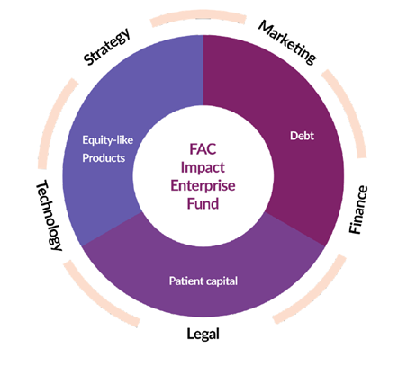
- Repayment holidays
- Capitalised interest
- Longer term

Mixed / flexible funding products to bridge the capital gap

First Australians Capital – Point of Difference

First Australians Capital ambition is to unlock the cultural, creative and economic capital of First Australians to drive a new economy and create sustainable livelihoods for First Australians.

Our strategy expands financing options for Indigenous businesses, bridging critical gaps in the market, and securing a long term market opportunity for driving a new Indigenous economy.

Lead by Indigenous Australians
First Australians Capital is proudly founded and run by experienced Aboriginal and Torres Strait Islander industry leaders and advisors. We have deep ties into our communities and understand the challenges and opportunities that exist.
Our mission: to empower self determination
We believe in the cultural, creative and economic capital of Indigenous Australians to achieve self determination and economic justice.
Identifying and filling the gaps
By working with underserved business start-ups, and accessing capital for early-stage businesses, FAC fills a gap in the Indigenous business ecosystem. Through partnerships with mainstream providers, industry players and leading advisory firms, we support Indigenous businesses to access mainstream finance.
Solid track record
We have a track record of success working nationally with over 400 Indigenous businesses since we began in 2016. We stand alongside Indigenous entrepreneurs to help break through the systemic barriers.
Industry and markets natural competitive advantage
We focus on developing industry and markets in which Indigenous businesses have a natural competitive advantage, such as cultural tourism, agriculture and environmental and sustainable markets. These are areas where Aboriginal and Torres Strait Islander people have been running sustainable enterprises for over 60,000 years.
Indigenous First:Impact First
FAC is pioneering the creation of a Impact Enterprise Fund to drive Indigenous economic growth and deliver lasting impact. Our Indigenous First:Impact First investment mandate delivers better outcomes for individuals, families, communities and businesses.
Contact for further information:
Leah Armstrong
Managing Director
E: leah@firstaustralianscapital.org
Website: https://firstaustralianscapital.org/

The Sleeping Giant, A Social Return on Investment Report on Supply Nation Certified Suppliers (2015), Supply Nation
Supply Nation Policy Brief No 1 October 2020 - Yonatan Dinku, Boyd Hunter and Francis Markham
Supporting Indigenous Business Project Research Report (December 2018), Department of Industry Innovation and Science, in partnership with Department of Jobs & Small Business, Department of Prime Minister & Cabinet and NSW Department of Industry. See also the Australian Government;s “The Indigenous Business Sector Strategy, Supercharging Indigenous Business Start-Up and Growth 2018–2028.

