

Pre-Budget Submission

2021-2022

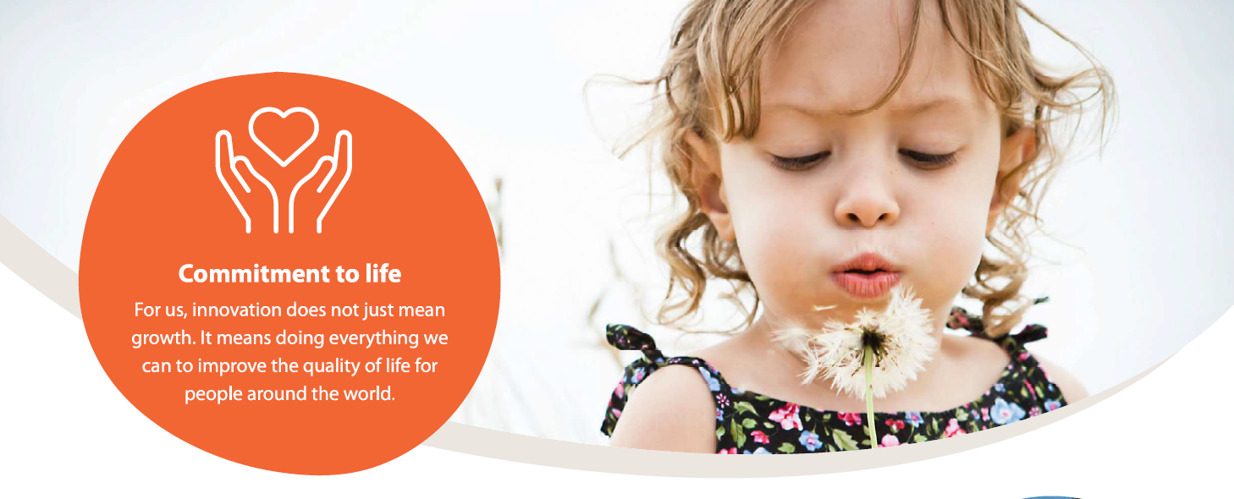

Kyowa Kirin is a proud partner of Rare Voices Australia

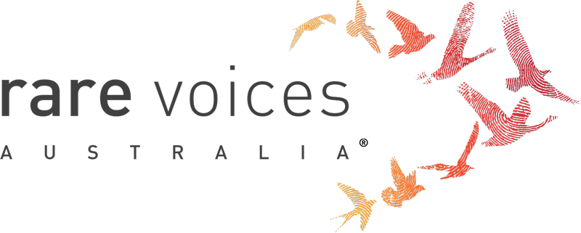

Executive Summary

On behalf of Kyowa Kirin Australia Pty Ltd, may I extend our sincere thanks of the opportunity to contribute to the 2021-22 Federal Budget process.

Kyowa Kirin is a Japan-based Global Specialty Pharmaceutical Company contributing to human health and wellbeing worldwide through innovative drug discovery and global commercialisation. We are driven by state-of-the-art antibody technologies in the core therapeutic areas of oncology, nephrology, central nervous system, and immunology.

Established in Australia in March 2019 and headquartered in Sydney, NSW, Kyowa Kirin Australia aims to bring Kyowa Kirin’s patient focussed therapies to Australia, with a strong focus on contributing to the health and well-being of patients and families in Australia.

Kirin is currently seeking to bring two (2) of its novel medicines to Australian patients and is working on submissions to the Therapeutic Goods Administration (TGA) and Pharmaceutical Benefits Advisory Committee (PBAC) to achieve this.

These products are:

|  |  |
| --- | --- |
|  |  |
|  | **Burosumab for X-linked Hypophosphatemia (XLH)**  XLH is a rare, progressive and lifelong phosphate wasting disease, which is primarily hereditary in origin. It usually presents early in childhood and frequently causes a range of debilitating clinical manifestations and symptoms. These symptoms can include rickets, lower-limb deformities, stunted growth, cranial synostosis, spontaneous dental abscesses, muscle weaknesses and impaired function, and occasionally, sensorineural hearing deficits and loss. |
|  | **Mogamulizumab for Mycosis Fungoides (MF) and Sézary Syndrome (SS)**  MF and SS are the two predominant subtypes of Cutaneous T-Cell Lymphoma (CTCL), a form of blood cancer which presents primarily in the skin. CTCL typically causes severe itching, discomfort, infection, and visible rash, and leading to significantly diminished quality of life, as well as premature mortality. |

Kyowa Kirin welcomed the Australian Government’s 2020 Budget Commitment which guaranteed a PBS new medicines funding commitment, signalling a new era of further certainty for Australian patients in accessing new and innovative therapies.

We congratulate the Australian Government’s commitment of $2.8 billion over four (4) years and for removing the requirement for cost offsets for new medicine listings on the PBS. It is in this context that Kyowa Kirin Australia make the following recommendations for the Australian Government’s consideration for inclusion in the 2021-22 Federal Budget.

|  |  |
| --- | --- |
|  | KYOWA KIRIN RECOMMENDATION |
|  | That the Australian Government considers investing in a Highly Specialised Technologies (HST) pathway for novel therapies addressing unmet needs in rare diseases |
|  | That the Australian Government acknowledge the severity of Cutaneous T-cell lymphoma and X-linked Hypophosphataemia |
|  | That the Australian Government continues to invest in clinical trials and recognises the important role they play in ensuring Australian patients have access to new treatments for rare cancers |

Recommendation 1: That the Australian Government investigates investing in a Highly Specialised Technologies (HST) pathway for novel therapies addressing unmet needs in rare diseases

Kyowa Kirin has been working on the development of burosumab for more than 22 years, largely in ignorance of access conditions and incentives in the Australian market. The decision to commercialise the medicine in Australia, however, was very much informed by our assessment of approval processes, prospects for achieving registration and reimbursement and associated transaction costs; and this decision could realistically have gone either way.

Burosumab is a highly specialised medicine that treats a very rare, hereditary, lifelong and debilitating disease, for which there are very limited current or even prospective treatment options available. The clinical development program has been long, challenging, and costly, while the global market opportunity is small and time-limited, meaning the cost of treatment is unavoidably high. International referencing pricing practices in other markets furthermore place restrictions on the extent to which this can be reduced in Australia.

Medicines like burosumab will always struggle to meet conventional PBAC cost-effectiveness criteria and evidence standards, which were established based on much simpler treatments for more common diseases. As it is life changing rather than strictly lifesaving, it also falls into the large gap that exists between the Pharmaceutical Benefits Scheme (PBS) and the Life Saving Drugs Program (LSDP).

In the United Kingdom (UK), burosumab has been assessed and funded through an alternate Highly Specialised Technologies (HST) pathway, for which more generous cost-effectiveness criteria are applied, commensurate with the complexity of such treatments and the rarity of the diseases they treat, but which do not require that they be strictly lifesaving, as in the LSDP. A similar scheme/pathway in Australia would considerably improve the feasibility of and incentives for commercialising novel therapies for rare diseases with high unmet clinical need.

Recommendation 2: That the Australian Government acknowledge the severity of Cutaneous T-cell lymphoma and X-linked Hypophosphataemia

Cutaneous T-cell lymphoma

Cutaneous T-cell lymphoma (CTCL) is a rare, serious, and potentially life-threatening form of cancer (non-Hodgkin’s lymphoma) that affects the skin. CTCL is characterised by localisation of cancerous white blood cells called T-lymphocytes (T-cells), to the skin. These cancerous T-cells consistently express a protein called CC-chemokine receptor 4 (CCR4), which enables them to move from the blood to the skin. When these cancerous T-cells move to the skin, they can create a localised inflammatory immune skin response, commonly resulting in visible skin symptoms of red patches or plaques, which can resemble psoriasis or eczema.

The incidence of CTCL increases with age, with most people being diagnosed between 50-80 years of age, and men being twice as likely to develop it. CTCL substantially deteriorates the quality of life for those living with the disease as it has a profound and severe impact on daily function and social interactions.

Skin symptoms are disfiguring, itchy, painful and unpredictable, often causing individuals to have trouble sleeping. Their mental health and emotional status can fluctuate and include feelings of depression, frustration, embarrassment and tiredness. This can often affect how close they can be with those they love.

There are many different types of CTCL: mycosis fungoides (MF) is the most common form of CTCL that starts in the skin. It appears as patches, plaques or tumours and causes painless swelling or lump, mainly in the neck, groin, or armpit.

Sézary Syndrome (SS) is a particularly rare and often aggressive, with cancerous T-cells found in high concentrations in the blood, and sometimes the lymph nodes.

Skin infections in patients with SS are common due to the extensively compromised skin. A compromised immune system and opportunistic infections are the most common causes of disease-related death in SS.

MF and SS can initially be mistaken for eczema and psoriasis, as these conditions may look similar, especially in the less advanced stages of the disease. As a result, it can take a long time – on average between 2 and 7 years – for individuals to receive a confirmed diagnosis.

It is critical for doctors to diagnose CTCL as early as possible, as if the disease progresses to later stages, the prognosis can be affected. Whilst most individuals that present with early-stage disease do not progress to a more severe stage, only around half of patients (52%) with advanced MF/SS survive for 5 years.

X-linked Hypophosphataemia

X-linked hypophosphataemia (XLH) is a rare genetic and progressive disease that affects multiple systems across the body, including the bones, muscles, joints, teeth and hearing. Although XLH is not life-threatening, it is a life-long and debilitating disease that can severely impact the quality of life for all those affected.

XLH is mainly diagnosed in childhood. The obvious features are the bow or bent legs, short body structure that could cause bone and joint pains, dental and hearing problems. It is characterised by renal phosphate wasting, which is caused by excess fibroblast growth factor 23 (FGF23).

Children with XLH suffer from poor quality of life, impaired mobility, and bone and joint pain. The immediate observation is the how different they look form the rest. In addition to skeletal disease and impaired growth, children with XLH may also have dental manifestations of the disease.

These symptoms can vary severely from one child to the other:

* A slow growth rate and noticeable bowing of the legs or other skeletal abnormalities, which are typically visible during the second year of life
* Short body stature
* Painful bones and joints at the lower limbs

XLH signs and symptoms continue to progress in adulthood, as bones continue to require phosphate for ongoing development. New and potentially irreversible manifestations may also appear, including osteoarthritis, enthesopathy and (pseudo) fractures. Recent literature suggests XLH may even be associated with increased and premature mortality.

Accurate and timely diagnosis of XLH is critical, as studies in children have shown that early identification and appropriate treatment has the potential to significantly improve long term outcomes. However, in practice, diagnosis is often delayed due to the rarity of the condition, complexity of the workup, and similarities in clinical, biochemical and/or radiological abnormalities to other conditions.

Burosumab is the first and only treatment to address the pathophysiology of XLH. Evidence of the efficacy and safety of burosumab has been collected in a global program including a Phase 3 direct randomised controlled trial comparing it with conventional therapy, which also included an open-label treatment extension period out to 144 weeks. The trials have demonstrated compelling effects against key pharmacodynamic endpoints, clinical and patient relevant outcomes, with acceptable safety with varying severity and duration of disease. It has shown superior efficacy compared to oral phosphate and activated Vitamin D in restoring phosphate homeostasis and improving key clinical outcomes in children with XLH, including rickets, lower limb deformity, growth and mobility.

Recommendation 3: That the Australian Government continues to invest in clinical trials and recognises the important role they play in ensuring Australian patients have access to new treatments for rare cancers

Australia is globally known as a country at the forefront of medical research and has seen many successes over recent years. In order to maintain this reputation, the Australian Government must make clinical trials an attractive option and present clear pathways for medicine companies to commercialise.

With knowledge surrounding rare cancers increasing (for example) and more subtypes of cancers emerging, the number of eligible patients is very limited. Combined with Australia’s population size, this leads to limited financial incentive for companies to invest in Australia. The PBS system currently is very effective at more common treatments however can overlook the tangible benefits offered by treatments for rare diseases.

Kyowa Kirin was encouraged by Minister for Health, the Hon Greg Hunt MP’s 2019 Election funding commitment of $7 million in funding to state and territory governments to support activities designed to achieve national consistency of clinical trial systems and welcomes the Australian Government’s recent support for the national harmonisation of clinical trials.

Whilst these initiatives will not directly impact Kyowa Kirin, it is emblematic of the Australian Government’s commitment to making Australia a more attractive location for clinical trials. Kyowa Kirin would welcome further reform initiatives for vital clinical trials in the area of new drugs and novel medical technologies.

Kyowa Kirin has carried out two clinical trials in Australia. Sites include the Peter MacCallum Cancer Centre in Melbourne and the Children's Hospital at Westmead in Sydney, where many rare disease patients participated. We are pleased that we have been able to include Australian patients in our clinical trials as well as support many Australian patients with compassionate access to our medicines.

Further Information

For any further information, please contact:.

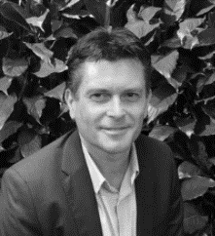Simon Dawson

General Manager

Kyowa Kirin Australia Pty Ltd

simon.dawson.m4@kyowakirin.com

68 York Street, Sydney, NSW 2000

Direct +61 456 550 405