Dr Steven Kennedy PSM

Secretary to the Treasury

Australian Economic Outlook[1]*

Keynote address to the Australian Government Fixed Income Forum

24 May 2023

# Introduction

I begin today by thanking the Australian Government Fixed Income Forum for the invitation to speak this afternoon. It is a great pleasure to be here with you for the 10th anniversary of the Forum.

I will speak today about Australia’s economic stability and strong fiscal performance and outlook. I will then discuss Australia’s green credentials, including emissions reductions efforts, the Sustainable Finance Strategy, and transitioning Australia’s economy and electricity grid to net zero.

## The Australia-Japan relationship has a long history

Japan and Australia have a long standing and close relationship. This is based on our shared trade, investment, and security interests, but also on our shared values and commitment to liberal democracy.

The strength of the relationship is demonstrated in the number of times our leaders have met since Australian Prime Minister Albanese came to office – five times in less than twelve months, including last week at the G7 Leaders meeting in Hiroshima.

The close strategic partnership is also evident in the scope of cooperation agreed by our leaders when Prime Minister Kishida visited Australia last October. Our Prime Ministers agreed significant defence, security and economic partnerships that will promote investment in critical minerals and decarbonisation through hydrogen and ammonia markets.

This builds on the Japan-Australia Economic Partnership Agreement and our many past international agreements, including the Indo‑Pacific Economic Framework for Prosperity, the Comprehensive and Progressive Agreement for Trans-Pacific Partnership, and the Trilateral Infrastructure Partnership.

Australia’s trade relationship with Japan is substantial. Japan is the second largest consumer of Australian exports and the fourth largest supplier of our imports.

Significantly, Japan has the highest concentration of individual investor institutions holding Australian Government Securities (AGS) in the world.

* AUD Government Bonds (AGS and semis) form a significant portion of the net flow into AUD fixed income by Japanese investors (Chart 1).

**Chart 1: Japan net flow AUD fixed income**

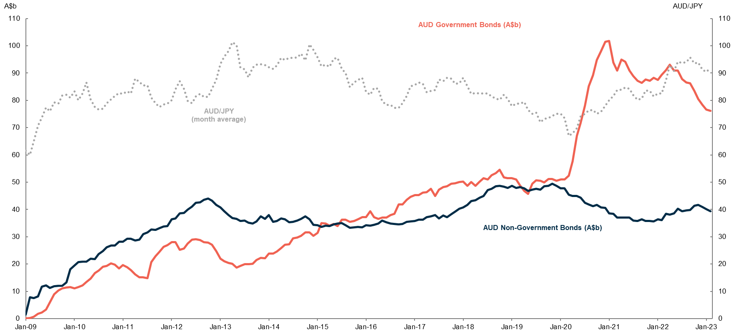

Source: Japan Ministry of Finance.

* As of December 2021, Japanese investors owned around 21.5 trillion Yen (A$250 billion) of AUD Fixed Income.
* AUD fixed income assets are the fourth most popular currency among Japanese fixed income investors (Chart 2).

**Chart 2: Japan fixed income holdings by currency**

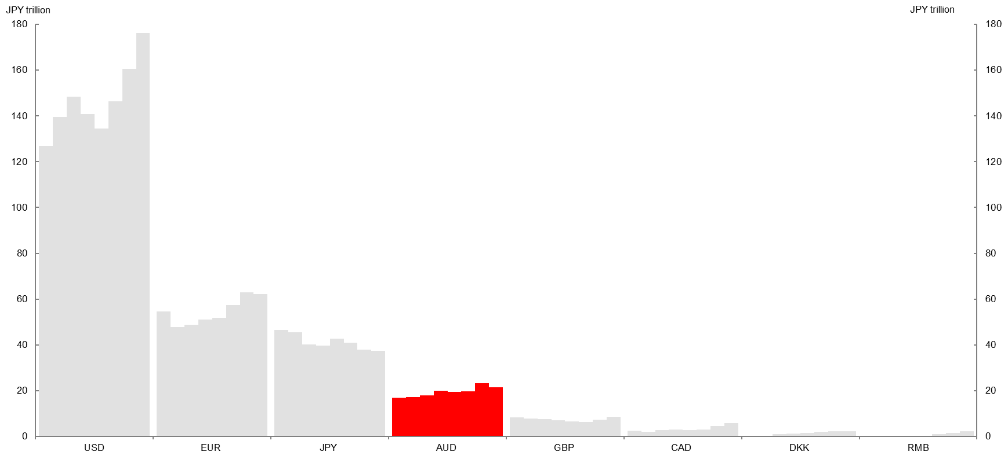

Source: Japan Ministry of Finance (2014-2021).

Australia is Japan’s largest and most trusted source of energy. Australia provides around 40 per cent of Japan’s LNG and around 75 per cent of Japan’s thermal coal.[2] Australian resources support the steelmaking for more than half of Japan’s infrastructure. Rio Tinto alone has exported 2 billion tonnes of iron to Japan since the first shipment in 1966.[3]

Australia’s first export coal mine was established in 1963 in Central Queensland through partnership between Australian firm Thiess and Peabody, and Japanese firm Mitsui and Co. Rio Tinto and Nippon Steel in iron ore followed in 1966, and Mitsubishi and Mitsui in the North-West Shelf LNG project beginning in 1989.

Japan is now looking to partner with Australia in the shift to clean energy. A pilot Hydrogen Energy Supply Chain project has been successfully completed. This saw the first shipment of hydrogen delivered from Australia to Japan last year on the world’s first dedicated hydrogen carrier – the Suiso Frontier.

Commercialisation of the project is now under consideration, with the consortium awarded 180 billion Yen (A$2 billion) from Japan’s Green Innovation Fund to establish a hydrogen supply chain.

The 2022 State of Hydrogen report also showcased Australia’s potential as a green hydrogen powerhouse. This presents vast potential for collaboration and a new chapter in energy security between our countries.

# Australia’s economy is strong and stable

I have made the case our partnership is close and important for our shared prosperity. I now turn to the equally case that Australia is a good place for Japan to continue to invest in.

## Strong foreign investment, economic foundations, and performance

Australia has had strong foreign investment for a long time – currently around 417.2 trillion Yen (A$4.6 trillion). This reflects the confidence overseas investors have in the strength, stability, and opportunities the Australian economy presents.

* We are the world’s 12th largest economy[4] with GDP of around 200 trillion Yen (A$2.2 trillion) in 2022 and we have the highest median wealth per adult of any large economy.[5]
* Australia is well known for our rich natural resources and mining sector, with mining exports valued at 37 trillion Yen (A$412 billion) in 2021-22. We also have large and thriving services sectors.
* Australia’s financial sector assets are valued at around 730 trillion Yen (A$8 trillion) and includes the world’s fourth largest pool of pension assets.
* Our stockmarket is among the 15 largest globally, and our dollar is the sixth most traded currency globally.
* Australia’s ‘unquestionably strong’ prudential requirements mean our banks have strong capital positions and liquidity coverage combined with rigorous underwriting standards.[6]

## Investment and business-friendly

Australia’s pro-business environment attracts foreign investment and encourages new enterprise. Australia enjoys a strong rule of law and institutions.

Australia is a low-taxing advanced economy. Our tax-to-GDP ratio is 29 per cent of GDP, compared to the OECD average of 34 per cent.[7]

According to the Heritage Foundation Economic Freedom Index, Australia’s ranks equal first for financial freedom and third for trade freedom.

Australia also ranks well internationally on number of days to start a business, judicial effectiveness, and access to credit.[8]

## Australia is well integrated into Asia

Australia is an export-driven economy focused on the dynamic Asian region.

We have an open economy, strong cultural links, and free trade agreements with Asian countries. This places Australia as a natural platform for commercial expansion into Asian economies and markets.

* 12 of our top 15 export markets are in Asia. In 2021-22, exports of goods and services to Asia were valued at around 43 trillion Yen (A$472 billion), or around 80 per cent of exports.

# Australia’s strong economic foundations

Australia has enjoyed solid and sustained economic growth for many years. Cumulative real GDP growth has been about 150 per cent over the past 30 years (over 60 percentage points higher than the OECD average) (Chart 3). Our resilient economy has experienced only six quarters of negative growth over the past 30 years, despite enduring the Asian Financial Crisis, Global Financial Crisis, and COVID-19 pandemic.

**Chart 3: Cumulative real GDP Growth**

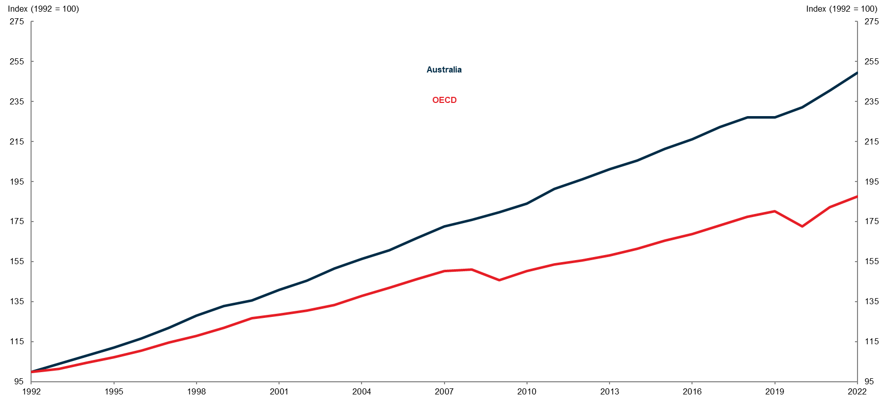

Source: OECD Stat.

Note: Index cumulative real GDP growth over past 30 years compared to OECD.

Australia weathered COVID-19 well and is recovering strongly.

* GDP is up around 7 per cent since December 2019, more than any major advanced economy (Chart 4).

**Chart 4: GDP growth relative to pre‑pandemic**

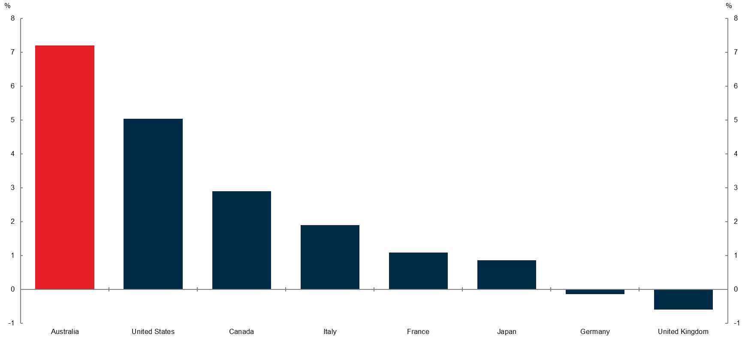

Source: Treasury, Refinitiv, national statistical agencies.

Note: Growth is calculated between the December quarter 2019 and December quarter 2022.

## Economic outlook

The outlook for the Australian economy is positive, but there are challenges ahead.

Global growth is expected to slow considerably in 2023, with growth over the next 2 years expected to be the weakest in over 2 decades, excluding the Global Financial Crisis and the pandemic.

High inflation, sharply rising interest rates, and a tightening in financial conditions associated with recent banking sector strains are all weighing on activity, particularly in advanced economies. These factors are expected to more than offset the boost from the reopening of China’s economy following the lifting of pandemic restrictions.

The Australian economy is not immune from these global economic challenges, but it is well placed to navigate them.

The unemployment rate remains low at 3.7 per cent, wages growth has picked up, and elevated commodity prices are flowing through to higher export revenues.

These factors have helped to deliver solid growth in 2022–23, and Australia’s growth is expected to exceed all major advanced economies in 2023.

High inflation and the rise in interest rates are squeezing households and weighing on activity in 2023–24 (Chart 5).

**Chart 5: Annual GDP growth forecasts**

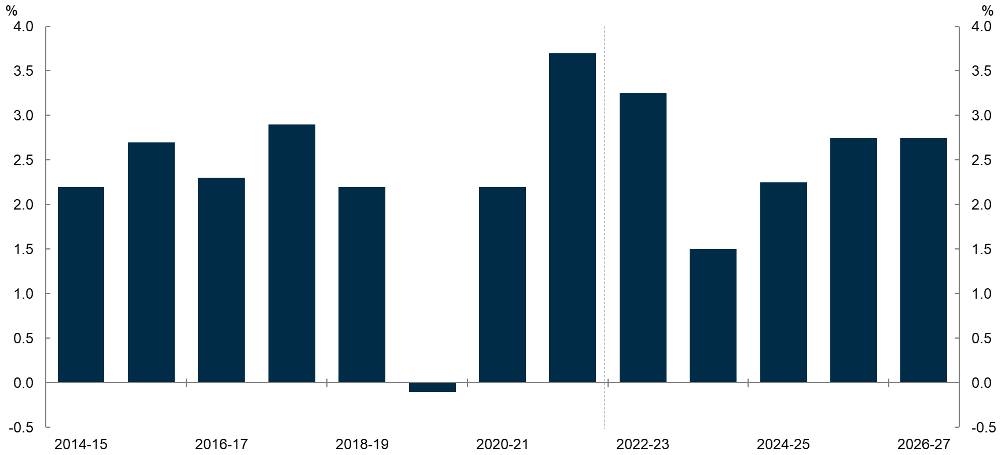

Source: ABS National Accounts; Income Expenditure and Product, Treasury.

Strong growth in migration will support the economy in the near term. The recovery in tourism and international education will offset some weakness in domestic demand.

This strength in migration and population growth is expected to be temporary, with migration forecast to largely return to normal patterns from 2024–25.

Employment growth is expected to moderate as the economy slows. The unemployment rate is expected to rise but remain low by historical standards (Chart 6).

Chart 6: Unemployment rate forecasts



Source: ABS Labour Force and Treasury.

Inflation has peaked and begun to moderate. While still uncomfortably high, Australian inflation outcomes have been less severe than in Europe, the UK and US (Chart 7).

**Chart 7: International inflation**

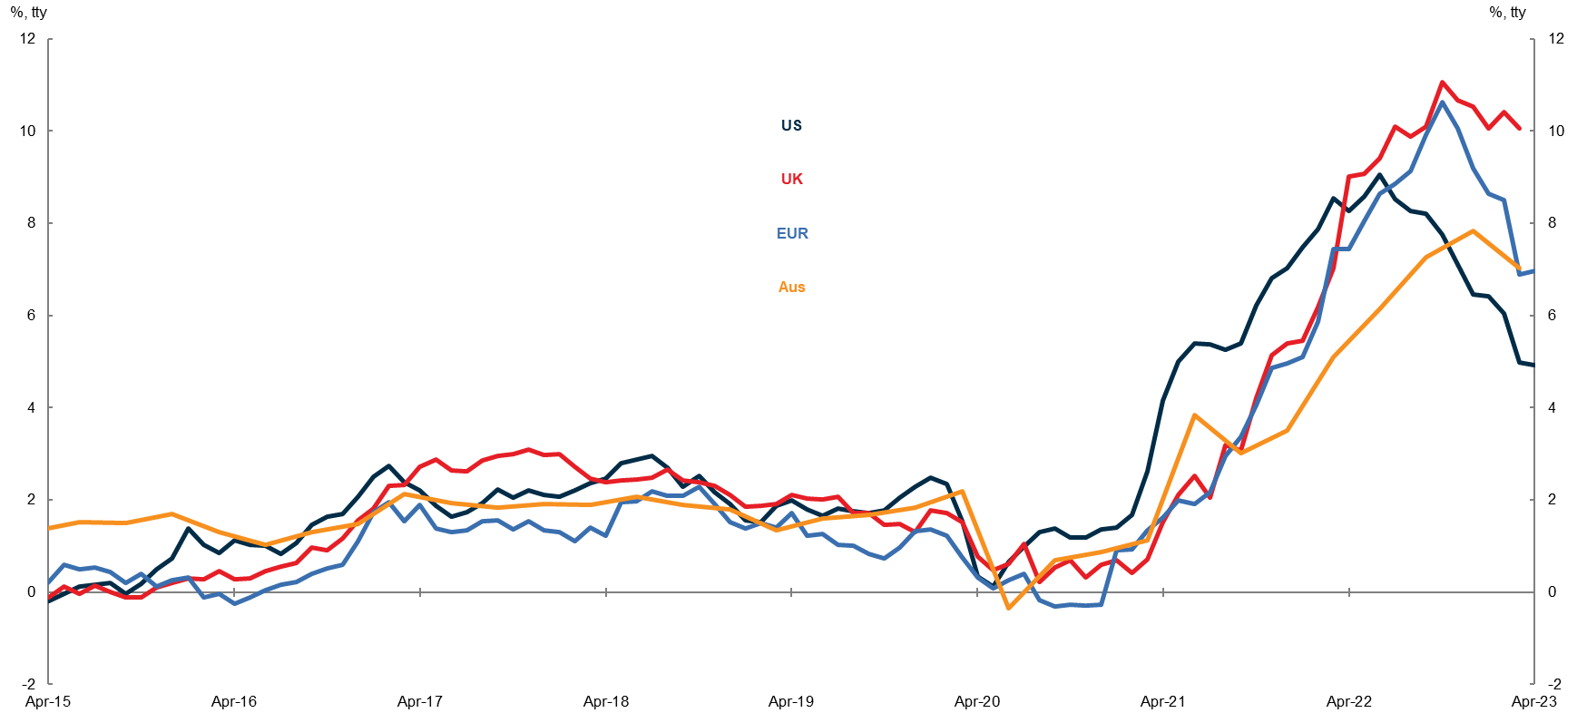

Source: Refintiv, national statistical agencies.

Domestic inflation peaked at 7.8 per cent in the December quarter of 2022, and fell to 7.0 per cent in the most recent quarter. We expect to return to the central bank’s inflation target in 2024-25 (Chart 8).

**Chart 8: Domestic Inflation**

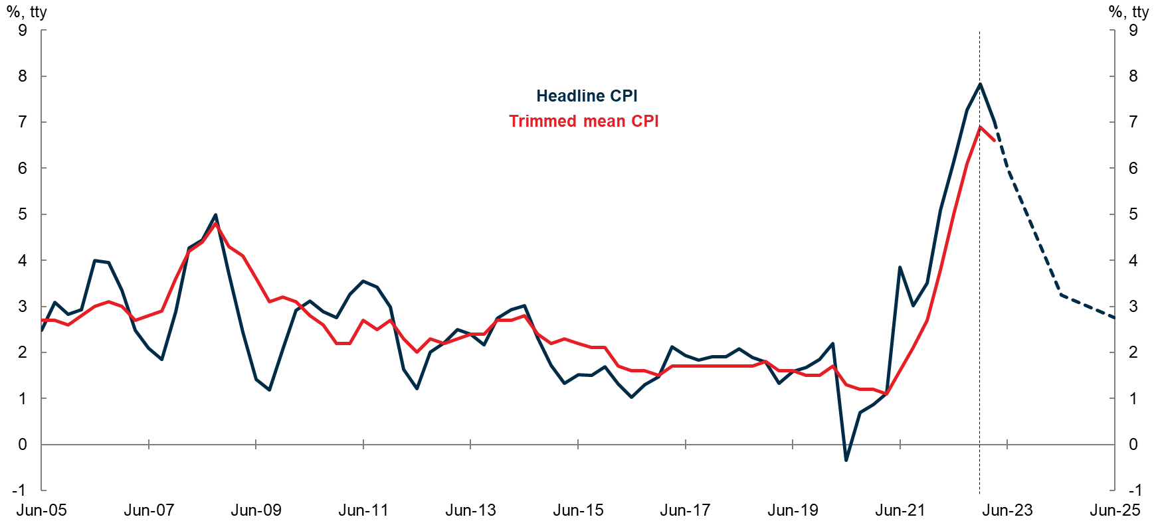

Source: ABS Consumer Price Index and Treasury.

A tight labour market has seen wage growth pick up over recent quarters and is expected to build further.

Economic growth is expected to strengthen in 2024–25 as inflation returns to target and positive real wage growth continues. The continued recovery in population growth and an associated increase in investment in new housing will reinforce the expected rebound.

# Australia’s fiscal position is strong

## Strong fiscal foundations

Australia has a comparatively low debt-to-GDP ratio internationally (Chart 9).

**Chart 9: Gross debt-to-GDP in advanced economies**



Source: IMF, World Economic Outlook Database, April 2023.

Notes: Range of Advanced Economies reflects IMF classification. Data are prepared by the IMF and include total government debt (inclusive of state and local debt), slightly different assets and liabilities, and are prepared on a calendar year basis. They are not comparable to debt metrics published in Commonwealth budgets.

This reflects the fiscal discipline of successive Australian governments over the past century (Chart 10). This has helped maintain the necessary fiscal space to respond to, and weather, economic shocks. As a result, Australia is one of only nine countries with a triple‑A credit rating from all three major credit rating agencies.

**Chart 10: Australian Government gross debt-to-GDP**



Source: ABS, AOFM, Butlin (1985), Federal Budget Papers, PBO and Treasury.

Notes: Gross debt is presented in face value terms. Commencement of debt accumulations noted in light blue. Shaded areas indicate debt reduction period. Data is in in financial years. Historical debt figures abstract from debt issued by the Commonwealth on behalf of the states and territories, and as such, differ from those reported in Commonwealth budgets.

## Fiscal Outlook

## Near-term strength

Australia’s near-term fiscal outlook is strong, despite the economic challenges.

Strong population and employment growth and elevated commodity prices have led to a fast recovery in revenues post pandemic.

As a result, we forecast a budget surplus this year, the first since before the Global Financial Crisis, ahead of most major advanced economies.

As labour market conditions ease and commodity prices return to long-run levels, the underlying cash balance is expected to return to a deficit of 0.5 per cent of GDP in 2023-24 and increase to 1.3 per cent of GDP by 2024-25, before beginning to improve (Chart 11).

**Chart 11: Budget balances**

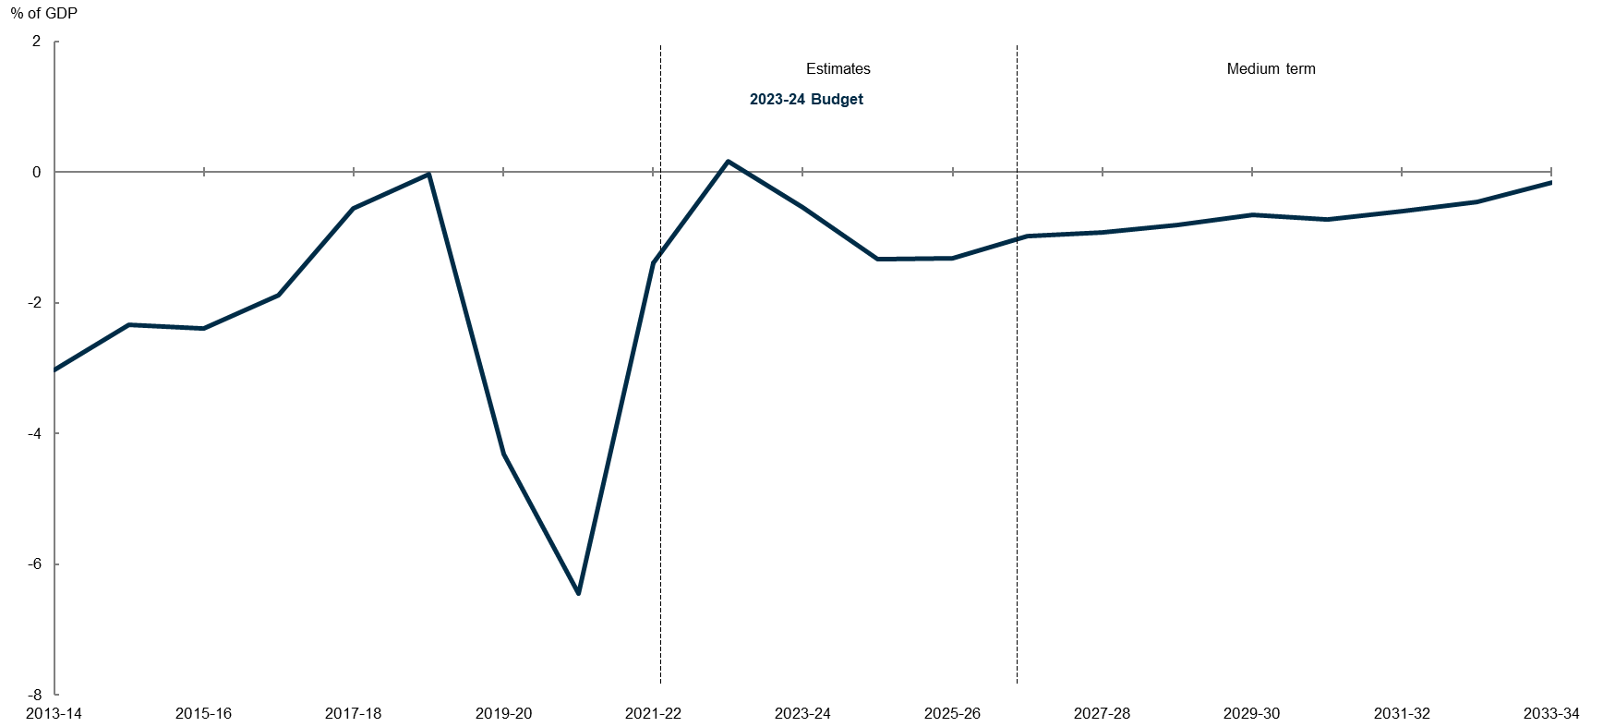

Source: Treasury.

Gross debt-to-GDP is expected to fall from the pandemic peak of 39.3 per cent of GDP in 2020‑21 to 34.9 per cent of GDP in 2022-23 (Chart 12).

Similarly, net debt is projected to fall from the pandemic peak of 28.5 per cent of GDP in 2020-21 to 21.6 per cent of GDP by 2022‑23. Gross and net debt are both expected to increase slightly as a share of the economy before reducing again from 2026-27.

**Chart 12: Gross debt**

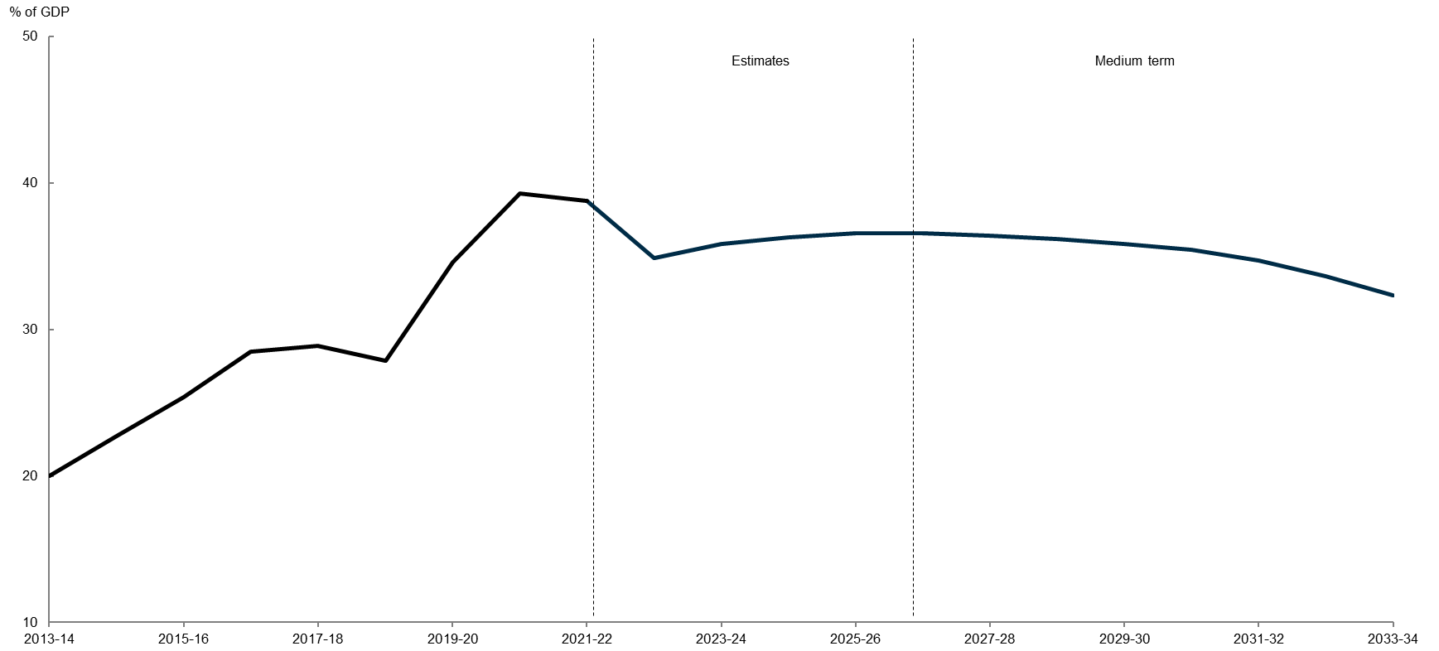

Source: Treasury.

### Managing medium-term pressures

The medium-term fiscal outlook is more challenging, despite our stronger starting point. Australia remains in structural deficit, albeit improving.

Debt as a share of the economy is projected to decline slowly over the medium term but remain above pre-pandemic levels.

The Government is taking steps to reduce the structural deficit over the medium term. The Government’s Budget earlier this month included actions to slow the growth in the National Disability Insurance Scheme, return revenue upgrades to the bottom line and target modest tax increases. This is supporting debt reduction and rebuilding fiscal buffers to manage future economic shocks.

# Australia has strong green credentials

Australia is also a good place for environmentally conscious investors. Our green credentials are well supported by Government commitments to take action on climate change and other environmental priorities.

## Australia’s emissions reduction commitments

Australia has committed to reduce greenhouse gas emissions by 43 per cent below 2005 levels by 2030. This puts us on track to achieve net zero emissions by 2050. Australia’s targets align with our major trading partners and international peers including Japan’s own 2030 target for a 46 per cent reduction on 2013 levels and 2050 net zero target.

The Australian Government is implementing a substantial and rigorous suite of new policies across the economy to drive the transition to net zero.

## Australia’s Sustainable Finance Strategy

The Australian Government is developing an ambitious and coordinated Sustainable Finance Strategy in 2023.

Key elements include:

* developing a green investment taxonomy
* measures to address greenwashing in financial markets; and
* establishing an Australian sovereign green bond program.

Australia will be joining over 40 other countries around the world in issuing green bonds to finance signature climate change and environmental projects and programs (Chart 13).

The first issuance is planned for mid-2024 following the development of a Green Bonds Framework and engagement with potential investors.

Green bonds will offer investors an opportunity to invest in public projects that support Australia’s transition to net zero and protect our environment.

Chart 13: Green bonds share of national debt

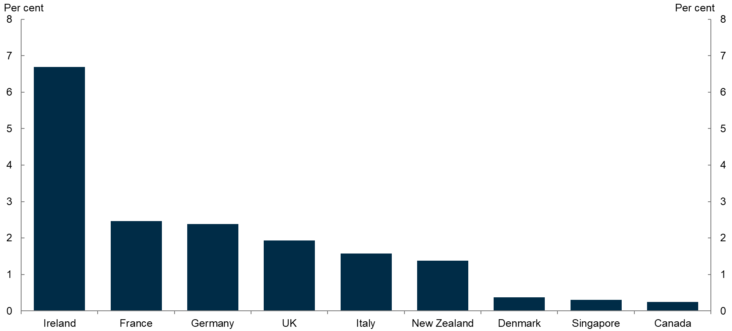

Source: Bloomberg, sovereign green bonds issuance as at 28 April 2023.

The Australian Government is developing and implementing internationally‑aligned requirements for climate-related financial disclosures.

Australia’s largest companies already make voluntary disclosures consistent with the international Taskforce on Climate-related Financial Disclosures requirements.

Implementing mandatory reporting will provide transparency to investors about the green credentials of companies.

## Powering Australia

The Australian Government’s Powering Australia Plan addresses medium to long term changes to transition Australia’s economy and electricity grid to net zero.

Australia’s latest emissions reductions projections show that Australia is on track for a 40 per cent reduction on 2005 levels by 2030 after incorporating key elements of the Plan (Chart 14).

|  |
| --- |
| Chart 14: Impact of current policies on Australia’s 2030 emissions target |
| Source: Australia’s emissions projections 2022 |

Powering Australia policies include:

* Rewiring the Nation, which provides 1.8 trillion Yen (A$20 billion) in concessional loans and equity for investment in transmission infrastructure projects that will allow for increased renewable energy in Australia’s electricity grids.
* The Powering the Regions Fund, which provides more than 117.2 billion Yen (A$1.3 billion) to support the decarbonisation of existing industries and the development of new clean energy industries.

## Safeguard Mechanism reforms

The Safeguard Mechanism will ensure Australia’s largest emitters reduce their emissions and contribute their share of Australia’s national abatement task. There are around 215 facilities covered by the Safeguard Mechanism (28 per cent of Australia’s emissions).

Reforms to the Safeguard Mechanism commencing on 1 July 2023 will predictably and gradually lower emissions ceilings of Safeguard facilities over time in line with Australia’s 2030 target and put these facilities on track to net zero by 2050.

## Energy transition: partnering on clean energy projects

The Australian Government has set an ambition to achieve an 82 per cent renewable electricity-based grid by 2030. Australia is well placed for renewable energy generation. We have abundant solar and wind resources, including the world’s second highest potential for solar power.

Australia is supporting global decarbonisation efforts by exporting gas as a flexible fuel to support renewable energy, supplying critical minerals needed for clean energy technologies, and developing new technologies like hydrogen. We are a complementary partner to Japan’s decarbonisation strategy.

Remaining a reliable and secure partner is critical in securing the investment we need for our domestic energy transition and to support other economies to decarbonise.

## Australia’s gas policies

The Australian Government’s strong commitments to climate action were designed in a way that would not affect the Government’s role as a reliable and committed energy partner.

The Government immensely values its trade relationships, particularly our relationship with Japan, and intends to maintain and build on these relationships through the transition to net zero.

We acknowledge the critical role of gas in the energy transition and Australia’s role as a reliable supplier of this resource for decades to come. Australia remains committed to being a reliable and secure energy and trade investment partner, including future opportunities presented by new, clean energy industries. The Government also welcomes initiatives to decarbonise gas, including supporting development of hydrogen industries and carbon capture and storage.

# Conclusion

In conclusion, the Australia-Japan relationship has a long history and a bright future.

Australia is a good partner and investment destination for Japanese investors with our strong economic, fiscal and green credentials.

I look forward to a continuing, strong relationship between Australia and Japan in the decades to come.

Thank you.

1. * I would like to express my appreciation to Oliver Richards, Emma Baudinette, Patrick D'Arcy, Matt Maloney and Elise Whalan for their assistance in preparing this address.
2. Herbert Smith Freehills, ‘Japan-Australia Investment Report 2022: Decarbonisation and Energy Security’, (2023), 6th Edition, March.
3. Australia’s Mining Monthly, [*https://www.miningmonthly.com/logistics/news/1423618/japan-takes-2-billionth-tonne-of-rio-iron-ore*](https://www.miningmonthly.com/logistics/news/1423618/japan-takes-2-billionth-tonne-of-rio-iron-ore), (2021), accessed 30 April 2023
4. International Monetary Fund, ‘World Economic Outlook Database, April 2023, *International Monetary Fund* (2023), U.S. Dollars, <https://www.imf.org/en/Publications/WEO/weo-database/2023/April>, accessed 26 April 2023.
5. Credit Suisse Research Institute, *Global Wealth Report 2022* (2022), 5.
6. Fitch Ratings, ‘Fitch Affirms Australia at 'AAA'; Outlook Stable’, *Fitch Ratings* (2 Dec. 2022), https://www.fitchratings.com/research/sovereigns/fitch-affirms-australia-at-aaa-outlook-stable-02-12-2022#:~:text=Fitch%20Ratings%20%2D%20Hong%20Kong%20%2D%2002,of%20this%20rating%20action%20commentary, accessed 26 April 2023.
7. Organisation for Economic Co-operation and Development, ‘Tax revenue’, *OECD Data* (2023), https://data.oecd.org/tax/tax-revenue.htm, accessed 26 April 2023.
8. IMD World Competitiveness Center, ‘IMD World Competitiveness Yearbook’, *Institute for Management Development* (2022)