# EXPOSURE DRAFT EXPLANATORY STATEMENT

## Issued by authority of the Assistant Treasurer and Minister for Financial Services

*Income Tax Assessment Act 1997*

*Treasury Laws Amendment Instrument 2024: Better Targeted Superannuation Concessions*

Section 909‑1 of the *Income Tax Assessment Act 1997* (ITAA 1997) provides that the Governor‑General may make regulations prescribing matters required or permitted by the Act to be prescribed, or necessary or convenient to be prescribed for carrying out or giving effect to the Act.

The Treasury Laws Amendment (Better Targeted Superannuation Concessions and Other Measures) Bill 2023 (the Amending Bill), together with the Superannuation (Better Targeted Superannuation Concessions) Imposition Bill 2023, were introduced into Parliament on 30 November 2023. These Bills, if enacted, will reduce the tax concessions available to individuals with a total superannuation balance exceeding $3 million.

The Amending Bill inserts a new Division 296 into the ITAA 1997, setting out rules for how the new Division 296 tax is to be calculated. The Amending Bill also amends rules for calculating an individual’s total superannuation balance (**TSB**) and introduces the concept of a TSB value for each of their superannuation interests.

The Amending Bill provides that regulations may be made under several provisionsin relation to the Division 296 tax:

* For working out your adjusted total superannuation balance for a year, the regulations may prescribe amounts to be included or excluded for the purpose of determining ‘your withdrawals total’ (paragraphs 296-50(1)(h) and 296-50(4)(b));
* For working out your adjusted total superannuation balance for a year, the regulations may prescribe amounts to be included or excluded for the purpose of determining ‘your contributions total’ (paragraphs 296-55(1)(j), and 296-55(6));
* Subsection 296-60(1) provides that the regulations may modify the operation of sections 296-50 and 296-55 and sets out a non-exhaustive list of how those provisions may be modified;
* Subsection 296-310 provides for the regulations to declare individuals who hold an excluded interest in a constitutionally protected fund;
* Paragraph 307-230(3) and (4) enable regulations to be made setting out circumstances where a non-member spouse is to be treated as having a superannuation interest where the member spouse’s interest is the subject of a family law payment split; and
* Paragraph 307-230A(1)(a) provides for the regulations to specify a value or method for determining the TSB value of a superannuation interest.

The purpose of the *Treasury Laws Amendment Instrument 2024: Better Targeted Superannuation Concessions* (the Regulations) is to amend the *Income Tax Assessment (1997 Act) Regulations 2021* (the Principal Regulations) to prescribe certain values, calculations, and methods so that all applicable superannuation interests are properly assessed for the purposes of the Division 296 tax. In particular, the Regulations provide rules to enable commensurate treatment to be applied to defined benefit superannuation interests.

Division 296 tax applies to individuals with total superannuation balances greater than $3 million at the end of an income year for certain superannuation interests that are captured by the Amending Bill. From the 2025-26 income year onwards, individuals with total superannuation balances exceeding $3 million will be liable to pay tax on the percentage of their superannuation earnings that correspond to the portion of their TSB that is above $3 million.

Schedule 1 of the Regulations contains modifications to ensure that defined benefits contributions, which are a notional amount, are counted towards a persons’ adjusted TSB for the purpose of Division 296. For accruing members, the actual employer contributions (if any) are disregarded to ensure that there is no double counting of amounts that represent employer contributions.

Schedule 2 of the Regulations prescribes rules for valuing defined benefit interests and certain other retirement phase interests. These modified rules are necessary where the withdrawal benefit value (set out in the Amending Bill) is inappropriate to value the interest: the withdrawal benefit value may be nil or may not fully reflect all potential benefits (or in some cases, overstate them). If these values were used in the formula contained in section 296-35 of the Amending Bill, they would understate or overstate earnings for some individuals which would allow some individuals to avoid any tax being imposed.

Schedule 3 makes adjustments to TSB values for defined benefit interests subject to a family law payment split, where that interest is not able to be split between the member spouse and non‑member spouse at the time of the order or agreement.

Schedule 4 of the Regulations updates some of the method assumptions in Schedules 1A and 1AA of the Principal Regulations, which are used to value notional taxed contributions and defined benefit contributions. The Regulations extend the grandfathering provisions (regulation 291-170.07) for pre-2009 notional taxed contributions so that where the new entrant rate for the defined benefit member has increased only because of the updating of the rates tables, the resultant contributions are still capped at the general concessional cap level.

Schedule 4 also lists certain State higher level office holders whose earnings from interests in a constitutionally protected fund are not subject to the new Division 296 tax.

Schedule 1 to the Regulations commence on the later of the day after this instrument is registered, and the day after Schedule 1 to the Amending Bill (if enacted) commences. Schedule 2 to the Regulations commence on the later of immediately after the commencement of Schedule 4 to the Regulations, and the time Schedule 2 to the Amending Bill commences. Schedule 3, Part 1 to the Regulations commence immediately after schedule 1, and schedule 3, Part 2 commence immediately after the provisions in schedule 2. Schedule 4 to the Regulations commence the day after this instrument is registered and is not contingent on commencement of the Amending Bill.

The ITAA 1997 does not specify any conditions that need to be satisfied before the power to make the Regulations may be exercised.

The Regulations are a legislative instrument for the purposes of the *Legislation Act 2003*.

The Regulations are subject to disallowance under section 42 of the *Legislation Act 2003*.

The Regulations are subject to sunsetting under section 50 of the *Legislation Act 2003*.

Details of the Regulations are set out in Attachment A.

**ATTACHMENT A**

**Details of the *Treasury Laws Amendment Instrument 2024: Better Targeted Superannuation Concessions***

Section 1 – Name

This section provides that the name of the regulations is the *Treasury Laws Amendment Instrument 2024: Better Targeted Superannuation Concessions* (the Regulations).

Section 2 – Commencement

Schedule 1 to the Regulations commences on the later of the day after the instrument is registered on the Federal Register of Legislation and the day Schedule 1 to the Treasury Laws Amendment (Better Targeted Superannuation Concessions and Other Measures) Bill 2023 (the Amending Bill) (if enacted) commences.

Schedule 2 to the Regulations commences on the later of immediately after the commencement of the provisions covered by table item 4, being Schedule 4 to the Regulations, and the time Schedule 2 to the Amending Bill (if enacted) commences.

Part 1 of Schedule 3 to the Regulations commences immediately after Schedule 1, and Part 2 of Schedule 3 commences immediately after the provisions in Schedule 2.

Schedule 4 to the Regulations commences on the day after this instrument is registered and is not contingent on commencement of the Amending Bill.

Section 3 – Authority

The Regulations are made under the *Income Tax Assessment Act 1997* (ITAA 1997).

Section 4 – Schedules

This section provides that each instrument that is specified in the Schedules to this instrument are amended or repealed as set out in the applicable items in the Schedules, and any other item in the Schedules to this instrument has effect according to its terms.

**Schedule 1 – Better targeted superannuation concessions**

Items 1 and 2 – Division 296 – Better targeted superannuation concessions

**Item 1** inserts Division 296 and Subdivisions 296-B and 296-E into the *Income Tax Assessment (1997 Act) Regulations 2021* (the Principal Regulations).

Section 296-55.01 specifies that for the purposes of paragraph 296-55(1)(j) of the ITAA 1997, your contributions total includes the sum of the amounts of your defined benefit contributions. Defined benefit contributions is an existing concept in Subdivision 293-D of the Principal Regulations. The effect of this is that defined benefit contributions will be included when determining the contributions total of an individual under section 296-55 of the ITAA 1997.

Subsection 296-55.01(2) ensures that certain provisions in Division 293 of the Act that would result in a ‘nil’ contribution for certain Judges Pension Scheme and State higher level office holders’ interests, are turned off for the purposes of the earnings calculation for Division 296 tax, ensuring the earnings are appropriately calculated.

Section 296-60.01 prescribes a modification for the purposes of subsection 296-60(1) of the ITAA 1997. The effect of this modification is that the amount of a contribution made to a superannuation fund for an individual in respect of a defined benefit interest that they have in the fund during an income year is to be disregarded when determining the individual’s contributions total, if they are an accruing member of the fund for the financial year corresponding to the income year. This modification is necessary to ensure consistent treatment of all defined benefit interests, with the Schedule 1AA methodology to be used, rather than any actual contributions. This will ensure there is no double counting of contributions for defined benefit interests.

However, this modification does not apply to the extent that the amount of the contribution is included in the member contributions amount for the financial year within the meaning of clause 1.7 of Schedule 1A; or, within the meaning of member contributions amount of subclause 4(3) of Schedule 1AA if section 293.115.20 applies, which applies if you are an accruing member of a superannuation fund for the financial year and your defined benefit interest in the fund for a financial year is not a funded benefit interest. These member contributions are subtracted from the defined benefit contributions calculation, and as such are not double-counted.

Item 1 also inserts section 296‑310.01 into new Subdivision 296-E. It provides that a State higher level office holder (as defined in section 995-01.01), is declared for the purpose of table item 1 in section 296-310 of the ITAA 1997. The declaration also covers former State higher level office holders. This means that an interest in a constitutionally protected fund held by a declared State higher level office holder is a Division 296 excluded interest, and will not be subject to tax on earnings attributable to that interest.

**Item 2** amends the definition of ***accruing member*** so that,for the purposes of subsection 296-60.01(2), it means a defined benefit member of the fund who is not a non-accruing member of the fund for the financial year.

**Schedule 2 – Definition of total superannuation balance**

Part 1, items 1 to 3 – Consequential amendments relating to the Amending Bill

**Items 1, 2 and 3** make consequential amendments to the Principal Regulations to ensure the Regulations correctly reference the ITAA 1997 as amended by the Amending Bill. The meaning of the paragraph in the ITAA 1997 and in the sections and subsections in the Principal Regulations are otherwise unchanged.

Part 2, items 4 and 8 – Total superannuation balance values

**Item 4** inserts sections 307-230A.01, 307-230A.02, 307-230A.03, 307-230A.04, 307‑230A.05, 307-230A.06, 307-230A.07 and 307-230A.08 to the end of Subdivision 307‑D in the Principal Regulations. These sections prescribe various methods for valuing certain types of superannuation interests for the purposes of determining an individual’s TSB under paragraph 307-230A(1)(a) of the ITAA 1997.

These valuation methods are used to value interests where the default method in Division 296 of the Amending Bill is not appropriate. The valuation methods fall into two broad categories:

* Defined benefit interests that are not in the retirement phase – commonly referred to as the ‘growth phase’. The value of these interests is generally not reflected by an identifiable ‘account’ comprising contributions and investment returns, with an individual’s entitlement instead being calculated based on a series of factors (for example, by multiplying their salary by an often service-based factor); and
* Interests supporting retirement phase income streams that do not have an account balance or identifiable lump sum amount. These are sometimes referred to as ‘defined benefit pensions’.

*Defined benefit interests that are not in the retirement phase*

The following diagram illustrates how ‘growth phase’ defined benefit interests are valued under these provisions:

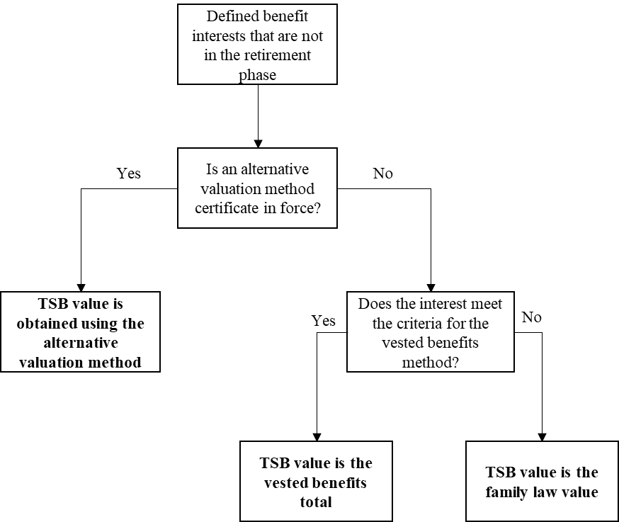

Section 307-230A.01 prescribes the method to be used for determining the value of a defined benefit interest if that interest is not in the retirement phase, has a family law value, and is not a non-public sector lump sum only interest mentioned in subsection (4). The method that is prescribed is the family law method (explained below), unless an alternative valuation method applies for the interest, in which case it is that alternative valuation method. The family law method reflects an approach considered by the Government to be an appropriate benchmark for TSB valuation, not only for the purposes of Division 296 tax, but more generally in the superannuation system. This method is already used to provide a suitable ‘point in time’ value for a defined benefit interest when that interest is subject to family law proceedings.

For non-public sector lump sum-only interests that are not in the retirement phase and fulfil certain other criteria, subsection 307-230A.01(4) provides that the method that applies is the vested benefit method, unless an alternative valuation method applies for the interest, in which case it is that alternative valuation method. The vested benefit method reflects a cost-effective approach for certain lower value interests where, due to the nature of benefits provided under these schemes, the method will generally not result in an undervaluation when compared to a family law value.

*Retirement phase interests*

The following diagram illustrates how interests supporting retirement phase income streams are valued under these provisions:

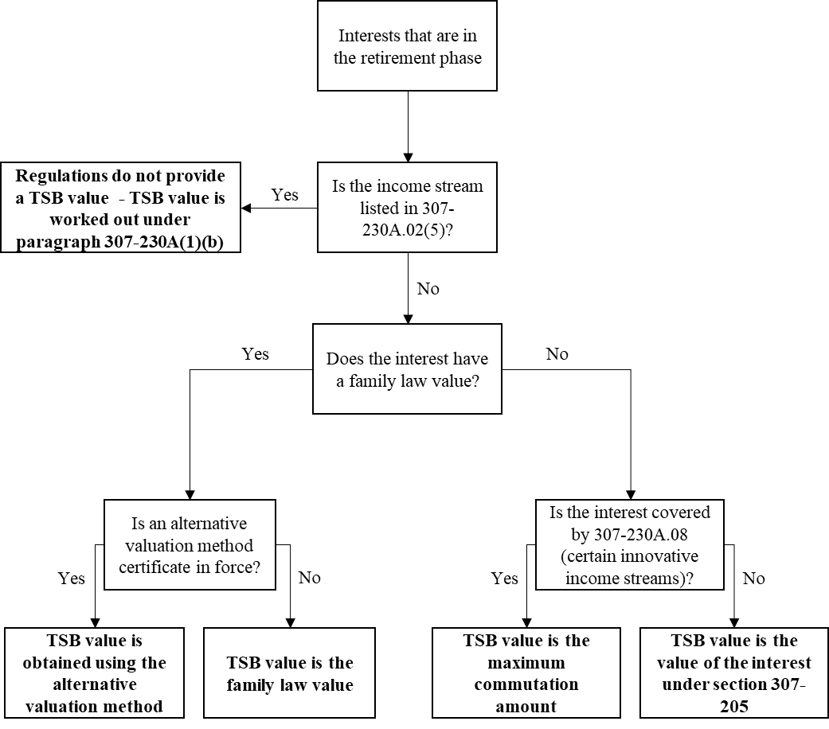

Sections 307-230A.02 prescribes the method to be used for determining the value of an interest in the retirement phase. If the interest is in the retirement phase and has a family law value, subsections 307-230A.02(1) and (2) provide that the prescribed method is the family law method, unless an alternative valuation method applies for the interest, in which case it is that alternative valuation method.

Subsections 307-230A.02(3) and (4) deal with superannuation interests in the retirement phase that do not have a family law value. If the interest supports a superannuation income stream to which subsection 307-230A.08 applies, the valuation method is the maximum commutation amount. For all other superannuation interests in the retirement phase that do not have a family law value, the valuation method is the value of the superannuation interest, within the meaning of section 307-205 of the ITAA 1997. This approach reflects existing methods used to value such interests for other superannuation purposes and is an appropriate option where they do not have an applicable family law method.

The valuation methods set out in section 307-230A.02 do not apply to certain allocated, account-based, and market-linked pensions and annuities that are set out in subsection 307-230A.02(5). For those interests, the valuation method is the withdrawal benefit, which is the default method in the Amending Bill. These income streams all have identifiable account balances that provide a suitable value for the interest using the withdrawal benefit method.

*Family law methods*

Subsection 307-230A.03 sets out how the family law values are to apply when used for the purpose of Division 296 of the ITAA 1997.

The family law method is based on the method in the *Family Law (Superannuation) Regulations 2001* (Family Law Regulations), which contain default valuation factors and methods of calculation to be used for the valuation of superannuation interests, including defined benefit interests, for the purpose of dividing superannuation in a family law separation process. The methods and factors are designed to provide a best estimate of the value of these superannuation interests at a given point in time.

The Family Law Regulations also provide the Attorney-General with the power to approve, by legislative instrument, valuation methods and factors that apply to a specific scheme or interest. Generally, this occurs if the default valuation methods or factors are considered inappropriate considering the benefit design or underlying experience of a particular scheme. Under these provisions, if a scheme or interest has methods or factors approved in such an instrument, the family law method will be based on those methods or factors.

The current default valuation methods and factors in the Family Law Regulations were produced in 2001. The Family Law Regulations are due to sunset on 1 April 2025 and will be remade. As part of this process, the Attorney-General’s Department is reviewing the Family Law Regulations to ensure they are fit for purpose. This includes reviewing the default valuation methods and factors to ensure they can continue to provide an accurate and reasonable estimate of the value of a superannuation interest.

*Certificates – alternative valuation method*

Sections 307-230A.04, 307-230A.05 and 307-230A.06 deal with the alternative valuation method. An alternative valuation method can be used for certain interests instead of the family law method. To use an alternative valuation method, there must be a family law value for the interest, and a certificate under section 307-230A.05 must be in force.

This approach reflects a recognition from the Government that a superannuation actuary may have an existing valuation method that could be used instead of the family law method that would result in a very similar value to the benchmark family law method for a particular benefit category or whole scheme. This is intended to reduce the regulatory burden of additional costs associated with moving to the family law method, where an alternative valuation method would achieve an appropriate value.

Section 307-230A.05 provides for a superannuation actuary to issue an alternative valuation certificate if certain criteria are met. A superannuation actuary may issue a certificate if the actuary is requested to do so by the trustee of the fund. The certificate may set out an alternative method for valuing the interests in the fund. To issue a certificate, the actuary must be of the opinion that if the alternative valuation method is used, the value determined for each interest would be no less than 90 per cent, and no more than 110 per cent, of the value that would be determined if it was the family law valuation method that was used for those interests.

To be valid, the certificate must be in writing and state:

* the name of the fund,
* the name of the actuary, and
* that, in the actuary’s opinion, the specified alternative valuation method meets the criteria.

The certificate comes into force at the time specified in the certificate, and ceases to be in force either:

* at the end of three years from when it came into force;
* when it is withdrawn under section 307-230A.06; or
* when another certificate comes into force that meets the requirements of a certificate and is issued in relation to the same interests as the initial certificate.

However, the certificate is not in force at a time before it is issued if the trustee of the fund has given the Commissioner of Taxation a member information statement under subsection 390-5(1) of Schedule 1 to the *Taxation Administration Act 1953*, and the statement contains the TSB value of any of the specified interests at that time. This limitation ensures that a certificate cannot apply retrospectively when a statement has already been provided to the Commissioner – that is, if the trustee has already reported TSB values for the interests for a time prior to the certificate’s issue, those values cannot be rendered incorrect by the certificate.

Section 307-230A.06 provides that a certificate may be withdrawn, either by a superannuation actuary, or by a trustee of a defined benefit fund in relation to which the certificate was issued. An actuary is required to withdraw a certificate if the actuary forms the opinion that the alternative valuation method in the certificate does not meet the requirements in subsection 307-230A.05(3). The actuary must make the withdrawal in writing, and it must be given to the trustee of the relevant defined benefit fund. A trustee of a defined benefit fund may withdraw a certificate at any time, and the withdrawal must be in writing.

A certificate that is withdrawn will cease to apply from the time it is withdrawn. However, any TSB values that were determined using the alternative valuation method in the certificate while it was in force prior to its withdrawal are not rendered incorrect by the withdrawal.

**Example 1: Withdrawal of certificate during the three-year period**

The QQQ scheme is a defined benefit scheme. It has a class of 20 members in ‘benefit category A’, whose entitlements are calculated under the same rules.

The QQQ scheme trustee wishes to use its existing ‘scheme value’ method to ascertain TSB values, rather than changing to the family law method. The trustee engages an actuary to provide an alternative valuation method certificate for the purposes of determining TSB values. The actuary certifies that, as at 30 June 2025, for all of the members in benefit category A the value produced by the ‘scheme value’ method would be within 90 and 110 per cent of the family law value.

The certificate is issued to the trustee in September 2025, with a specified date of 30 June 2025. The TSB values for benefit category A members are determined using the ‘scheme value’ method for 30 June 2025 and 30 June 2026.

In August 2026 there is an amendment to the governing rules of the QQQ scheme that materially impacts how entitlements are calculated for benefit category A members. The QQQ scheme trustee engages their actuary to review their certificate. The actuary forms the opinion that the ‘scheme value’ method would no longer produce values within 90 and 110 per cent of family law value and withdraws the certificate on 30 August 2026.

On 30 June 2027 the TSB values for benefit category A members will be determined using the family law method. However, the previous use of the ‘scheme value’ method for 30 June 2025 and 30 June 2026 remains valid.

*Vested benefits total*

Section 307-230A.07 sets out criteria to determine whether a non-public sector lump sum only interest is valued using the vested benefit method, and rules to work out the vested benefits total for these interests. The vested benefits method is used for those interests if there is no alternative valuation method certificate in force.

The section applies to an interest in a superannuation fund at a particular time if:

* under the fund rules, the interest can never support a superannuation income stream;
* the fund is not a public superannuation income stream, and;
* 12 months before valuation:
  + the vested benefits total in relation to the interest was $1 million or less, and it met these same criteria (and accordingly was valued under the vested benefits method), or
  + the interests did not exist.

These criteria mean that non-public sector lump sum only interests under the threshold value of $1 million are valued using the vested benefits method. If an interest’s value exceeds the $1 million threshold on 30 June of a year, it will still use the vested benefits method for that valuation, however from the following 30 June onwards the interest will be valued using the family law method.

**Example 2: non-public sector lump sum only interest surpassing the $1 million threshold**

Matilda is a member of the XYZ scheme, a defined benefit scheme that pays a single lump sum when a member retires. The scheme is not a public sector superannuation scheme.

On 30 June 2026, the TSB value of Matilda’s interest was calculated using the vested benefit method, with a TSB value of $980,000.

On 30 June 2027, the vested benefit method is again used to determine the TSB value of Matilda’s interest, as on 30 June 2026:

* the interest met the criteria in section 307-230A.07(1) to be valued using the vested benefits method; and
* the vested benefits total was less than $1 million.

Using the vested benefits method, the TSB value on 30 June 2027 is $1,010,000.

On 30 June 2028, the family law method must be used to determine the TSB value of Matilda’s interest, as the vested benefits total was greater than $1 million on 30 June 2026. Using the family law method, the TSB value is $950,000.

On 30 June 2029, the family law method must still be used to determine the TSB value of Matilda’s interest, irrespective of whether the vested benefits total was above or below $1 million. This is because the interest did not satisfy all of the criteria in subsection 307‑230A.07(1) on 30 June 2028.

The vested benefits total for an interest covered by this section is the total value of the superannuation benefits to which an individual would be entitled if the individual had the right to and voluntarily caused the superannuation interest to cease or became entitled to a pension (noting the interests in question do not carry pension entitlements) or deferred benefit from the scheme.

A deferred benefit is a right or interest that was part of a defined benefit interest which became deferred after the individual holding the right or interest ceased contributing to the defined benefit scheme. The deferred benefit remains deferred until the individual becomes eligible to receive the benefit. The value of a deferred benefit is included for the purpose of determining the vested benefits total for an individual.

To determine the value of a non-public sector lump sum only interest at a particular time, total vested benefits at the time is to be worked out in accordance with accounting standards in force at the time.

Item 8 (discussed below) sets out transitional arrangements relevant to valuations under section 307‑230A.07 to work out whether the criteria are met for the first year the provisions apply following their commencement.

*Maximum commutation amount*

Section 307-230A.08 provides the valuation method for certain superannuation income streams that do not have family law values and do not have any suitable valuation method available in the existing Principal Regulations. This section covers a superannuation interest that at a particular time supports one or more superannuation income streams that are:

* provided under a contract or rules that meet the standards of subregulation 1.06A(2) of the *Superannuation Industry (Supervision) Regulations 1994* (SIS Regulations); and
* are not covered by sections 307-205.02C, D or E of the Principal Regulations.

Subregulation 1.06A(2) of the SIS Regulations provides standards for certain innovative superannuation income streams. This section applies to a subset of those income streams that do not have an appropriate valuation method already prescribed by the Principal Regulations. Namely, it applies to income streams that are not deferred superannuation income streams (which have a method provided in section 307-205.02C) and are also not pooled investment pensions or annuities (which have methods provided in sections 307‑205.02D and 307-205.02E respectively).

The valuation method for the interests covered by section 307-230A.08 is the maximum commutation amount, which is the total at the time of the amounts worked out under paragraph 1.06B(1)(c) of the SIS Regulations for each of those superannuation income streams.

**Item 8** inserts a transitional provision into Chapter 7 of the Principal Regulations. The conditions are altered for the purposes of working out whether section 307-230A.07 applies to a superannuation interest at a particular time if that time occurs before 30 June 2026. In that case, the requirement that the conditions applied 12 months before valuation is to be disregarded, and the reference to vested benefits total of the interest should be treated as being a reference to the value of the superannuation interest.

Given the criteria in section 307-230A.07 require the consideration of circumstances from 12 months prior, this alteration ensures that the provision still operates correctly for determining TSB values on 30 June 2025, which is the first time TSB values will need to be obtained for the purposes of the Amending Bill.

Items 5 to 7 – Definitions

**Items 5 and 6** amend the existing definitions of ***benefit category*** and ***defined benefit fund*** in section 995-1.01 of the Principal Regulations so that the existing definitions apply when the term is used in Subdivision 307-D.

**Item 7** adds new definitions to section 995-1.01 of the Regulations.

***alternative valuation method*** means the method specified in the certificate issued under section 307-230A.05. This meaning is given by subsection 307-230A.04(2).

***family law value*** means the value of the interest, determined using the method approved for that interest in the family law regulations. This meaning is given by subsection 307‑230A.03(2).

***maximum commutation amount*** means, in relation to an interest, the total at the time of the amount worked out under paragraph 1.06B(1)(c) of the SIS Regulations for each of those superannuation income streams. This meaning is given by subsection 307‑230A.08(2).

***superannuation actuary*** has the same meaning as in the SIS Act.

***vested benefits total*** means, in relation to an interest, the total value of the benefits to which an individual would become entitled if the individual had the right to, and did voluntarily, cause the superannuation to cease, or became entitled to a pension or deferred superannuation benefit. This meaning is given by subsection 307-230A.07(2).

**Schedule 3 – Family law splits**

Under the *Family Law Act 1975*, a superannuation interest may be split between spouses via a court order or via an agreement between the parties (see sections 90 XT or 90XJ of the *Family Law Act 1975*). The Amending Bill includes provisions to deal with such family law payment splits. Those provisions include amounts in the contributions total and/or withdrawals total for adjusted TSB values to reflect the share each spouse receives when a superannuation interest is actually split between a member spouse and a non‑member spouse. This reflects that, where the interest is actually split, both the member spouse and non-member spouse will be left with superannuation interests that have their own TSB values.

However, some defined benefit interests are unable to be split between a member spouse and non-member spouse at the time the splitting order or agreement is made. Where the full (unsplit) amount of the defined benefit interest must be kept in the name of member spouse until retirement (and possibly beyond, depending on the rules of the specific defined benefit scheme), further modifications are needed to both spouses’ TSBs to reflect the notional split between the two spouses.

The amendments in Schedule 3 make modifications to TSB values, withdrawals, and contributions to reflect notional splits between the member spouse and non‑member spouse, and to ensure superannuation earnings are calculated appropriately for the purposes of Division 296 in the years an interest is notionally split.

Part 1, items 1 to 3 – Adjustments to withdrawals and contributions

*Initial adjustments following a splitting order or agreement*

In the first year that notional splits are applied to the defined benefit interest, a one-off adjustment to withdrawals and contributions is needed to neutralise the impact of the notional splits on each spouse’s earnings for the year.

**Item 1** inserts new section 296-50.01, which includes an amount in the withdrawals total for the member spouse in the first year that notional splits are applied to the defined benefit interest. This ensures that the member spouse’s adjusted TSB (under section 296-45 of the Amending Bill) does not experience a decrease compared to the previous year due to the notional split (which would otherwise result in reduced earnings for the year and hence lower Division 296 tax).

**Item 2** inserts new section 296-55.02, which includes an amount in the contributions total for the non‑member spouse in the first year that notional splits are applied to the defined benefit interest. This ensures that the non-member spouse’s TSB does not experience an increase compared to the previous year due to the notional split (which would otherwise result in higher earnings for the year and hence higher Division 296 tax).

The amount of the withdrawal for the member spouse matches the amount of the contribution for the non-member spouse. This amount is the non-member spouse’s TSB value at the time of the splitting order or agreement (calculated in accordance with section 307-230A.09 as described below).

*Final adjustments in the payment phase*

Once the defined benefit interest reaches the payment phase, the actual amounts received by the member and non-member spouse need to be treated as withdrawals (under section 296‑50 of the Amending Bill) for the purposes of calculating their respective adjusted TSBs (under section 296‑40 of the Amending Bill). Schedule 3 amends withdrawals under section 296‑50 of the Amending Bill to ensure that the portion of the payment made to the non‑member spouse is included in their withdrawals for the year and excluded from the member spouse’s withdrawals for that year.

For the non-member spouse, this is achieved by subsection 296‑50.02 (**item 1**), which prescribes that the amount of any payment to the non‑member spouse must be included as a withdrawal (under paragraph 296-50(1)(h) of the Amending Bill) for the year in which the payment is made.

For the member spouse, this is achieved by section 296-60.02 (**item 3**), which switches off the withdrawal provision (at paragraph 296-50(1)(c) of the Amending Bill) which would otherwise apply when a payment is made to the non‑member spouse. The amount of the actual payment made to the member spouse would still be treated as a withdrawal under the standard rule in paragraph 296-50(1)(a) of the Amending Bill.

For interests that are paid out entirely via lump sum payment, these adjustments would only be made in the year that the defined benefit interest is paid out. For pensions and annuities, these adjustments would be made each year a payment is made from the defined benefit superannuation interest.

Part 2, items 4 and 5 – Annual modifications to TSB values to reflect notional splits

While the defined benefit interest remains subject to the payment split – that is, while the non‑member spouse’s share remains in the name of the member spouse – the TSB values of both the member and non-member spouse need to be modified each year to reflect the notional splits. This means annual modifications to both parties’ TSB values are required as follows:

* during the growth phase—each year; and
* during the retirement phase, if the defined benefit interest is paid out as a pension—each year, except the final payment year (the member’s ordinary TSB value for this defined benefit interest will be nil in the final payment year);
* during the retirement phase, if the defined benefit interest is paid out as a lump sum—no modifications are needed (the member’s ordinary TSB value for this defined benefit interest will be nil in the payment year).

Subsection 307‑230(3) of the ITAA 1997 (as amended by the Amending Bill) provides that, if a superannuation interest is subject to a payment split, and circumstances prescribed by regulations exist, the non-member spouse is taken to have a superannuation interest in that superannuation plan despite the interest that is subject to the split remaining an interest of the member spouse. **Item 4** inserts section 307‑230.01, which prescribes these circumstances as follows:

* the superannuation interest is a defined benefit interest;
* the interest is subject to a splitting order or agreement (under sections 90 XT or 90XJ of the *Family Law Act 1975*);
* the interest is either in the growth phase or, if it is in the retirement phase, it supports a superannuation income stream via a pension or annuity; and
* the non‑member spouse’s share of that defined benefit interest has not been split from the member spouse’s share, that is:
  + the non‑member spouse’s share has not been transferred or rolled over to the non‑member spouse; and
  + a separate interest has not been created within the defined benefit plan in which the non‑member spouse’s share is held in their own name.

This ensures that the share of the defined benefit interested notionally allocated to the non‑member spouse will be treated as a defined benefit interest for the purposes of calculating their Division 296 tax liability.

**Item 5** sets out the methodology to determine TSB values for interests subject to a family law payment split for the non-member spouse (section 307-230A.09) and for the member spouse (section 307-230A.10).

First, the TSB value of the full defined benefit interest – referred to as the ***unsplit TSB value*** – is calculated using the appropriate valuation method as outlined in Schedule 2 (e.g. family law method). Once the unsplit TSB value has been determined, one of the methods in section 307‑230A.09 would then be used to split that interest between the member and non‑member spouse.

The appropriate method for calculating the non‑member spouse’s share of the defined benefit interest depends on whether the splitting order or agreement specifies a percentage payment split or a base amount payment split.

For **percentage payment splits**,the non-member spouse’s share is calculated as follows:



For example, if a splitting order allocates 40 per cent of the defined benefit interest to the non-member spouse and 60 per cent to the member spouse, then each year 40 per cent of the unsplit TSB value (calculated using the appropriate method, e.g. family law method) would be allocated to the non-member spouse. For percentage payment splits, this same method applies whether the defined benefit interest is in the growth phase or the retirement phase (other than when the unsplit TSB value is nil).

For **base amount payment splits** during the growth phase:

* In the first year, the non‑member spouse’s share is the base amount allocated to them in the splitting order or agreement.
* In subsequent years, the non‑member spouse’s share is the ***adjusted base amount*** calculated in accordance with the SIS Regulations. This reflects an annual increase to the base amount reflecting an interest accrual, as provided by the Family Law Regulations.

For example, if a splitting order prescribed a base amount of $500,000 for a non-member spouse, in the year the splitting order was made the non-member spouse’s TSB value would be $500,000. If, in the subsequent year, the adjusted base amount was $525,000 after adding interest, the non-member spouse’s TSB value would be $525,000.

For **base amount payment splits** during the retirement phase, where the non-member spouse’s share cannot be paid as a lump sum, their share is calculated as follows:



This formula converts the adjusted base amount owing to the non-member spouse at the time the member spouse enters the retirement phase into a percentage of the full unsplit TSB value of the defined benefit interest at that time. This mirrors the existing formula in subsection 54(2) of the *Family Law (Superannuation) Regulations 2001*, whereby the non‑member spouse then receives that percentage out of each pension payment that is made to the member. This ensures the notional split allocated to the non-member spouse reflects the actual proportion of payments they receive from that superannuation interest each year during the retirement phase.

For example, if at the time the member spouse entered the retirement phase:

* the adjusted base amount in relation to the non-member spouse was $500,000; and
* the full unsplit TSB value of the defined benefit interest was $2,000,000,

the non-member spouse would effectively become entitled to 25 per cent of pension payments being paid from that defined benefit interest. If in the subsequent year the unsplit TSB value of the interest grew to $2,200,000, the non-member spouse’s TSB value would be calculated as:

$$\frac{\$2,200,000×\$500,000}{\$2,000,000}=\$550,000$$

Section 307-230A.10 provides that the member spouse’s share of the defined benefit interest is calculated as the residual amount, after the non-member spouse’s share has been subtracted from the unsplit TSB value each year:



Item 6 – Definitions

**Item 6** adds new definitions to section 995-1.01 of the Regulations.

***adjusted base amount*** has the same meaning as in the SIS Regulations.

***base amount payment split*** has the same meaning as in the SIS Regulations***.***

***percentage payment split*** has the same meaning as in the SIS Regulations.

***RSA annuity*** means an annuity (within the meaning of the RSA Act).

***RSA pension*** means a pension (within the meaning of the RSA Act).

***SIS annuity*** means an annuity (within the meaning of the SIS Act).

***SIS pension*** means a pension (within the meaning of the SIS Act).

***splitting order*** has the same meaning as in the SIS Regulations.

***superannuation agreement*** has the same meaning as in the SIS Regulations.

Division 2, items 7 to 16 – Consequential amendments

**Items 7 to 16** make consequential amendments to the Principal Regulations. These changes are to ensure consistent use of terminology when referring to a SIS pension, SIS annuity, RSA pension and RSA annuity, and do not change the operation of those provisions.

**Schedule 4 – Other Amendments**

Part 1 – Valuation parameters

Division 1, items 1 to 13 – Amendments to Schedules 1A and 1AA of the Principal Regulations

Division 1 makes various amendments to Schedule 1A and Schedule 1AA of the Principal Regulations to update values tables that are used to work out a fund members’ amount of notional taxed contributions and defined benefit contributions. The amendments reflect updated guidance from the Australian Government Actuary. The amendments will improve the accuracy of contributions calculations.

The changes in Division 1 will impact the ‘new entrant rate’ that is calculated by an actuary for the purposes of the formulae used in Schedule 1A and Schedule 1AA to determine notional taxed contributions and defined benefit contributions respectively. As such, it is expected that an actuary will be required to recalculate the ‘new entrant rate’ following the commencement of these amendments.

**Items 1 and 7** reduce the rate to be used to discount projected future benefits and salaries from 8 per cent to 6 per cent.

**Items 2 and 8** reduce the assumed fund earning rate from 8 per cent to 6 per cent.

**Items 3 and 9** reduce the salary growth rate in subclause 3.4(1) of Schedule 1A and subclause 13(1) of Schedule 1AA from 4.5 per cent to 3.5 per cent.

**Items 4, 10, and 11** replace the table of voluntary exit rates listed in subclause 3.7 of Schedule 1A and subclause 16(1) of Schedule 1AA with updated voluntary exit rates. Reflecting that funds may have a normal retirement age of either 65 or 60, the amendments insert two separate tables.

**Items 5 and 12** amend the method of valuing a reversionary pension as set out in subclause 3.8 of Schedule 1A and subclause 17(2) of Schedule 1AA by reducing the ‘single life pension assumption’ markup from 10 per cent to 2.5 per cent.

**Items 6** **and 13** replace the table of pensioner mortality rates listed in clause 3.9 of Schedule 1A and clause 18 of Schedule 1AA. The amendments reflect updated guidance from the Australian Government Actuary. The updated table also includes different rates to be used for males and females.

Division 2, items 14 and 15 – Other amendments to the Principal Regulations

**Items 14 and 15** amend paragraphs 291-170.05 and 292-170.07 of the Principal Regulations to ensure that the amendments made by Division 1 of Schedule 4 do not disqualify defined benefit interests from otherwise qualifying for the grandfathered notional tax contributions treatment provided for by the section 291-170 of the *Income Tax (Transitional Provisions) Act 1997*.

Regulations 291-170.05 and 292-170-07 specify certain conditions that must be met for defined benefit interests to qualify for grandfathered treatment, including that the new entrant rate for a benefit category must not have increased since the specified date. The variables that are amended in Division 1 are used to calculate the new entrant rate for benefit categories and so could automatically disqualify grandfathered benefits if they caused the new entrant rate to increase. The amendments to paragraphs 291-170.05 and 292.170.07 exclude increases to the new entrant rate that are a direct result of the amendments contained in these Regulations from consideration in meeting that condition.

Part 2, items 16 and 17 – State higher level office holders

The amendments in Part 2 relate to those interests that are excluded from Division 293 and Division 296 tax due to constitutional limitations.

**Item 16** repeals the current list of constitutionally protected State higher level office holders in section 293-145.01 of the Principal Regulations. This list will be replaced by the definition of State higher level office holder inserted by item 2, which will apply to both Division 293 and Division 296 tax.

**Item 17** inserts a new definition of State higher level office holder into section 995-1.01 of the Principal Regulations. This list is consistent with the previous list of declared State higher level office holders for Division 293, but has been updated for enhanced readability and to include additional higher level office holders that have been identified through judicial interpretation of Division 293. State higher level office holders are offices that are critical to the constitutional functioning of a State. The list includes Governors, Ministers and members of Parliament, heads of State departments, offices and commissions, judges, magistrates, and senior legal office holders, such as solicitors-general and directors of public prosecution.

Part 3, item 18 – Application provisions

**Item 18** inserts Part 1000-5 into the Principal Regulations, which deals with the application of the amendments made to the Principal Regulations by the Amending Regulations.

Section 1000-5.01 deals with the application of amendments to the valuation parameters in Schedules 1A and 1AA made by Division 1 of Part 1 of Schedule 4 of the regulations. The amendments to Schedule 1A made by the Amending Regulations apply for the purposes of working out an individual’s notional taxed contributions for a financial year starting on or after 1 July 2025. The amendments to Schedule 1AA made by the Amending Regulations apply for the purposes of working out an individual’s defined benefit contributions for a financial year starting on or after 1 July 2025.

Section 1000-5.02 deals with the application of amendments relating to exclusions of certain earnings of State higher level office holders made by Part 2 of Schedule 4. Those amendments apply in relation to income years starting on or after 1 July 2025.